Supplementary Table 1. Dementia diagnoses from 2007 to 2013 in SveDem and ReDeGi stratified by age groups [n (%)].

 | SveDem  (n=22,384) | ReDeGi (n=5,032) | Odds ratio  (95% CI)
Alzheimer's Disease
<65 years | 740 (9.1) | 68 (2.4) | 4.01 (3.11-5.16)
65-74 years | 2,190 (26.9) | 420 (15.0) | 2.08 (1.85-2.33)
75+ years | 5,206 (64.0) | 2,308 (82.6) | 0.36 (0.32-0.40)
Vascular dementia
<65 years | 170 (4.0) | 32 (10.0) | 0.37 (0.25-0.56)
65-74 years | 795 (18.9) | 67 (21.0) | 0.87 (0.66-1.15)
75+ years | 3,242 (77.1) | 220 (69.0) | 1.51 (1.17-1.93)
Mixed dementia
<65 years | 87 (1.6) | 10 (1.5) | 1.04 (0.54-2.02)
65-74 years | 845 (15.2) | 87 (13.0) | 1.19 (0.94-1.51)
75+ years | 4,636 (83.3) | 573 (85.5) | 0.84 (0.67-1.05)
Dementia with Lewy bodies
<65 years | 33 (4.7) | 3 (1.2) | 3.98 (1.21-13.12)
65-74 years | 202 (29.1) | 37 (15.3) | 2.28 (1.55-3.35)
75+ years | 460 (66.2) | 203 (83.5) | 0.38 (0.26-0.56)
Frontotemporal dementia
<65 years | 154 (29.9) | 20 (13.6) | 2.70 (1.63-4.50)
65-74 years | 185 (35.9) | 50 (34.0) | 1.08 (0.73-1.59)
75+ years | 176 (34.2) | 77 (52.4) | 0.47 (0.32-0.68)
Parkinson's disease dementia
<65 years | 30 (7.0) | 5 (3.2) | 2.31 (0.88-6.08)
65-74 years | 176 (41.3) | 29 (18.4) | 3.13 (2.00-4.89)
75+ years | 220 (51.6) | 124 (78.4) | 0.29 (0.19-0.44)
Unspecified
<65 years | 169 (7.3) | 9 (2.7) | 2.84 (1.43-5.61)
65-74 years | 516 (22.1) | 52 (15.3) | 1.55 (1.13-2.12)
75+ years | 1,645 (70.6) | 275 (82.0) | 0.53 (0.39-0.71)
Others
<65 years | 124 (24.5) | 73 (20.1) | 1.28 (0.92-1.78)
65-74 years | 174 (34.3) | 85 (23.4) | 1.70 (1.26-2.31)
75+ years | 209 (41.2) | 205 (56.5) | 0.54 (0.41-0.70)

Supplementary Table 2. Medication (ATC codification) at time of diagnosis in AD [n (%)].

 | SveDem †  (n=8,136) | ReDeGi*  (n=2,395) | Odds ratio  (95% CI)
Anticholinesterase (N06DA) | 6,000 (74.6%) | 1,512 (63.1%) | 1.71 (1.55-1.88)
NMDA antagonists (N06DX) | 883 (11.0%) | 498 (20.8%) | 0.47 (0.41-0.53)
Antidepressants (N06AB) | 1,700 (23.0%) | 571 (23.8%) | 0.95 (0.85-1.05)
Antipsychotics (N05A) | 312 (4.2%) | 219 (9.1%) | 0.43 (0.36-0.52)
Anxiolytics and/or sleeping aids (N05B + N05D) | 1,247 (16.9%) | 731 (30.5%) | 0.46 (0.41-0.51)
Cardiovascular (B01AA + B01AC + C02 + C03 + C07 + C08 + C09 + C10) | 4,392 (59.5%) | 1,839 (76.8%) | 0.44 (0.39-0.49)

† SveDem missing values: antipsychotics 763; antidepressants 758; NMDA antagonist 127; anticholinesterase 91; anxiolytics and/or sleeping aids 773; cardiovascular 753; *ReDeGi: 401 missing medication profile

Supplementary Table 3. Medication (ATC codification) at time of diagnosis in VaD [n (%)].

 | SveDem †  (n=4,207) | ReDeGi*  (n=245) | Odds ratio  (95% CI)
Anticholinesterase (N06DA) | 255 (6.1%) | 67 (27.3%) | 0.17 (0.12-0.23)
NMDA antagonists (N06DX) | 231 (5.6%) | 12 (4.9%) | 1.14 (0.63-2.07)
Antidepressants (N06AB) | 1,175 (27.9%) | 67 (27.3%) | 1.08 (0.80-1.44)
Antipsychotics (N05A) | 330 (8.1%) | 24 (9.8%) | 0.81 (0.52-1.25)
Anxiolytics and/or sleeping aids (N05B + N05D) | 1,009 (24.8%) | 76 (31.0%) | 0.77 (0.58-1.01)
Cardiovascular (B01AA + B01AC + C02 + C03 + C07 + C08 + C09 + C10) | 3,471 (85.2%) | 212 (86.5%) | 0.89 (0.61-1.30)

† SveDem missing values: antipsychotics 146; antidepressants 145; NMDA antagonist 63; anticholinesterase 54; anxiolytics and/or sleeping aids 287; cardiovascular 131; *ReDeGi: 74 missing medication profile

Supplementary Table 4. Medication (ATC codification) at time of diagnosis in mixed dementia [n (%)].

 | SveDem †  (n=5,568) | ReDeGi*  (n=592) | Odds ratio  (95% CI)
Anticholinesterase (N06DA) | 2,984 (54.2%) | 309 (52.2%) | 1.08 (0.92-1.28)
NMDA antagonists (N06DX) | 1,007 (18.3%) | 113 (19.1%) | 0.95 (0.76-1.18)
Antidepressants (N06AB) | 1,146 (21.7 %) | 135 (22.8%) | 0.93 (0.76-1.14)
Antipsychotics (N05A) | 285 (5.4%) | 68 (11.5%) | 0.43 (0.33-0.58)
Anxiolytics and/or sleeping aids (N05B + N05D) | 1,145 (21.7%) | 197 (33.3%) | 0.55 (0.46-0.66)
Cardiovascular (B01AA + B01AC + C02 + C03 + C07 + C08 + C09 + C10) | 4,065 (76.8%) | 504 (85.1%) | 0.57 (0.45-0.73)
† SveDem missing values: antipsychotics 283; antidepressants 284; NMDA antagonist 77; anticholinesterase 59; anxiolytics and/or sleeping aids 287; cardiovascular 273; *ReDeGi: 78 missing medication profile

Supplementary Table 5. Medication (ATC codification) at time of diagnosis in dementia with Lewy bodies [n (%)].

 | SveDem †  (n=695) | ReDeGi*  (n=199) | Odds ratio  (95% CI)
Anticholinesterase (N06DA) | 517 (74.9%) | 133 (66.8%) | 1.48 (1.05-2.08)
NMDA antagonists (N06DX) | 109 (15.8%) | 26 (13.2%) | 1.25 (0.79-1.98)
Antidepressants (N06AB) | 186 (27.9%) | 57 (28.6%) | 0.96 (0.67-1.37)
Antipsychotics (N05A) | 100 (15.0%) | 35 (17.6%) | 0.82 (0.54-1.26)
Anxiolytics and/or sleeping aids (N05B + N05D) | 143 (21.6%) | 55 (27.6%) | 0.72 (0.50-1.03)
Cardiovascular (B01AA + B01AC + C02 + C03 + C07 + C08 + C09 + C10) | 408 (61.4%) | 160 (80.4%) | 0.38 (0.26-0.56)
† SveDem missing values: antipsychotics 29; antidepressants 29; NMDA antagonist 7; anticholinesterase 5; anxiolytics and/or sleeping aids 32; cardiovascular 30; *ReDeGi: 44 missing medication profile

Supplementary Table 6. Medication (ATC codification) at time of diagnosis in Frontotemporal dementia [n (%)].

 | SveDem †  (n=515) | ReDeGi*  (n=115) | Odds ratio  (95% CI)
Anticholinesterase (N06DA) | 33 (7.0%) | 48 (41.7%) | 0.10 (0.06-0.17)
NMDA antagonists (N06DX) | 23 (4.9%) | 12 (10.9%) | 0.44 (0.21-0.91)
Antidepressants (N06AB) | 135 (30.5%) | 30 (26.1%) | 1.24 (0.78-1.97)
Antipsychotics (N05A) | 30 (6.8%) | 15 (13.0%) | 0.48 (0.25-0.93)
Anxiolytics and/or sleeping aids (N05B + N05D) | 85 (19.2%) | 29 (29.6%) | 0.70 (0.43-1.14)
Cardiovascular (B01AA + B01AC + C02 + C03 + C07 + C08 + C09 + C10) | 239 (53.7%) | 75 (76.5%) | 0.68 (0.40-0.94)
† SveDem missing values: antipsychotics 74; antidepressants 72; NMDA antagonist 46; anticholinesterase 44; anxiolytics and/or sleeping aids 73; cardiovascular 70; *ReDeGi: 32 missing medication profile

Supplementary Table 7. Medication (ATC codification) at time of diagnosis in Parkinson’s disease dementia [n (%)].

 | SveDem †  (n=426) | ReDeGi*  (n=129) | Odds ratio  (95% CI)
Anticholinesterase (N06DA) | 235 (55.4%) | 87 (67.4%) | 0.60 (0.39-0.90)
NMDA antagonists (N06DX) | 58 (13.7%) | 7 (5.6%) | 2.77 (1.23-6.24)
Antidepressants (N06AB) | 132 (31.7%) | 31 (24.0%) | 1.46 (0.93-2.30)
Antipsychotics (N05A) | 65 (15.6%) | 48 (37.2%) | 0.31 (0.19-0.48)
Anxiolytics and/or sleeping aids (N05B + N05D) | 84 (20.1%) | 35 (27.1%) | 0.67 (0.42-1.06)
Cardiovascular (B01AA + B01AC + C02 + C03 + C07 + C08 + C09 + C10) | 231 (55.4%) | 103 (79.8%) | 0.46 (0.28-0.75)
† SveDem missing values: antipsychotics 9; antidepressants 9; NMDA antagonist 4; anticholinesterase 2; anxiolytics and/or sleeping aids 9; cardiovascular 70; *ReDeGi: 29 missing medication profile

Supplementary Table 8. Medication (ATC codification) at time of diagnosis in unspecified dementia [n (%)].

 | SveDem †  (n=2,330) | ReDeGi*  (n=282) | Odds ratio  (95% CI)
Anticholinesterase (N06DA) | 509 (22.5%) | 116 (41.1%) | 0.41 (0.32-0.53)
NMDA antagonists (N06DX) | 198 (8.8%) | 72 (25.5%) | 0.27 (0.20-0.37)
Antidepressants (N06AB) | 627 (28.9%) | 62 (22.0%) | 1.44 (1.07-1.94)
Antipsychotics (N05A) | 217 (10.0%) | 28 (9.9%) | 1.01 (0.66-1.53)
Anxiolytics and/or sleeping aids (N05B + N05D) | 606 (28.0%) | 109 (38.7%) | 0.61 (0.47-0.79)
Cardiovascular (B01AA + B01AC + C02 + C03 + C07 + C08 + C09 + C10) | 1,370 (63.2%) | 233 (82.6%) | 0.36 (0.26-0.49)
† SveDem missing values: antipsychotics 167; antidepressants 163; NMDA antagonist 68; anticholinesterase 68; anxiolytics and/or sleeping aids 168; cardiovascular 162; *ReDeGi: 54 missing medication profile

Supplementary Table 9. Medication (ATC codification) at time of diagnosis in other dementia diagnoses [n (%)].

 | SveDem †  (n=507) | ReDeGi*  (n=295) | Odds ratio  (95% CI)
Anticholinesterase (N06DA) | 92 (18.6%) | 68 (23.1%) | 0.76 (0.53-1.08)
NMDA antagonists (N06DX) | 25 (5.1%) | 11 (4.0%) | 1.37 (0.66-2.83)
Antidepressants (N06AB) | 140 (29.5%) | 72 (24.4%) | 1.29 (0.93-1.80)
Antipsychotics (N05A) | 59 (12.4%) | 48 (16.3%) | 0.72 (0.48-1.10)
Anxiolytics and/or sleeping aids (N05B + N05D) | 137 (28.8%) | 108 (34.6%) | 0.70 (0.51-0.95)
Cardiovascular (B01AA + B01AC + C02 + C03 + C07 + C08 + C09 + C10) | 261 (55.2%) | 229 (73.4%) | 0.35 (0.25-0.49)
† SveDem missing values: antipsychotics 32; antidepressants 33; NMDA antagonist 12; anticholinesterase 13; anxiolytics and/or sleeping aids 32; cardiovascular 34; *ReDeGi: 68 missing medication profile

Supplementary Figure 1. Coverage of SveDem in 2013 relative to the expected dementia incidence in the different regions of Sweden.
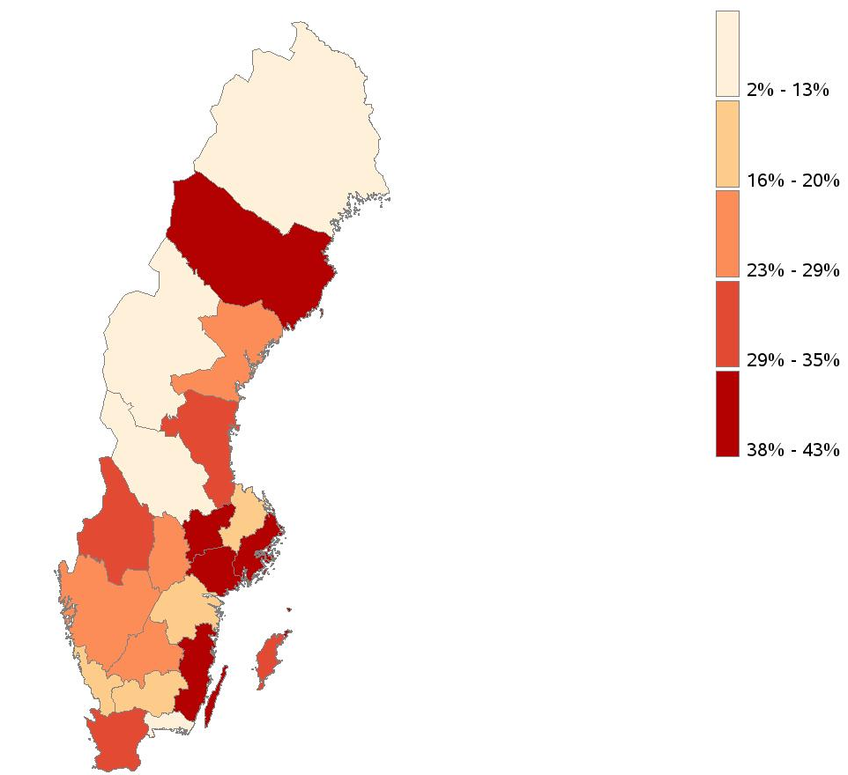

Reproduced with permission from SveDem from the SveDem yearly report from 2013 (Årsrapport 2013 available in Swedish at http://www.svedem.se). ©SveDem 2014

