Supplementary Materials

Supplementary Methods
Supplementary Table 1 provides supplementary information on participants’ APOE status and health characteristics at the time of the MCI diagnosis. Independent samples’ t-tests and two-sided Fisher’s exact tests were performed to determine NC-NC versus NC-MCI group differences regarding these variables using an alpha level of p < 0.05. Statistical analyses were performed with SPSS version 21 (SPSS Inc. IBM company, 2012). Significant group differences emerged with respect to the APOE status (p = 0.02), with NC-MCI patients having more APOEε4 alleles than NC-NC patients, and with respect to the number of cardiac events (p = 0.004), which was likewise greater in the NC-MCI group, while groups were comparable with respect to the scores on the Geriatric Depression Scale (GDS), body mass index (BMI), use of antidepressant medication, smoking status, prevalence of diabetes, history of stroke and cancer, and severe systemic diseases (all p-values ≥ 0.13).

Supplementary Table 1.Participants’ APOE status and health characteristics at time of MCI diagnosis (i.e., visit 0).

 | NC-NC  (n = 60) | NC-MCI  (n = 27) | T/χ^{2*} | p
APOE ε4 status |  |  | 7.9* | 0.02
no ε4 allele, no. (%) | 43 (71.7) | 11 (40.7)
one ε4 allele, no. (%) | 15 (25.0) | 15 (55.6)
two ε4 allele, no. (%) | 2 (3.3) | 1 (3.7)
GDS, mean (SD)** | 0.59 (0.84) | 0.57 (1.16) | 0.07 | 0.94
BMI, mean (SD)** | 25.01 (2.77) | 24.37 (4.56) | 0.60 | 0.56
use of antidepressant medication, no. (%) | 3 (5.0) | 2 (7.41)
Smoking status |  |  | 1.86* | 0.40
current smoker, no. (%) | 4 (6.67) | 2 (7.41)
ex-smoker, no. (%) | 14 (23.33) | 10 (37.04)
non-smoker, no. (%) | 42 (70.00) | 15 (55.56)
Insulin-dependent diabetes, no. (%) | 0 (0.00) | 1 (3.70) | 2.25* | 0.13
History of stroke, no. (%) | 1 (1.67) | 1 (3.70) | 0.34* | 0.56
History of cancer, no. (%) | 7 (11.67) | 3 (11.11) | 0.006* | 0.94
Cardiac events, no. (%)*** | 1 (1.67) | 5 (18.50) | 8.24* | 0.004
Severe systemic disease, no. (%)† | 2 (3.33) | 0 (0.00) | 0.92* | 0.34
GDS, Geriatric Depression Scale; BMI, body mass index.
*Fisher’s exact test.
**Information on BMI was missing for 10 NC-NC participants and 17 NC-MCI participants and on GDS for 11 NC-NC and 13 NC-MCI participants.
***cardiac events: arteriosclerosis, arrhythmia, bypass surgery, arterial hypertension, atrial fibrillation.
†severe systemic disease: severe pancreas dysfunction; lung emphysema.

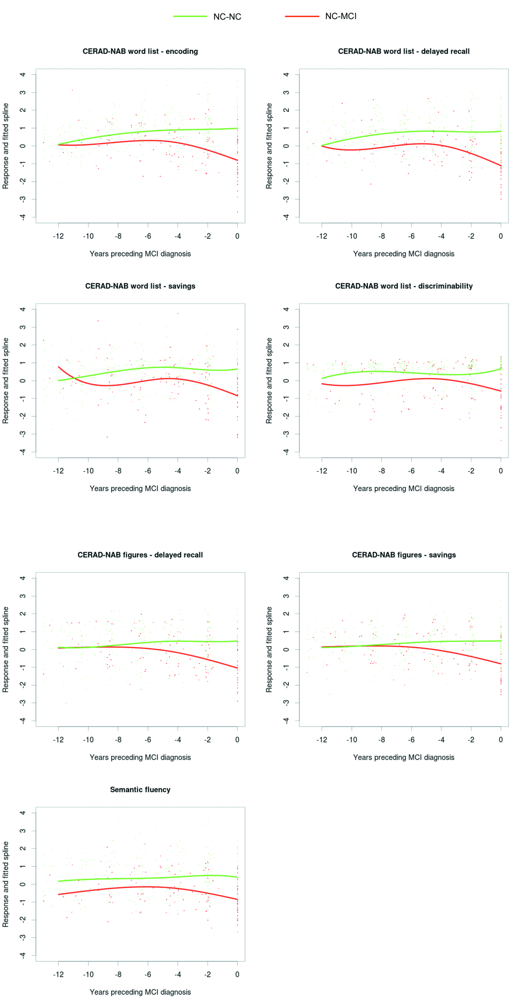
Supplementary Figure 1. Distribution of the neuropsychological performance and cubic splines estimated from linear mixed effects models of the longitudinal courses of NC-NC and NC-MCI’s verbal and visual episodic and semantic memory functioning during the 12 years preceding the diagnosis of MCI due to AD. Cubic splines were computed on a grid of times (to achieve smooth curves).

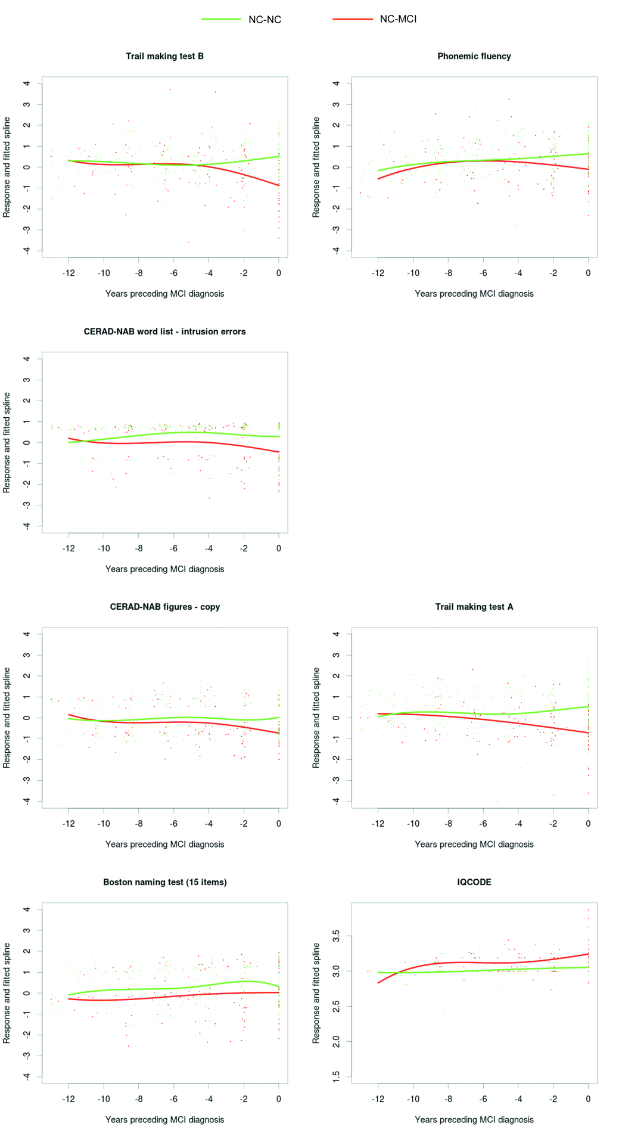
Supplementary Figure 2. Distribution of the neuropsychological performance and cubic splines estimated from linear mixed effects models of the longitudinal courses of NC-NC and NC-MCI’s neuropsychological functioning and informant-based report of cognitive functioning during the 12 years preceding the diagnosis of MCI due to AD. Cubic splines were computed on a grid of times (to achieve smooth curves).

