Supplementary Material
Supplementary Table 1. Patient characteristics

 | AD Cases (n=10) | Non-AD Controls (n=10)
Age (y) ± SEM | 71.6 ± 3.6 | 71.5 ± 3.8
Gender (Female) | 4 | 4
APOE allele
4/4 | 3 | 0
3/4 | 5 | 1
3/3 | 2 | 6
2/3 | 0 | 3
Race (Caucasian)  Braak Stage (n, %)  0  I  II  III  IV  V  VI | 9  0  0  0  0  0  0  10 (100%) | 8  1 (10%)  0  9 (90%)  0  0  0  0

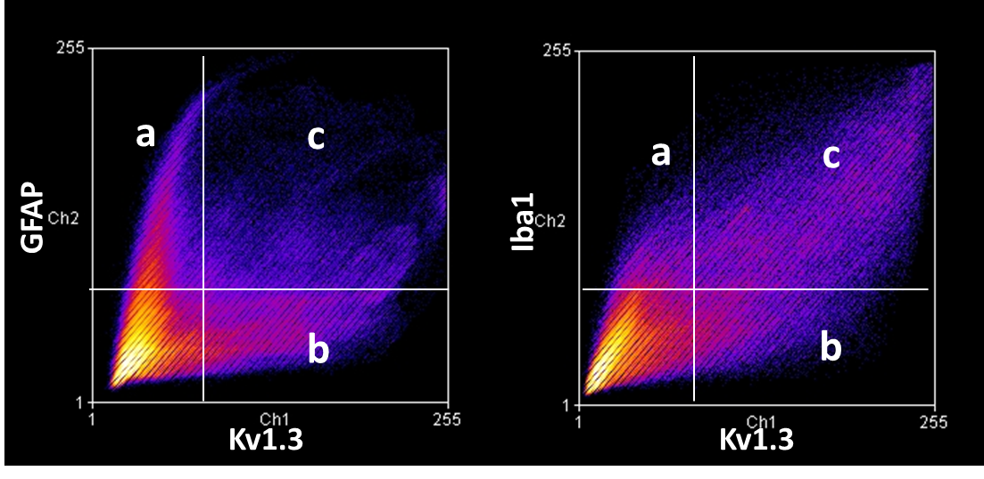
Supplementary Figure 1. Co-localization analysis. Degree of co-localization was defined as the percentage of pixels positive on both channels, defined as follows: % co-localization = [c/(a+b)] x 100. Pixels negative on either channel were excluded as these represented irrelevant or acellular regions. % co-localization between Kv1.3 and Iba1 (Right) was higher than that between Kv1.3 and GFAP (Left).

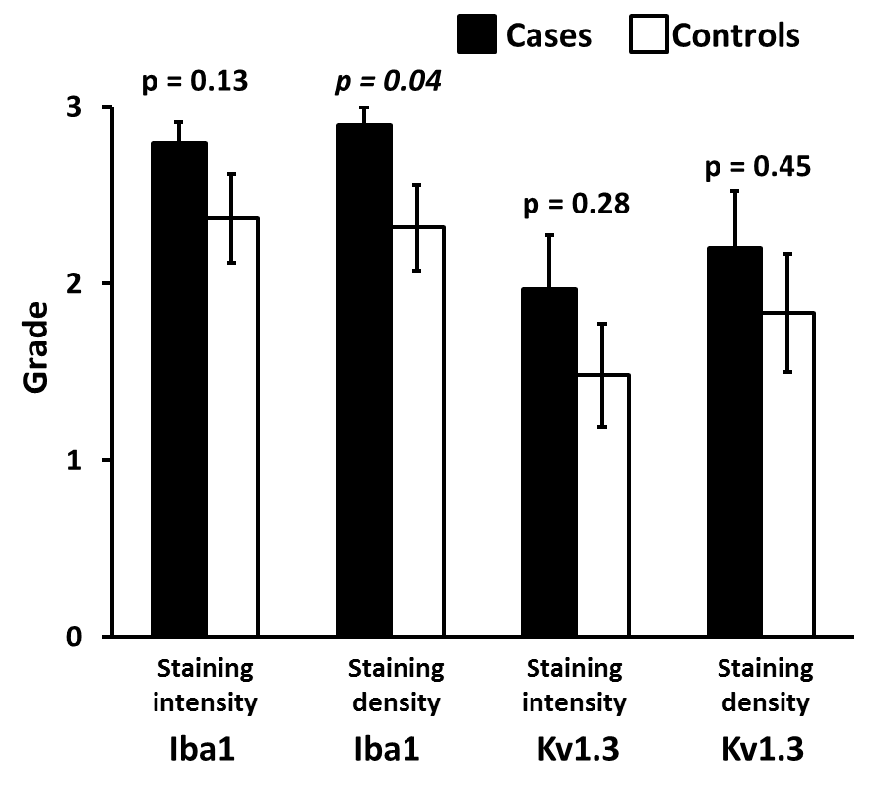
Supplementary Figure 2. Iba1 and Kv1.3 expression in white matter regions of frontal cortex of human AD brain. Iba1 staining density was significantly higher in AD cases as compared to controls. No significant differences in Iba1 staining intensity, Kv1.3 staining intensity or Kv1.3 staining density were observed between AD cases and controls.

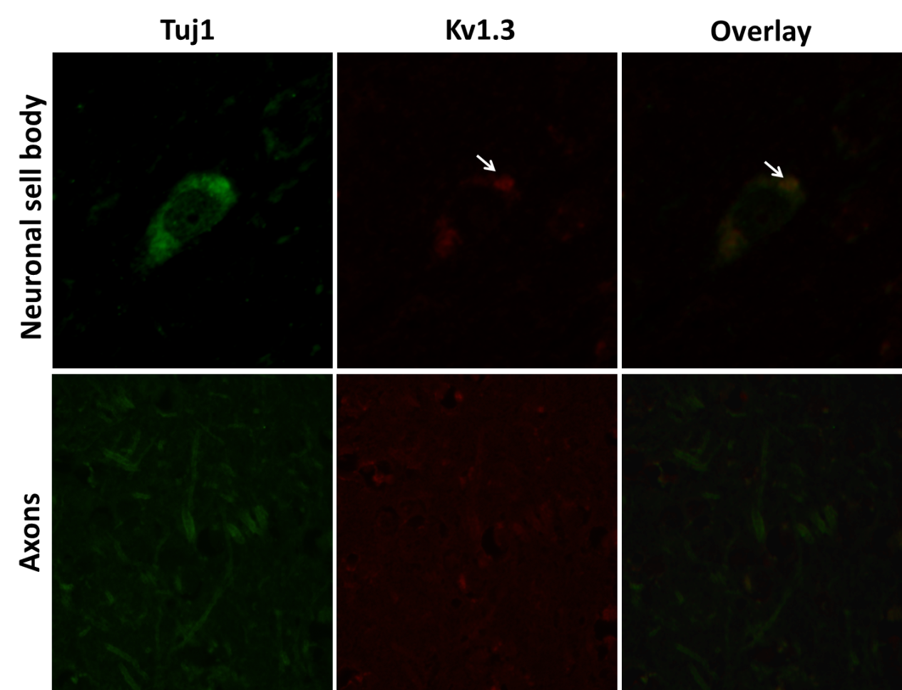
Supplementary Figure 3. Low level of Kv1.3 expression by neurons. Neuronal cell bodies (upper panel) expressed low levels of Kv1.3 channel protein while axons (lower panel) showed minimal to no Kv1.3 channel expression (n=3 AD cases).

