Supplementary Material

Neuronal Deposition of Amyloid-β Oligomers and Hyperphosphorylated Tau Is Closely Connected with Cognitive Dysfunction in Aged Dogs

Supplementary Figure 1. Photomicrographs of Congo red staining in the brain hippocampal and cortical region of a 15-year-old small size Pomeranian. No distinctive red-brick staining of amyloid fibrils and apple-green birefringence with Congo red staining were observed in the brain A, B) hippocampus C, D) frontal cortex of a 15-year-old small size Pomeranian (scale bar = 20 µm and inserts scale bar = 5 µm). Representative of all aged dogs.
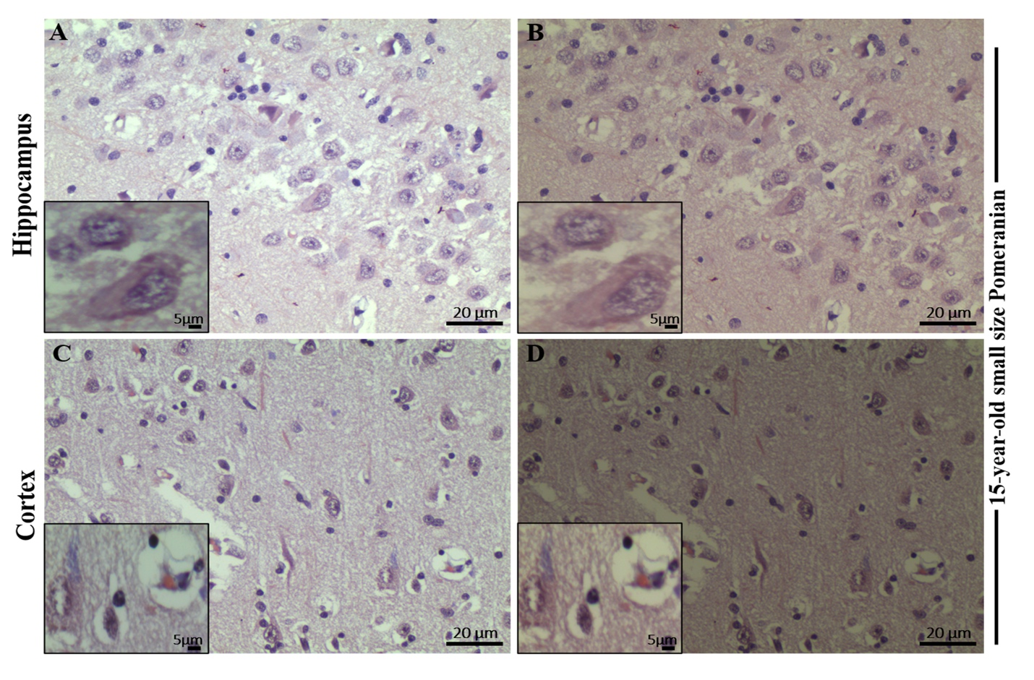

Supplementary Figure 2. Immunofluorescence staining with PrioAD13 anti-Aβ₁₋₄₂ oligomer nanobody, 4G8 anti-Aβ, and AT8 anti phospho-Tau (Ser202, Thr205) antibody in brain hippocampal and cortical region of an aged dog. LSM800 confocal images were taken at 40x and 100x respectively for each tissue section with a standard FITC/Texas Red double band-pass filter set. Staining with anti-Aβ₁₋₄₂ (PrioAD13) nanobody (GREEN) demonstrated widespread intracellular deposition of Aβ₁₋₄₂ oligomers (white arrows) in the hippocampus at A) 40x magnification, scale bar = 20 µm and B) higher magnification at 100x, scale bar = 5 µm and also in the frontal cortex at C) 40x magnification, scale bar = 20 µm and D) higher magnification at 100x, scale bar = 5 µm of a 17-year-old medium size Mongrel; Staining with 4G8 anti-Aβ antibody (red) displayed extracellular diffuse plaque (white arrows) in the hippocampus both at E) 40x magnification, scale bar = 20 µm and F) higher magnification at 100x, scale bar = 5 µm and in the frontal cortex at G) 40x magnification, scale bar = 20 µm and H) higher magnification at 100x, scale bar = 5 µm of a 17-year-old medium size Mongrel; Staining with AT8 anti-p-Tau antibody (red) exhibited extensive intracellular p-Tau (white arrows) in the hippocampus both at I) 40x magnification, scale bar = 20 µm and J) higher magnification at 100x, scale bar = 5 µm and in the frontal cortex both at K) 40x magnification, scale bar = 20 µm and L) higher magnification at 100x, scale bar = 5 µm of a 17-year-old medium size Mongrel. Representative of all aged dogs.

Supplementary Figure 3. Immunofluorescence staining of hippocampal region of an aged dog. Secondary antibody with the omission of the primary antibody was used as a negative control. Secondary anti-IgG Texas Red (red) or FITC (green) antibodies were used in the hippocampus (A, B) of a 15-year-old small size Pomeranian, scale bar = 20 µm, insert scale bar = 5 µm. Representative of all aged dogs.

