Supplementary Material

Superior Frontal Gyrus TOMM40-APOE Locus DNA Methylation in Alzheimer’s Disease

Supplementary Table 1. Cohort characteristics stratified by APOE ε4 status.
 | APOE ε4 status
Variable | Carrier  (n = 22) | Non-carrier  (n = 44) | p  (test statistic)
Age at death, y (SD) | 86.8 (7.4) | 87.8 (5.4) | 0.516 (t = 0.652)
Females, n (%) | 17 (77) | 29 (66) | 0.405
Postmortem delay, h (SD)a | 79.1 (39.3) | 72.3 (45.7) | 0.582 (t = 0.553)
Whole brain weight, g (SD)b | 1241 (125.2) | 1189 (144.9) | 0.244 (t = 1.182)
ªData available in: carrier n = 19, non-carrier n = 39
^{b}Data available in: carrier n = 16, non-carrier n = 26

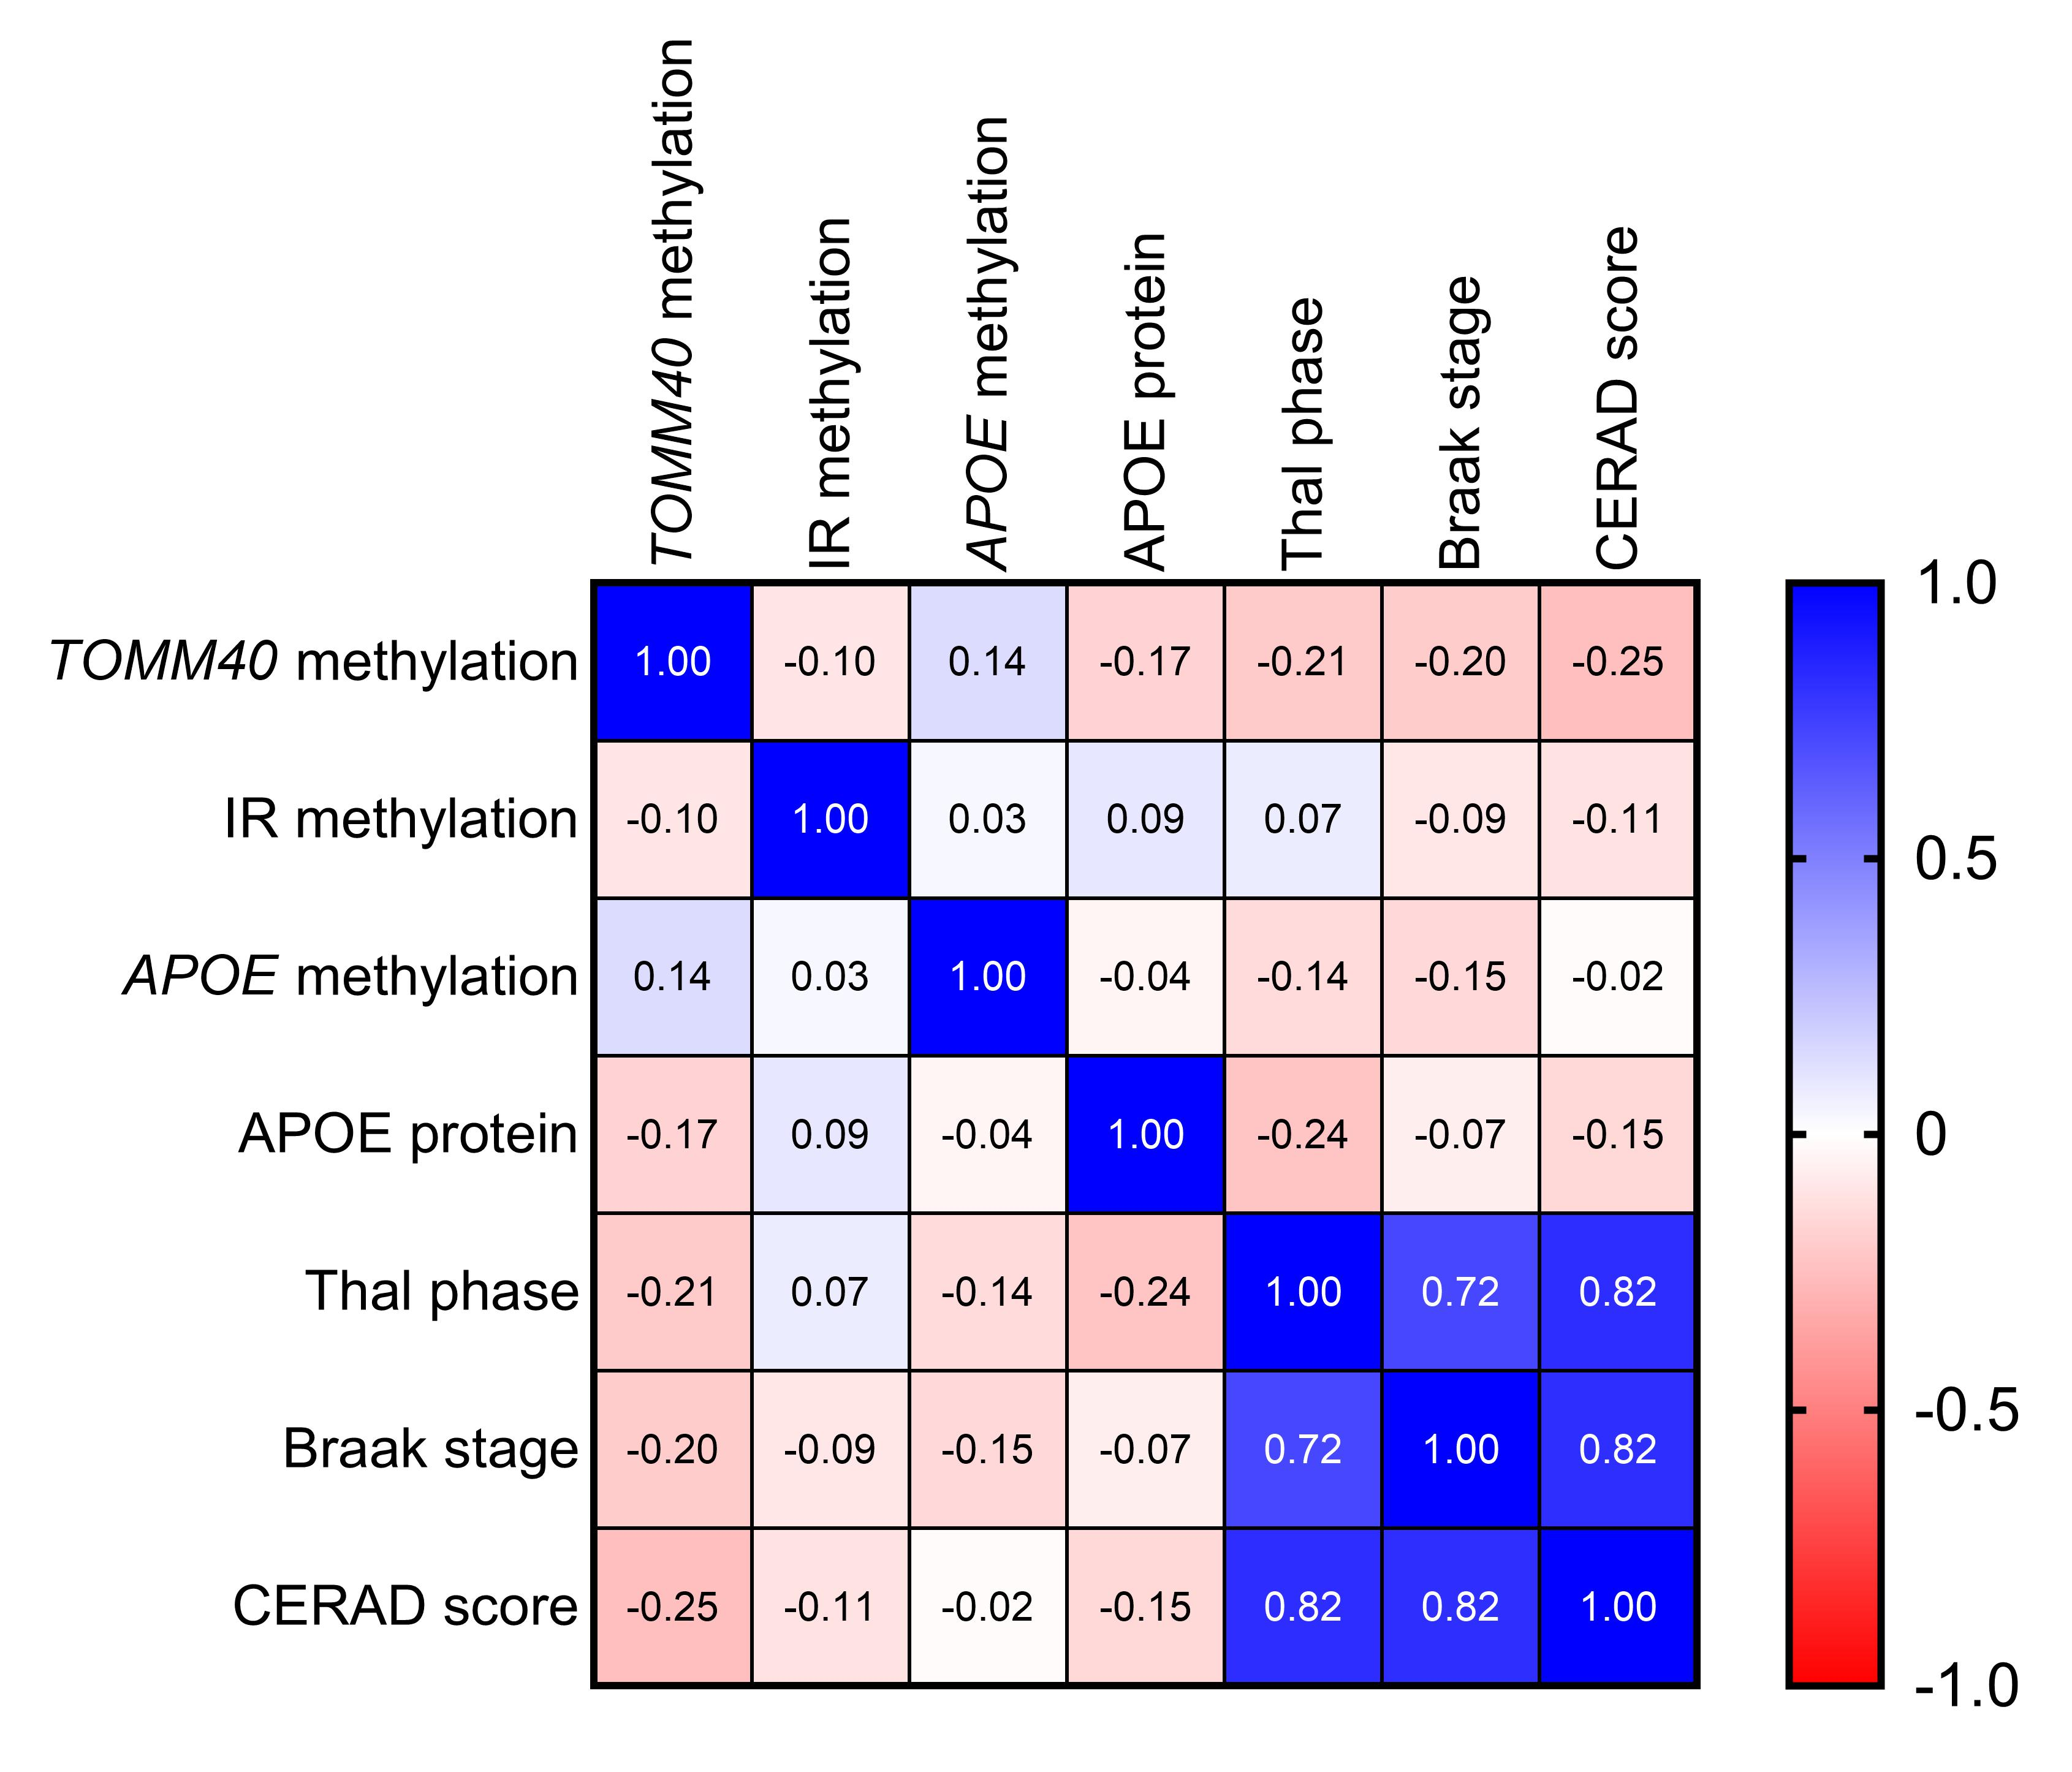

Supplementary Figure 1. Correlation matrix between TOMM40 CpG island, APOE promoter region, and APOE CpG island methylation, ApoE protein, and neuropathological scores (Thal, Braak, and CERAD). Results presented are Spearman correlation coefficient values. N = 46-66.

