Supplementary Table 1. Details of pyrosequencing targets.

Gene | Position in gene | Location on GRCh37/hg19 Assembly | CpG island number | Target sequence | Primer sequences
SIRT1 | promoter | chr10: 69647485- 69647502 | 101 | CACTACGCCCGGCTAAT | Sirtp2f1 AGTTTTTTTAGTAGTTGGGATTATATGTA  Sirtp2r1b CAAAACCAACCTAACCAACATAAA  Sirtp2s1 AGTTGGGATTATATGTATATGTTA
ABCA7 | promoter | chr19:1020798-1044962 | 43 | CGCCCAATAGCAGCGTGCAGAGGCAGGGGCGTGCCCCGGCGCTGCTACCTGCGC | Abca7_4_f1 GGTTAGGAGAGGTTTTTTTGTGATT  Abca7_4_r1b TCCTTCTCACCTTCCAAAAACTC  Abca7_4_s1 AGTAGGTTAGTGAGTG  abca74_s2 GTGTAGAGGTAGGGG
PTK2β | promoter | chr8:27182721-27285249 | 27 | CGTCCCGGCTCACCTGGCGGTGCCCGAGGAGTAGTCG | Ptk2b_py1f1 GAGGAGGAGGGAGAATTTAATTT  Ptk2b_py1r1b AACTCCCAACTCAAATACCC  Ptk2b_py1s1 ATTTGTTAGGTAGATTTATTTGTA
MEF2C(1) | promoter | chr5:88179867- 88179895 | 38 | CGAAATGAAGACAACACGGCGAGCTGCG | Mef2c_pcor_f1 GTGTTTAAAAGGGGGAAAAGTTATAAGA  Mef2c_pcor_r1 ACACATACCATACCCAAACCTAATAACAAT  Mef2c_pcor_s1 AGAGGAGTAGGGAGT
MEF2C(2) | promoter | chr5:88,200,070-88,200,105 | n/a | TGCTTCCCTCCCCTCCCCCCTCCCGACCCCCTATG | Mef2c_py1f1 GATTGGATATTTTTTATTGGAATTAGTAGT  Mef2c_py1r1b TATCACTAACAACCAAACCTTTATCAA  Mef2c_py1s1 ATTGGAATTAGTAGTATAGGG
RIN3 | 3’UTR | chr14:93153018-93209772 | 124 | CGGTCTCCGCCGAGCCGGGATCCTCAGCCGCTTCCCGCG | RIN3_pyf1 GGGTTTAGGGTTGTAGGTAGAGA  RIN3_pyr1 AAACCCTAACCACCAATTACCATCAC  RIN3_pys1 ATTGGGAATAGTAGGTTT

Supplementary Table 2. Details of pyrosequencing PCRs.

PCR | Cycle details
SIRT PCR | 95°C (15 min), 15 cycles of (96°C (30 s), 64 (-1°C per cycle), 72°C (30 s), 50 cycles (94°C (30 s), 53.8°C (30 s), 72°C (60 s)), 72°C (10 min)
ABCA7, PTK2β, and MEF2C(1) | 95°C (15 min), 15 cycles of (96°C (30 s), 64 (-1°C per cycle), 72°C (30 s), 50 cycles (94°C (30 s), 58.7°C (30 s), 72°C (60 s)), 72°C (10 min)
MEF2C(2) | 95°C (15 min), 15 cycles of (96°C (30 s), 55 (-1°C per cycle), 72°C (30 s), 50 cycles (94°C (30 s), 48°C (30 s), 72°C (60 s)), 72°C (10 min)
RIN3 | 95°C (15 min), 15 cycles of (96°C (30 s), 60 (-1°C per cycle), 72°C (30 s), 50 cycles (94°C (30 s), 55°C (30 s), 72°C (60 s)), 72°C (10 min)

Supplementary Figure 1. Pyrosequencing targets PTK2β, ABCA7, and SIRT1. Image showing positions of the CpG island targeted within A) PTK2β, B) ABCA7, and C) SIRT1 genes shown using images taken from the USCS genome browser.

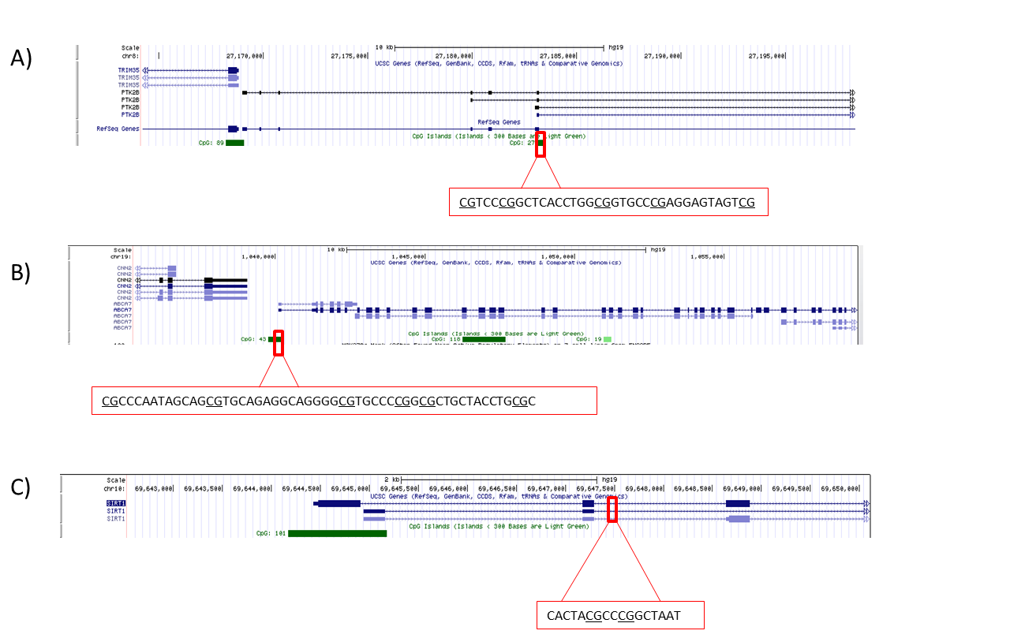

Supplementary Figure 2: MEF2C and RIN3 3’ UTR regions targeted by pyrosequencing. A) Target sites for the two MEF2C pyrosequencing assays are shown. MEF2C(1) covered CpGs within CGI 38 while MEF2C(2) covered one upstream CpG site. B) Position of the CpG island within the RIN3 gene show on the USCS genome browser.

MEF2C (1) CGI target : CGAAATGAAGACAACACGGCGAGCTGCG
MEF2C (2) target upstream CpG site: TGCTTCCCTCCCCTCCCCCCTCCCGACCCCCTATG
A)
B)

Supplementary Figure 3: ABCA7, SIRT1, and MEF2C(1) blood and brain; resolution of each CpG. No significant difference in methylation was observed at individual CpG resolution in any of the targets. A, C, and E show average methylation found at each CpG investigated in ABCA7, SIRT1, and MEF2C(1) blood respectively and B, D, and F show average methylation at each CpG in brain. White bars represent control average and black bars represent AD average. Error bars show S.E.M. For ABCA7: control blood n=7, AD blood n=4, control brain n=3, and AD brain=6. For SIRT1: control blood n=4, AD blood n=5, control brain n=3, and AD brain n=3. For the MEF2C(1): CGI region control blood n=3, AD blood n=5, control brain n=3, and AD brain n=4.

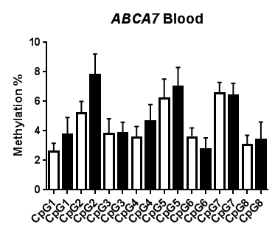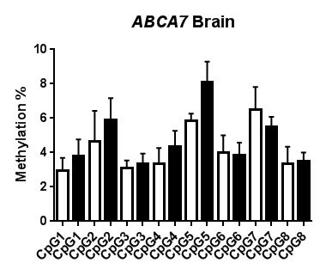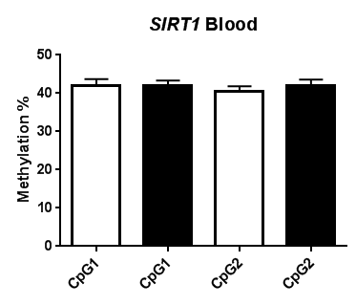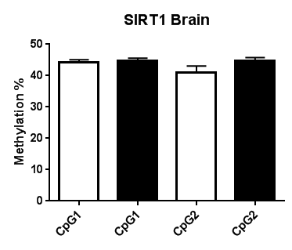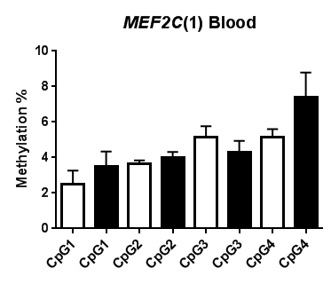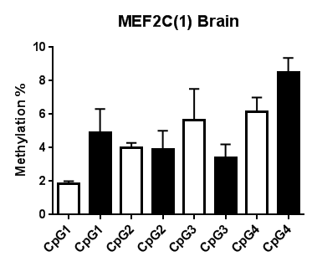
A)
C)
E)
B)
D)
F)

Supplementary Figure 4. Average blood and brain methylation at MEF2C(2). At the CpG investigated upstream of MEF2C CGI brain samples were found to be significantly hypomethylated when compared to blood samples. Graph shows average methylation at the CpG in blood and brain (n=51 and 24, respectively). Error bars represent S.E.M. (p=2.43E-06 (two tail)).

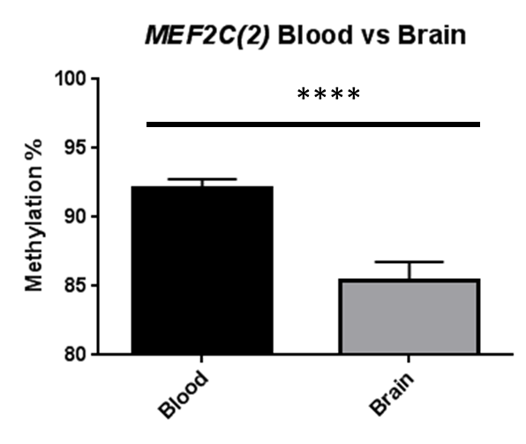

Supplementary Figure 5. Average methylation in blood and brain for targets. No significant difference in methylation was observed between blood and brain tissue in control or AD in any of the regions investigated in (A) PTK2β, (B) ABCA7, (C) SIRT1, or (D) MEF2C CGI. Graphs show average methylation in brain and blood tissue for all of the regions investigated. Bar represents average methylation and error bars shows S.E.M. For PTK2β: control blood n=6, AD blood n=5, control brain n=3, and AD brain n=4. For ABCA7: control blood n=7, AD blood n=4, control brain n=3, and AD brain=6. For SIRT1: control blood n=4, AD blood n=5, control brain n=3, and AD brain n=3. For the MEF2C: CGI region Control blood n=3, AD blood n=5, Control brain n=3, and AD brain n=4.

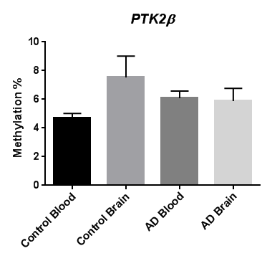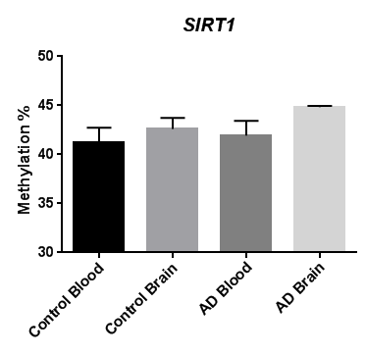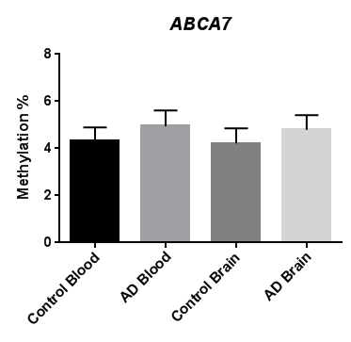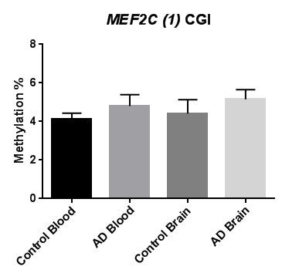
A)
B)
C)
D)

Supplementary Figure 6. No significant differences between genders group wide. *p<0.05 two tailed test. Control blood male to female n=12/14, AD blood male to female n=15/7, for brain control female n=6, male n=4, for AD brain female n=10, male n=4.
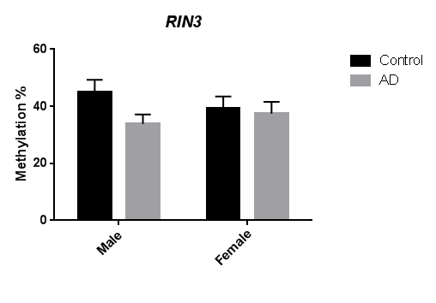
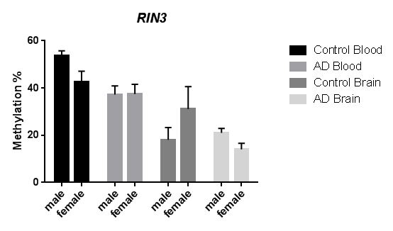
All AD males versus females blood and brain
*
Supplementary Figure 7. Significant hypomethylation was observed at the region investigated for RIN3 in AD brain and in control brain. Graphs shows average methylation found for the investigated RIN3 region in control and AD blood and brain. Error bars show S.E.M. Control blood versus brain two-tail 0.006315, AD blood versus brain, two-tail 6.15E-07. Control blood n= 26, Control brain n=10, AD blood n= 22, and AD brain n=14.





