Supplementary Figure 1. Average sagittal SUV PET images of [18F]FDG uptake in 3, 6, 11, and 15 months old APOE2/3/4 TR mice.

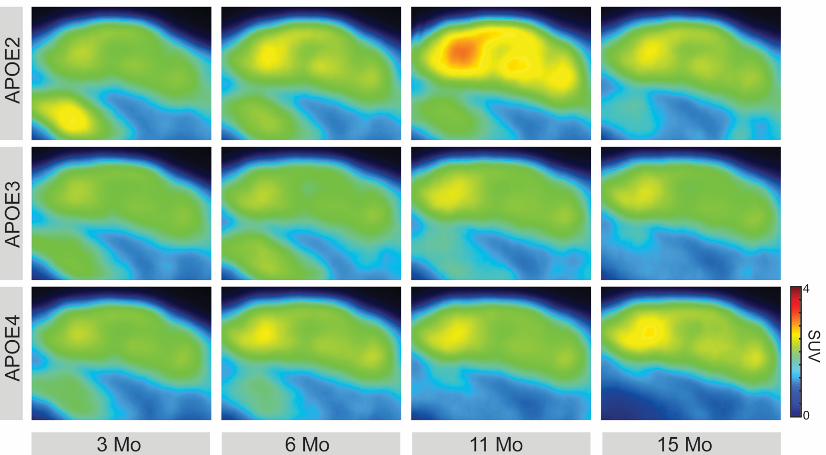
Supplementary Table 1. Animal weight (g), mean ± SD.

 | 3 months | 6 months | 11 months | 15 months
APOE2 | 19.7 ± 1.4 | 23.2 ± 1.5 | 27.5 ± 2.4 | 27.8 ± 1.6
APOE3 | 20.5 ± 1.0 | 24.6 ± 1.4 | 30.8 ± 3.1 | 30.1 ± 2.4
APOE4 | 20.2 ± 1.0 | 24.0 ± 1.5 | 27.2 ± 1.1 | 27.3 ± 2.0

Supplementary Table 2. Injected radioactivity (MBq), mean ± SD.
 | 3 months | 6 months | 11 months | 15 months
APOE2 | 12.2 ± 1.3 | 12.3 ± 1.3 | 13.8 ± 1.2 | 13.0 ± 0.9
APOE3 | 12.2 ± 0.9 | 13.4 ± 1.0 | 14.7 ± 3.7 | 13.0 ± 1.1
APOE4 | 12.1 ± 1.2 | 12.7 ± 1.2 | 12.9 ± 0.9 | 13.0 ± 1.5

Supplementary Table 3. Coefficient estimates in the LME model.

 | Estimate | Std. Error | p-value
(Intercept) | 1.406 | 0.239 | <0.001
APOE2 | 0.153 | 0.096 | 0.111
Time 6 months | -0.059 | 0.069 | 0.391
Time 11 months | 0.041 | 0.118 | 0.726
Time 15 months | -0.122 | 0.11 | 0.267
APOE4 | 0.045 | 0.096 | 0.639
ROI Cingulate Cortex | 0.604 | 0.038 | <0.001
ROI Cortex | 0.251 | 0.038 | <0.001
ROI Harderian Glands | 1.594 | 0.038 | <0.001
ROI Hippocampus | 0.383 | 0.038 | <0.001
ROI Whole BRAIN | 0.288 | 0.038 | <0.001
Weight | 0.022 | 0.01 | 0.025
Injected Radioactivity | -0.04 | 0.008 | <0.001
APOE2: Time 6 months | 0.185 | 0.077 | 0.017
APOE2: Time 11 months | 0.505 | 0.081 | <0.001
APOE2: Time 15 months | 0.171 | 0.078 | 0.029
APOE4: Time 6 months | 0.11 | 0.077 | 0.151
APOE4: Time 11 months | -0.006 | 0.085 | 0.948
APOE4: Time 15 months | 0.239 | 0.081 | 0.003

Supplementary Table 4. Predicted means (pm) and standard errors (SE) of the fitted LME model with weight = 25g and injected radioactivity = 13 MBq.

Region | Time (months) | APOE2 |  |  | APOE3 |  | APOE4 |  | p-value APOE2 versus APOE3 | p-value APOE4 versus APOE3
 |  | pm | SE | pm |  | SE | pm | SE
Cerebellum | 3 | 1.36 | 0.15 | 1.43 |  | 0.13 | 1.38 | 0.14 | 0.2814 | 0.3994
Cerebellum | 6 | 1.48 | 0.06 | 1.60 |  | 0.05 | 1.59 | 0.05 | 0.1519 | 0.8795
Cerebellum | 11 | 1.87 | 0.10 | 1.52 |  | 0.15 | 1.54 | 0.09 | 0.0172 | 0.9124
Cerebellum | 15 | 1.48 | 0.09 | 1.35 |  | 0.13 | 1.57 | 0.09 | 0.2323 | 0.0562
Cingulate Cortex | 3 | 2.10 | 0.34 | 1.99 |  | 0.29 | 2.07 | 0.31 | 0.4851 | 0.6028
Cingulate Cortex | 6 | 2.49 | 0.13 | 1.89 |  | 0.10 | 2.19 | 0.11 | 0.0009 | 0.0502
Cingulate Cortex | 11 | 2.93 | 0.15 | 1.96 |  | 0.23 | 2.02 | 0.14 | 0.0001 | 0.7717
Cingulate Cortex | 15 | 2.18 | 0.19 | 1.68 |  | 0.27 | 2.20 | 0.18 | 0.0362 | 0.0370
Cortex | 3 | 1.83 | 0.22 | 1.72 |  | 0.19 | 1.74 | 0.20 | 0.2897 | 0.8250
Cortex | 6 | 2.04 | 0.08 | 1.69 |  | 0.07 | 1.85 | 0.07 | 0.0031 | 0.1196
Cortex | 11 | 2.40 | 0.12 | 1.68 |  | 0.18 | 1.67 | 0.11 | 0.0001 | 0.9552
Cortex | 15 | 1.79 | 0.13 | 1.45 |  | 0.19 | 1.80 | 0.12 | 0.0408 | 0.0452
Harderian Glands | 3 | 4.16 | 0.40 | 3.45 |  | 0.35 | 3.66 | 0.37 | 0.0011 | 0.2855
Harderian Glands | 6 | 3.53 | 0.17 | 2.94 |  | 0.14 | 3.01 | 0.15 | 0.0111 | 0.7317
Harderian Glands | 11 | 3.63 | 0.21 | 2.88 |  | 0.33 | 3.20 | 0.20 | 0.0167 | 0.3182
Harderian Glands | 15 | 3.38 | 0.24 | 2.82 |  | 0.35 | 3.02 | 0.23 | 0.0722 | 0.5218
Hippocampus | 3 | 1.92 | 0.28 | 1.86 |  | 0.24 | 1.91 | 0.25 | 0.6270 | 0.6799
Hippocampus | 6 | 2.18 | 0.10 | 1.78 |  | 0.08 | 2.01 | 0.08 | 0.0046 | 0.0627
Hippocampus | 11 | 2.55 | 0.13 | 1.78 |  | 0.20 | 1.83 | 0.12 | 0.0003 | 0.7979
Hippocampus | 15 | 1.93 | 0.15 | 1.54 |  | 0.22 | 1.98 | 0.14 | 0.0394 | 0.0271
Whole Brain | 3 | 1.91 | 0.20 | 1.84 |  | 0.18 | 1.86 | 0.19 | 0.5248 | 0.8323
Whole Brain | 6 | 2.04 | 0.08 | 1.75 |  | 0.07 | 1.91 | 0.07 | 0.0092 | 0.1083
Whole Brain | 11 | 2.36 | 0.12 | 1.72 |  | 0.18 | 1.74 | 0.11 | 0.0006 | 0.9403
Whole Brain | 15 | 1.80 | 0.13 | 1.50 |  | 0.19 | 1.85 | 0.12 | 0.0730 | 0.0419

