Supplementary Material

A Meta-Analysis on the Link Between Young People’s Social Environment, Socioeconomic Status, and Political Violence Outcomes

Supplementary Table S1
Domains, Variables, and Variable Names
Domain/ Variables | Variable names from included samples (translated to English) ª
Parents and Family
Familial support | Involvement in family decisions, Parental attention, Parents’ coldness-rejection, Parental attention childhood, Parental support, Social support family, Relationship with parents, Disturbed family relationships, Authoritative parenting, Emotional support from the family, Family support, Family cohesiveness, Can talk to parents about everything, Parental neglect
Familial conflict | Parent-adolescent conflict, Conflict with parents in everyday life, Potential for conflict within the family, Problems because parents have different perspective
Parental control | Parental control, Parental control childhood, Parental control youth, Behavioral control
Importance of family | Importance of family, Importance of parents' expectations, Subjective importance of parents
Parental violence | Physical punishment by parents, Severe parental violence, Violence during childhood, Violence during youth, Parental experience of violence childhood, Parental experience of violence youth, Parental violence, Experience of violence during childhood, Experience of violence during youth, Family experience of violence
Peers and Radical Networks
Friends with racist or violent attitudes | Friends' racism, Friends who talk constantly about violent topics, Peer racism, Radical social network
Membership in political group that opposes mainstream politics | Member of autonomous leftwing groups or Antifa, Member of rightwing group, Membership in rightwing group/ comradeship
General membership in peer group | Peer-group membership, Affiliation with youth clique
School
School attachment | bullying at school (integration), Like to go to school, truancy, Educational value, Importance of education, Importance of college, Relationship with classmates, Relationship with teachers, School social bonds, School social integration
School achievement | Average grade (from math, German, history), Grades, Repeat class, school finishing certificate (matura)
Socioeconomic Status | socioeconomic status, Unemployment/ social welfare of parents, Relative deprivation, Social welfare/unemployment of parents, Unemployment of parents or social welfare benefits, Absolute deprivation ("getting by with money"), Dependence on social benefits, Economic security, Income, Unemployment of parents/social welfare, Average income, Family income, Household income, Job status: employed vs. unemployed, Parental education, Social welfare, Net income, Financial situation of the family, Precarious economic status, Parents' professional status
ª inversely coded variables are written in cursive

Supplementary Table S2
Main Search String for All Databases
Concept | Search String and filters
Political violence outcomes | "political violence" OR "politically violent" OR "political aggression" OR "motivated violence" OR "ethnic violence" OR "religious violence" OR "radical*" OR "extremism" OR "extremist*" OR "illegal political" OR "unconventional political" OR "illegal protest*"  OR  (suicide AND (bomb* OR attack*) OR terroris*) AND support*)  OR  (violence AND (Islam* OR Muslim* OR fundamental* OR Jihad* OR Salaf* OR "right-wing" OR "left-wing"))
Filters | On Pubmed, we used filters to selectively retrieve quantitative studies and studies sampling primarily participants below the age of 30 ("Adolescence, Young Adulthood, Childhood, School Age" and "quantitative"). For the remaining databases, such filters were not available. Therefore, we created a search string based on terms indicating young participant age (see below) and quantitative methodology (see below)
Age | youth* OR adolescen* OR pupil* OR child* OR boy* OR girl* OR teen OR young OR student* OR "emerging adult*" OR juvenile OR puberty OR teenage* OR "teen-age*" OR school* OR class* OR "below the age of" OR "below age" OR undergraduate* OR online
Quantitative studies | hypothes* OR "moderation analys?s" OR "mediation analys?s" OR "risk factor*" OR "protective factor*" OR "structural equation modeling" OR ((factor* OR determinant*) AND (associat* OR predict* OR "unrelated to" OR "related to" OR explaining OR "controlling for")) OR "statistically controlled" OR ANOVA OR ANCOVA OR "analys?s of variance" OR "analys?s of covariance" OR "factor analys?s" OR "Chi square" OR "t-test*" OR predictor* OR regression* OR correlat* OR statistic* OR multivariate OR multifactor* OR data OR dataset OR "results show*" OR "results reveal*" OR "results indicate*" OR „results suggest*“ OR variance* OR „standard deviation*“ OR quantitative* OR "pre-test*" OR "post-test*" OR longitudinal* OR "cross-sectional*" OR "self-report*" OR experiment* OR "control group*" OR "control condition*" OR randomiz* OR "randomly assigned" OR sample* OR participant* OR "a total of" OR "literature review" OR "systematic review" OR "review of the literature" OR "meta-analysis" OR empirical* OR survey* OR item* OR questionnaire* OR scale* OR measure*

Supplementary Table S3

Overview of the Characteristics of the Included Samples

Reference Sample ª | N | Mean Age ^{b} | Sample Description | Peer Review | Country | Name Independent variable(s) | Dimensions | Name Dependent Variable(s) | Ideology | Level of violence
Baier & Pfeiffer (2011), SP no migration background | 1489 | 15.12 | Berlin, 9th graders, no migration background | no | DE | Average grade (from math, German, history), Parental attention, Truancy (days and hours), Violence during childhood, Like to go to school, Parental control, Social welfare/unemployment of parents, Violence during youth | School_achieve, Fam_Support, School_attach, Par_Violence, Par_Control, SES | Leftwing viol. attitude, Leftwing viol. attitude (antifacism), Leftwing viol. behavior, Rightwing viol. behavior | LW, RW | Beh, Att
Baier & Pfeiffer (2011), SP migration background | 1184 | 15.12 | Berlin, 9th graders, with migration background | no | DE | Truancy (days and hours), Average grade (from math, German, history), Like to go to school, Parental attention, Parental control, Social welfare/unemployment of parents, Violence during childhood, Violence during youth | School_attach, School_achieve, Fam_Support, Par_Control, SES, Par_Violence | Anti-German viol. behavior, Leftwing viol. attitude, Leftwing viol. attitude (antifacism), Leftwing viol. behavior | OI, LW | Beh, Att
Baier & Rabold (2012), SP no migration background | 1510 | 15.15 | Saarland, 9th graders, no migration background | no | DE | Truancy, Average grade (from math, German, history), Like to go to school, Member of autonomous leftwing groups or Antifa, Parental attention, Parental control, Social welfare/unemployment of parents, Violence during childhood, Violence during youth | School_attach, School_achieve, Group_pol, Fam_Support, Par_Control, SES, Par_Violence | Leftwing viol. attitude, Leftwing viol. support, Leftwing viol. attitude, Leftwing viol. behavior, Rightwing viol. behavior | LW, RW | Beh, Att
Baier & Rabold (2012), SP with migration background | 516 | 15.15 | Berlin, 9th graders, with migration background | no | DE | Parental attention, Parental control, Violence during childhood, Violence during youth, Social welfare/unemployment of parents, Truancy, Like to go to school, Member of autonomous leftwing groups or Antifa, Average grade (from math, German, history) | Fam_Support, Par_Control, Par_Violence, SES, School_attach, Group_pol, School_achieve | Anti-German viol. behavior, Leftwing viol. support, Leftwing viol. attitude, Leftwing viol. behavior | OI, LW | Beh, Att
Baier et al. (2009) | 19526 | 15.28 | 9th and 10th graders, no migration background | no | DE | Experience of violence during childhood, Experience of violence during youth, (Non) truancy (days and hours), Average grade (from math, German, history), Like to go to school, Membership in rightwing group/ comradeship, Social welfare/unemployment of parents | Par_Violence, School_attach, School_achieve, Group_pol, SES | Rightwing extremist crimes, Rightwing viol. behavior | RW | Beh
Baier et al. (2010) | 2237 | 15.12 | Saxony-Anhalt, 9th graders, no migration background | no | DE | Parental attention childhood, Parental control childhood, Parental control youth, Parental experience of violence Childhood, Parental experience of violence Youth, truancy (days and hours), Average grade (from math, German, history), Like to go to school, Member of rightwing group, Social welfare | Fam_Support, Par_Control, Par_Violence, School_attach, School_achieve, Group_pol, SES | At least one rightwing crime, Rightwing viol. behavior | RW | Beh
Baier et al. (2016), SP no migration background - or few with migration backround ^{c}, Baier et al. (2016)_SP no migration background | 5008 | 14.88 | Lower Saxony, 9th graders, every third person, Lower Saxony, 9th graders, no migration background | yes | DE | Bullying at school (integration), Average grade (from math, German, history), Parental attention, Unemployment of parents or receipt of social welfare benefits, Severe parental violence, Like to go to school, Relative Deprivation, Absolute deprivation ("getting by with money") | School_attach, School_achieve, Fam_Support, SES, Par_Violence | Leftwing extremist attitudes, Leftwing extremist behavior, Leftwing viol. support, Leftwing viol. attitude, Leftwing viol. behavior, Rightwing extremist behavior, Rightwing viol. behavior | LW, RW | Beh, Att
Baier et al. (2016), SP with migration background | 376 | 14.88 | Lower Saxony, 9th graders, with migration background | yes | DE | (No) bullying at school (integration), Like to go to school, Average grade (from math, German, history), Parental attention, Relative Deprivation, Severe parental violence, Unemployment of parents or receipt of social welfare benefits | School_attach, School_achieve, Fam_Support, SES, Par_Violence | Anti-German crimes, Anti-German viol. behavior | OI | Beh
Barber (1999) boy SP | 3500 | 14.5 | Boys, 9th graders | yes | PS | Behavioral Control, Grades, Importance of Education, Parent-Adolescent Conflict, Parental Support | Par_Control, School_achieve, School_attach, Fam_Conflict, Fam_Support | Experience in the Intifada | OI | Beh
Barber (1999) girl SP | 3500 | 14.5 | Girls, 9th graders | yes | PS | Behavioral Control, Educational Value, Grades (higher scores - better grades), Parent-Adolescent Conflict, Parental Support | Par_Control, School_attach, School_achieve, Fam_Conflict, Fam_Support | Experience in the Intifada | OI | Beh
Bélanger et al. (2019) | 422 | 20.7 | Study 2a, students | yes | PK | Radical Social Network | Peer_Attitudes | Support for pol. viol. | US | Att
Brettfeld & Wetzels (2007) | 500 | 15.7 | Students, 9th + 10th graders, only Muslims | no | DE | Unemployment of parents/social welfare | SES | Islamist viol. attitude | IS | Att
Frindte (1999) | 1835 | 15.76 | Students in Bavaria, Brandenburg, Schleswig-Holstein and Thuringia | no | DE | Affiliation with youth clique, Family support, Financial situation of the family | Group_gen, Fam_Support, SES | Violence acceptance, Willingness to use viol. | US, RW | Att, Will
Glatz & Dahl (2016) | 1976 | 14.75, 16.87 ^{d} | Students; before Analytic Sample, Students, T3 | yes | SE | Involvement in Family Decisions, Parent's coldness-rejection | Fam_Support | Actual participation in illegal pol. activity, Approval of pol. viol., Illegal pol. activities, Readiness to use illegal pol. means | US | Beh, Will
Goede et al. (2019), Muslim SP | 939 | 14.7 | Muslim students, 9th graders | no | DE | Socioeconomic status, Parental control, Unemployment/ social welfare of parents | SES, Par_Control | Acceptance of ideologically motivated group viol., At least one Islamist offense, At least one leftwing extremist offense, Left-wing viol. attitude (antifacism), Leftwing viol. support, Leftwing viol. attitude (antifacism), Violent extremist attitudes scale | IS, LW, US | Att, Beh
Goede et al. (2019), no minority religion, no migration SP | 3639 | 14.7 | Students with no migration background and no minority religious affiliation, 9th grade | no | DE | Socioeconomic status, Parental control, Unemployment/ social welfare of parents | SES, Par_Control | At least one leftwing extremist offense, At least one rightwing extremist offense, Left-wing viol. attitude (antifacism), Leftwing viol. support, Leftwing viol. attitude (antifacism), Rightwing viol. support, Violent extremist attitudes scale | LW, RW, US | Beh, Att
Haddad & Khashan (2002) | 337 | 29.98 e | Sunnis and Shiites from Beirut | yes | LB | Income | SES | Endorsement of pol. Islam | IS | Att
Haddad (2003a) | 262 | 29.97 e | Sunnis and Shiites from Beirut | yes | LB | Income | SES | Endorsement of pol. Islam | IS | Att
Haddad (2003b) | 309 | 29.42e | Lebanese Muslims from Beirut | yes | LB | Economic security | SES | Endorsement of pol. Islam | IS | Att
Hadjar et al. (2019) | 875 | 20.78 | Young Muslims | yes | DE | Precarious economic status | SES | Violence-accepting attitude | IS | Att
Hammak et al. (2011) | 351 | 15.79 | Students, 10th +11th graders | yes | IL | Family income | SES | Political viol. participation | OI | Beh
Heitmeyer et al. (1997) | 1221 | 16.85 | Turkish students in North Rhine-Westphalia | no | DE | Emotional support from the family, Potential for conflict within the family | Fam_Support, Fam_Conflict | Religiously based willingness to use viol. | IS | Will, Att
Hinsch & Langner (1997) | 2683 | 15.47 | Youth from Brandenburg | no | DE | Family cohesiveness, Parental neglect | Fam_Support | Willingness to use pol. viol. | US | Will
Khoury-Kassabri et al. (2015) | 167 | 16.84 | Arab male at-risk youth in East Jerusalem | yes | IL | socioeconomic status | SES | Political viol. | OI | Beh
Krieg & Kliem (2019) 2017 SP | 4107 | 14.85 | Students from Lower Saxony, sample 2017 | yes | DE | Dependence on social benefits, Parental violence, Relative Deprivation | SES, Par_Violence | At least one rightwing extremist offense | RW | Beh
Krieg & Kliem (2019) 2015 SP | 5248 | 14.85 | Students from Lower Saxony, sample 2015 | yes | DE | Absolute deprivation ("getting by with money"), Dependence on social benefits, Parental violence, Relative Deprivation | SES, Par_Violence | At least one rightwing extremist offense | RW | Beh
Kuhn (2004) ^{f} | 1309 | 18.61 | Youth from Brandenburg | yes | DE | Conflict with parents in everyday life, Parental education | Fam_Conflict, SES | Readiness to use viol. in pol. action | US | Will
Kuhn (2004), boy SP | 337 | 16.00 | Boys from Brandenburg, 10th graders | yes | DE | Authoritative Parenting, Importance of Parents' Expectations, Peer-group membership, Subjective Importance of Parents | Fam_Support, Fam_Import, Group_gen | Readiness to use viol. in pol. action | US | Will, Beh
Kuhn (2004), girl SP | 502 | 16.00 | Girls from Brandenburg, 10th graders | yes | DE | Authoritative Parenting, Importance of Parents' Expectations, Peer-group membership, Subjective Importance of Parents | Fam_Support, Fam_Import, Group_gen | Readiness to use viol. in pol. action | US | Will, Beh
Miconi et al. (2019) | 1645 | 19.93 | Students | yes | CA | Social support family | Fam_Support | Radicalism (from Activism Radcalism Intention Scale), Sympathy for viol. radicalization | US | Will, Att
Moskalenko et al. (2009), S1 | 141 | 19.6 | Study 1, students | yes | US | Family income, Importance of college, Importance of Family | SES, School_attach, Fam_Import | Radicalism (from Activism Radcalism Intention Scale) | US | Will
Moskalenko et al. (2009), S2 | 146 | 17.5 | Study 2, students | yes | UA | Importance of college, Importance of Family | School_attach, Fam_Import | Radicalism (from Activism Radcalism Intention Scale), reference country, Radicalism (from Activism Radcalism Intention Scale); reference party | US | Will
Moyano & Trujillo (2014), Christian SP | 49 | 14.7 | Christians from secondary school | yes | ES | Friends who talk constantly about violent topics | Peer_Attitudes | Radicalism (from Activism Radcalism Intention Scale) | US | Will
Moyano & Trujillo (2014), Muslim SP | 66 | 14.7 | Muslims from secondary school | yes | ES | Friends who talk constantly about violent topics | Peer_Attitudes | Radicalism (from Activism Radcalism Intention Scale) | US | Will
Nivette et al. (2017) | 1214 | 17.00 | Children and adolescents from longitudinal Zurich Project on the Social Development of Children and Youths | yes | CH | Parents' professional status | SES | Violent extremist attitudes scale | US | Att
Pauwels & Heylen (2017) | 723 | 21.50 | Young people from Flanders | yes | BE | Friends' racism | Peer_Attitudes | Political viol. towards property, Support for viol. extremism rightwing | US, RW | Beh, Att
Pauwels & Schiels (2014) | 4453 | 20.00 | Young people from Flanders and Wallonia | yes | BE | (did not have to) Repeat class, Parental control, Peer Racism, School social bonds, School social integration | School_achieve, Par_Control, Peer_Attitudes, School_attach | Self-reported pol. viol. towards persons and property, Support for leftwing extremism, Support for rightwing extremism | US, LW, RW | Beh, Att
Schroeder & Schroeder (2003) | 862 | 16.31 | Students | yes | DE | Disturbed family relationships | Fam_Support | Readiness for viol. (note: assesses sympathy for pol. viol.) | US | Att
Šerek et al. (2018) | 1137 | 15.97 | Students, 9th + 10th graders | yes | CZ | Relationship with classmates, Relationship with parents, Relationship with teachers | School_attach, Fam_Support | Readiness for non-normative participation | US | Will
Shuman et al. (2016) | 108 | 28.67 | Bedouin and non-Bedouin Palestinians | yes | IL | Average Income | SES | Nonnormative collective action | OI | Will
Simon et al. (2013) | 341 | 24.00 | Turkish and Russian migrants | yes | DE | Net income | SES | Sympathy for radical action (Time 1) | US | Att
Sturzbecher et al. (1994) | 2436 | 15.33 | Youth | no | DE | Family experience of violence | Par_Violence | Terrorist goals and methods, Willingness to engage in illegal pol. activity | US | Att, Will
Trujillo et al. (2016) | 75 | 29.05 | S2, people of whom identified with the 15-M social movement | yes | ES | Job status: employed vs. unemployed | SES | Radicalism (from Activism Radcalism Intention Scale) | US | Will
Weiss et al. (2016) | 310 | 23.00 | Muslims 2nd generation | no | DE | Can talk to parents about everything, Problems because parents have different perspective, School finishing certificate (matura), Physical punishment by parents | Fam_Support, Fam_Conflict, School_achieve, Par_Violence | Acceptance of viol.: terror | IS | Att
Wong et al. (2019) | 454 | 20.00 | Students | yes | HK | Household income | SES | Radicalism (from Activism Radcalism Intention Scale) | US | Will
Note. S = Study, SP = Sample
Dimensions were coded as follows: Fam_Support = Familial support; Fam_Conflict = Familial conflict; Par_Control = Parental control; Fam_Import = Importance of family; Par_Violence = Parental violence; Peer_Attitudes = Friends with racist or violent attitudes; Group_pol =
Membership in political group, Group_gen = General membership in peer group; School_attach = School attachment; School_achieve = School achievement; SES = Socioeconomic status. Country was coded based on international country codes: BE = Belgium, CA = Canada, CH = Switzerland, CZ = Czech Republic, DE = Germany, ES = Spain, HK = Hong-Kong, IL = Israel, LB = Lebanon, PK = Pakistan, PS = Palestine, SE = Sweden, UA = Ukraine, US = United States of America. Ideology was coded as follows: RW = Right-wing violence, IS = Islamist violence, O = Other ethnic, national, or religious violence, LW = Left-wing violence, US = Unspecific violence. Level of violence was coded as follows: Att = Attitudes, Int = Intentions, Beh = Behavior. viol. = violence.
ª If results based on the same sample were published in multiple sources, one publication was chosen as an index publication, preferably a peer-reviewed publication. Relevant information from other available sources not included in the index population was added during the extraction phase.
^{b} sample sizes can vary as several studies provide multiple effect sizes based on different sample sizes (e.g., because of missing values or subgroup analyses). We included the maximum sample size in this table.
^{c} in this survey, a third of the participants received questions about leftwing political violence outcomes (irrespective of whether they had an immigration background or not). However, all participants without an immigration background received questions about rightwing political violence outcomes.
^{d} some effect sizes are only reported at t3, when participants were two years older.
^{e} samples were skewed towards younger participants, but the exact means were not provided and could not be retrieved in communication with the author. For all three studies, the authors reports the percentages of participants in the group of 18 to 28 yrs., 29 to 39 years, and over 39 years. We estimated the mean ages for each sample by assuming a mean age of 23, 34, and 44 for the three age groups.
^{f} Note that the Kuhn (2004) sample overlaps with Kuhn (2004) girl SP and Kuhn (2004) boy SP (both published in Schmid, 2012), but data were collected at a different point in time. Therefore, Kuhn (2004) was not counted as an independent sample, leading to N = 44 (not 45) samples.

Supplementary Table S4
Moderator Analyses (Age, Rate of Female Participants, Peer-review Status, Subordinate Status)
Variables  Moderator | familial support |  | parental control |  | parental violence |  | school attachment |  | school achievement |  | Low socioeconomic status
 | b [95% CI] | t (df) | b [95% CI] | t (df) | b [95% CI] | t (df) | b [95% CI] | t (df) | b [95% CI] | t (df) | b [95% CI] | t (df)
Age | 0.00 [-0.01, 0.02] | 0.80 (36) | 0.00 [-0.01, 0.02] | 0.49 (31) | -0.01 [-0.03, 0.004] | -1.53 (39) | 0.00 [-0.01, 0.02] | 0.58 (49) | -0.01 [-0.03, 0.004] | -1.56 (23) | 0.00 [-0.01, 0.002] | -1.23 (68)
Publication year | 0.00 [-0.003, 0.003] | 0.11 (36) | 0.00 [-0.01, 0.0005] | -1.77 (31) | 0.00 [-0.01, 0.002] | -0.97 (39) | 0.00 [-0.01, 0.004] | -0.76 (49) | 0.00 [-0.01, 0.002] | -1.45 (23) | -0.003 [-0.01, -0.0002] | -2.17 (68)
Rate of Female Participants | 0.14 [-0.20, 0.48] | 0.82 (34) | 0.08 [-0.42, 0.58] | 0.32 (31) | -0.53 [-1.36, 0.30] | -1.30 (39) | 0.07 [-0.30, 0.44] | 0.40 (49) | -0.18 [-0.79, 0.42] | -0.63 (23) | 0.20 [-0.01, 0.40] | 1.92 (68)
Peer-review (0 = no, 1 = yes) | 0.02 [-0.02, 0.06] | 0.88 (36) | - | - | - | - | 0.06 [0.02, 0.10] | 2.98 (49) | 0.01 [-0.05, 0.08] | 0.40 (23) | -0.03 [-0.06, -0.001] | -2.06 (68)
Group Status (0 = high, 1: low) | 0.03 [-0.01, 0.07] | 1.33 (36) | 0.03 [-0.01, 0.07] | 1.41 (31) | - | - | 0.02 [-0.04, 0.08] | 0.61 (49) | 0.02 [-0.05, 0.09] | 0.59 (23) | 0.02 [-0.02, 0.05] | 1.09 (68)
Intercept/Ref. Category: Unspecific | -0.10 [-0.13, -0.08] | -7.40 (28) | - | - | - | - | - | - | - | - | -0.04 [-0.07, -0.01] | -2.64 (65)
Right-wing | - | - | -0.08 [-0.12, -0.04] ^{I/RC} | -3.88 (22) | -0.07 [-0.11, -0.03] ^{I/RC} | -3.49 (15) | -0.12 [-0.16, -0.07] ^{I/RC} | -2.44 (17) | -0.07 [-0.13, -0.01] ^{I/RC} | -2.44 (17) | 0.01 [-0.02, 0.05] | 0.77 (65)
Islamist | - | - | - | - | - | - | - | - | - | - | 0 [-0.05, 0.04] | -0.21 (65)
Other ethnic, national, or religious | 0.06 [0.003, 0.12] | 2.15 (28) | - | - | - | - | - | - | - | - | -0.02 [-0.08, 0.05] | -0.51 (65)
Left-wing | -0.01 [-0.05, 0.03] | -0.53(28) | -0.00 [-0.05, 0.05] | 0.00 (22) | -0.05 [-0.10, 0.003] | -2.01 (15) | -0.04 [-0.09, 0.02] | -0.08 (17) | 0.00 [-0.08, 0.08] | -0.08 (17) | 0.02 [-0.01, 0.06] | 1.39 (65)
Intercept/Reference: Attitudes | -0.10 [-0.14, -0.07] | -6.54 (35) | -0.09 [-0.12, -0.06] | -5.74 (31) | 0.08 [0.05, 0.11] | -3.49 (15) | -0.15 [-0.19, -0.11] | -7.34 (44) | -0.10 [-0.15, -0.05] | -4.06 (23) | -0.03 [-0.05, -0.01] | -3.20 (67)
Willingness | -0.01 [-0.06, 0.03] | -0.54 (35) | - | - | - | - | - | - | - | - | 0.02 [-0.04, 0.07] | 0.61 (67)
Behavior | 0.04 [-0.03, 0.08] | 1.89 (35) | 0.02 [-0.02, 0.06] | 0.98 (31) | 0.01 [-0.02, 0.04] | -2.01 (15) | 0.03 [-0.02, 0.08] | -1.27 (44) | 0.04 [-0.03, 0.10] | 1.20 (23) | 0.00 [-0.02, 0.02] | 0.02 (67)
Note. Coefficients are displayed as z-scores. We calculated one model per moderator variable. Moderator analysis of categorical moderators were only conducted if each level included effect sizes from at least 5 samples (levels with less than 5 samples providing effect sizes were discarded). * p < .05. Significant results are bolded for emphasis (except for the intercept).
^{I/RC} Intercept/Reference category (in cases with less than 5 studies for the unspecific ideology or attitudes).

Supplementary Materials B: Additional Figures

Supplementary Figure S1
Forest Plot of Effect-Sizes for Familial Support
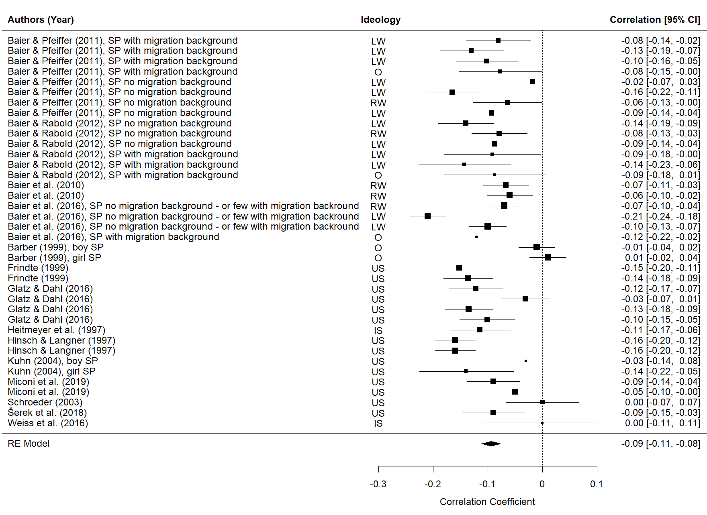

Supplementary Figure S2
Forest Plot of Effect-Sizes for Familial Conflict
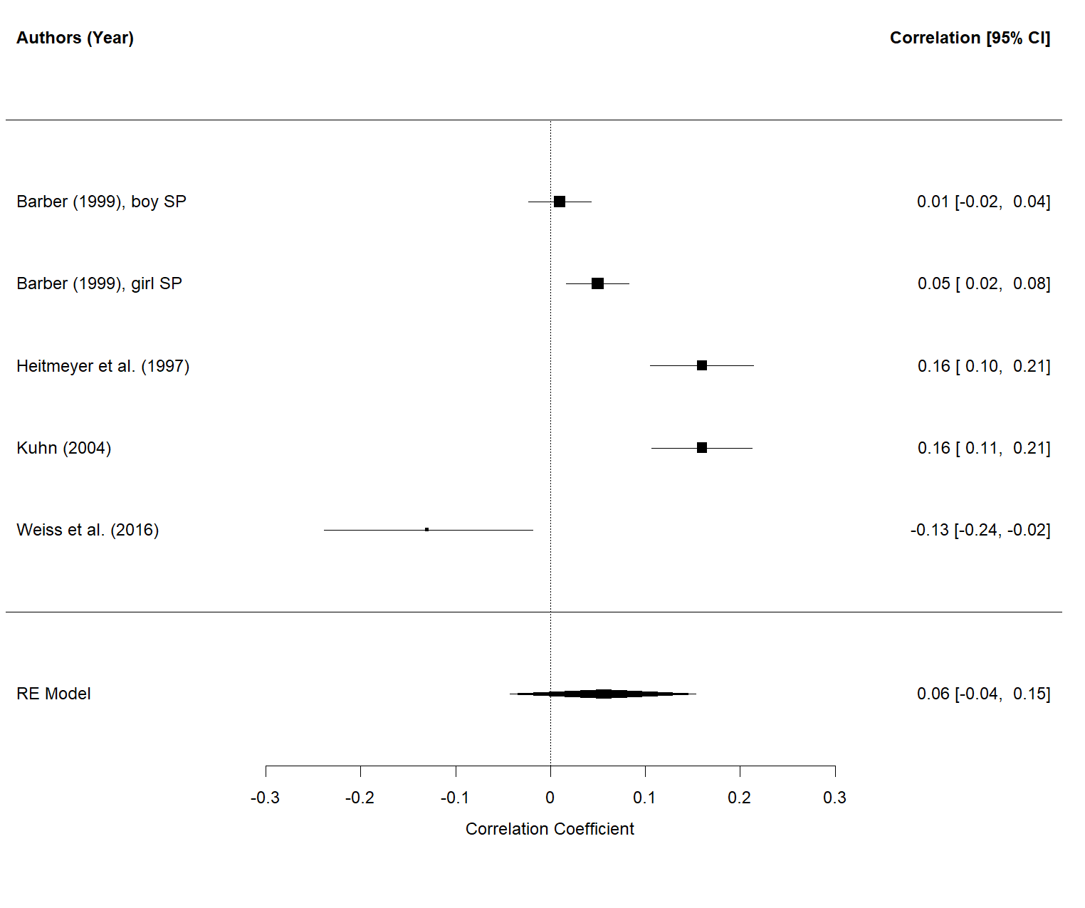

Supplementary Figure S3
Forest Plot of Effect-Sizes for Parental Control
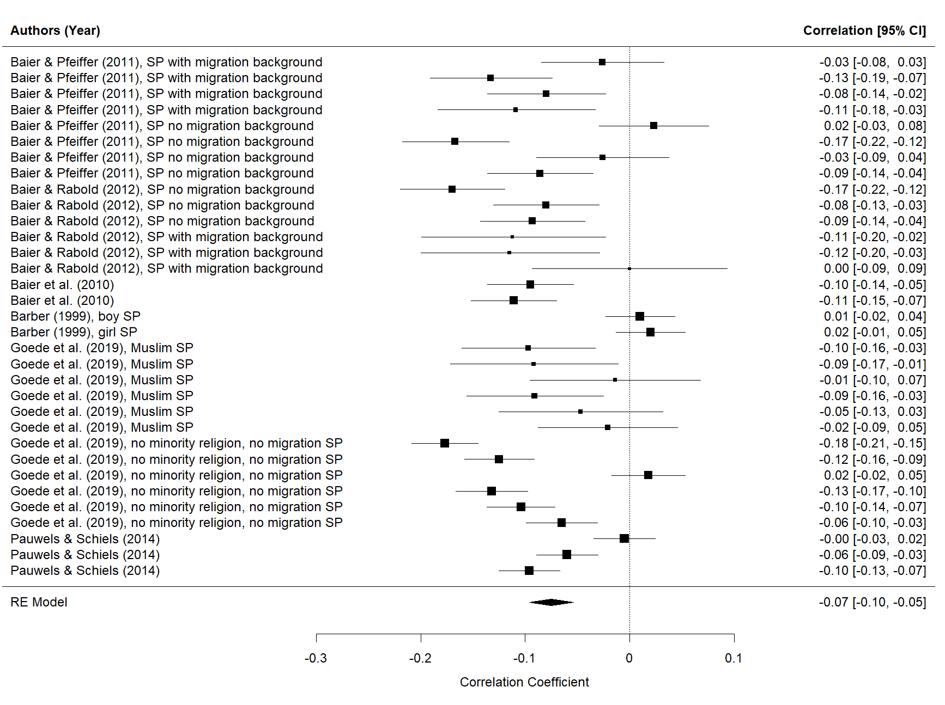

Supplementary Figure S4
Forest Plot of Effect-Sizes for Importance of Family
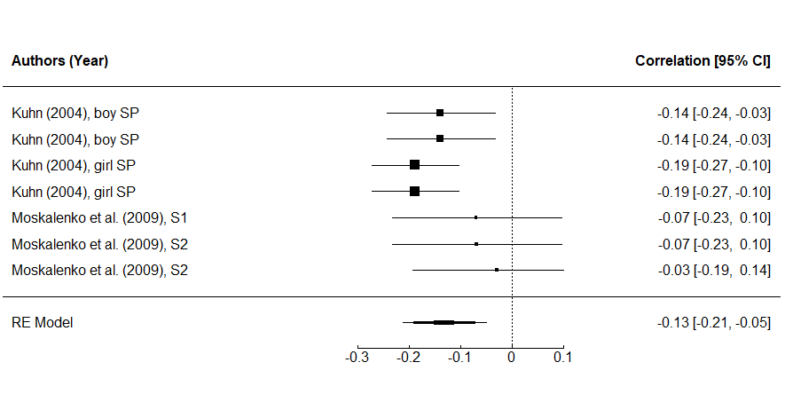

Supplementary Figure S5
Forest Plot of Effect-Sizes for Parental Violence
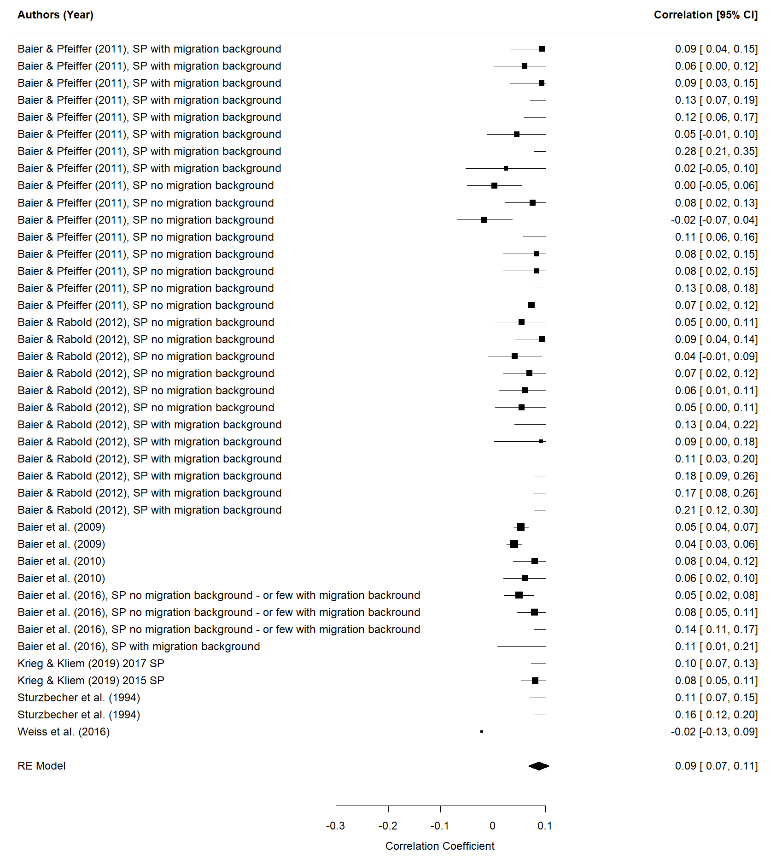

Supplementary Figure S6
Forest Plot of Effect-Sizes for Having Friends with Racist or Violent Attitudes
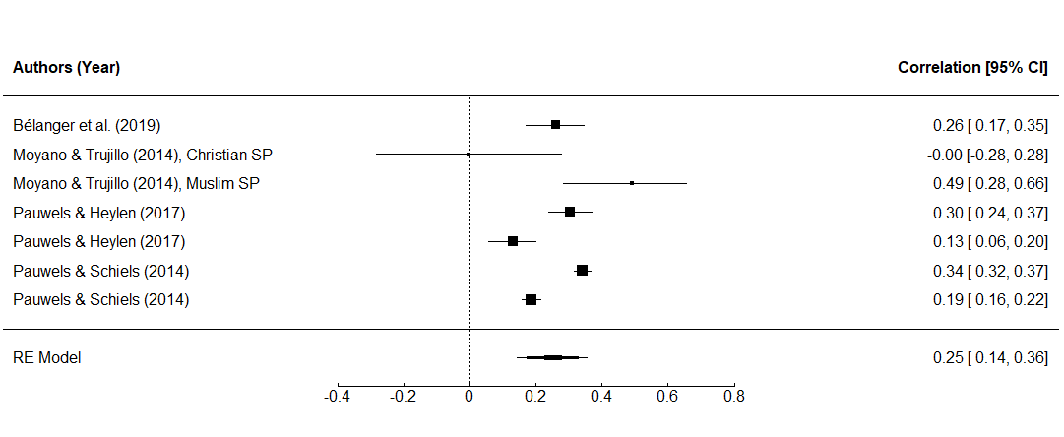

Supplementary Figure S7
Forest Plot of Effect-Sizes for Membership in Political Group that Opposes Mainstream Politics
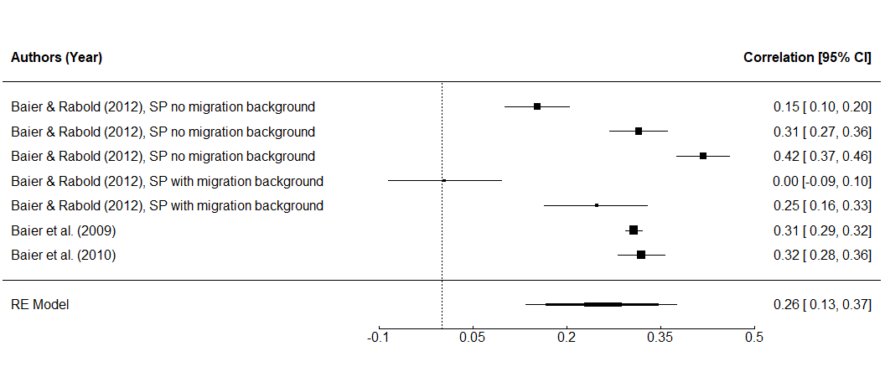

Supplementary Figure S8
Forest Plot of Effect-Sizes for General Membership in Peer Group
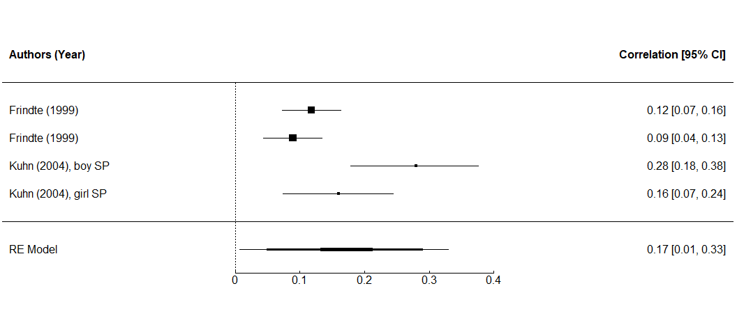

Supplementary Figure S9
Forest Plot of Effect-Sizes for School Attachment
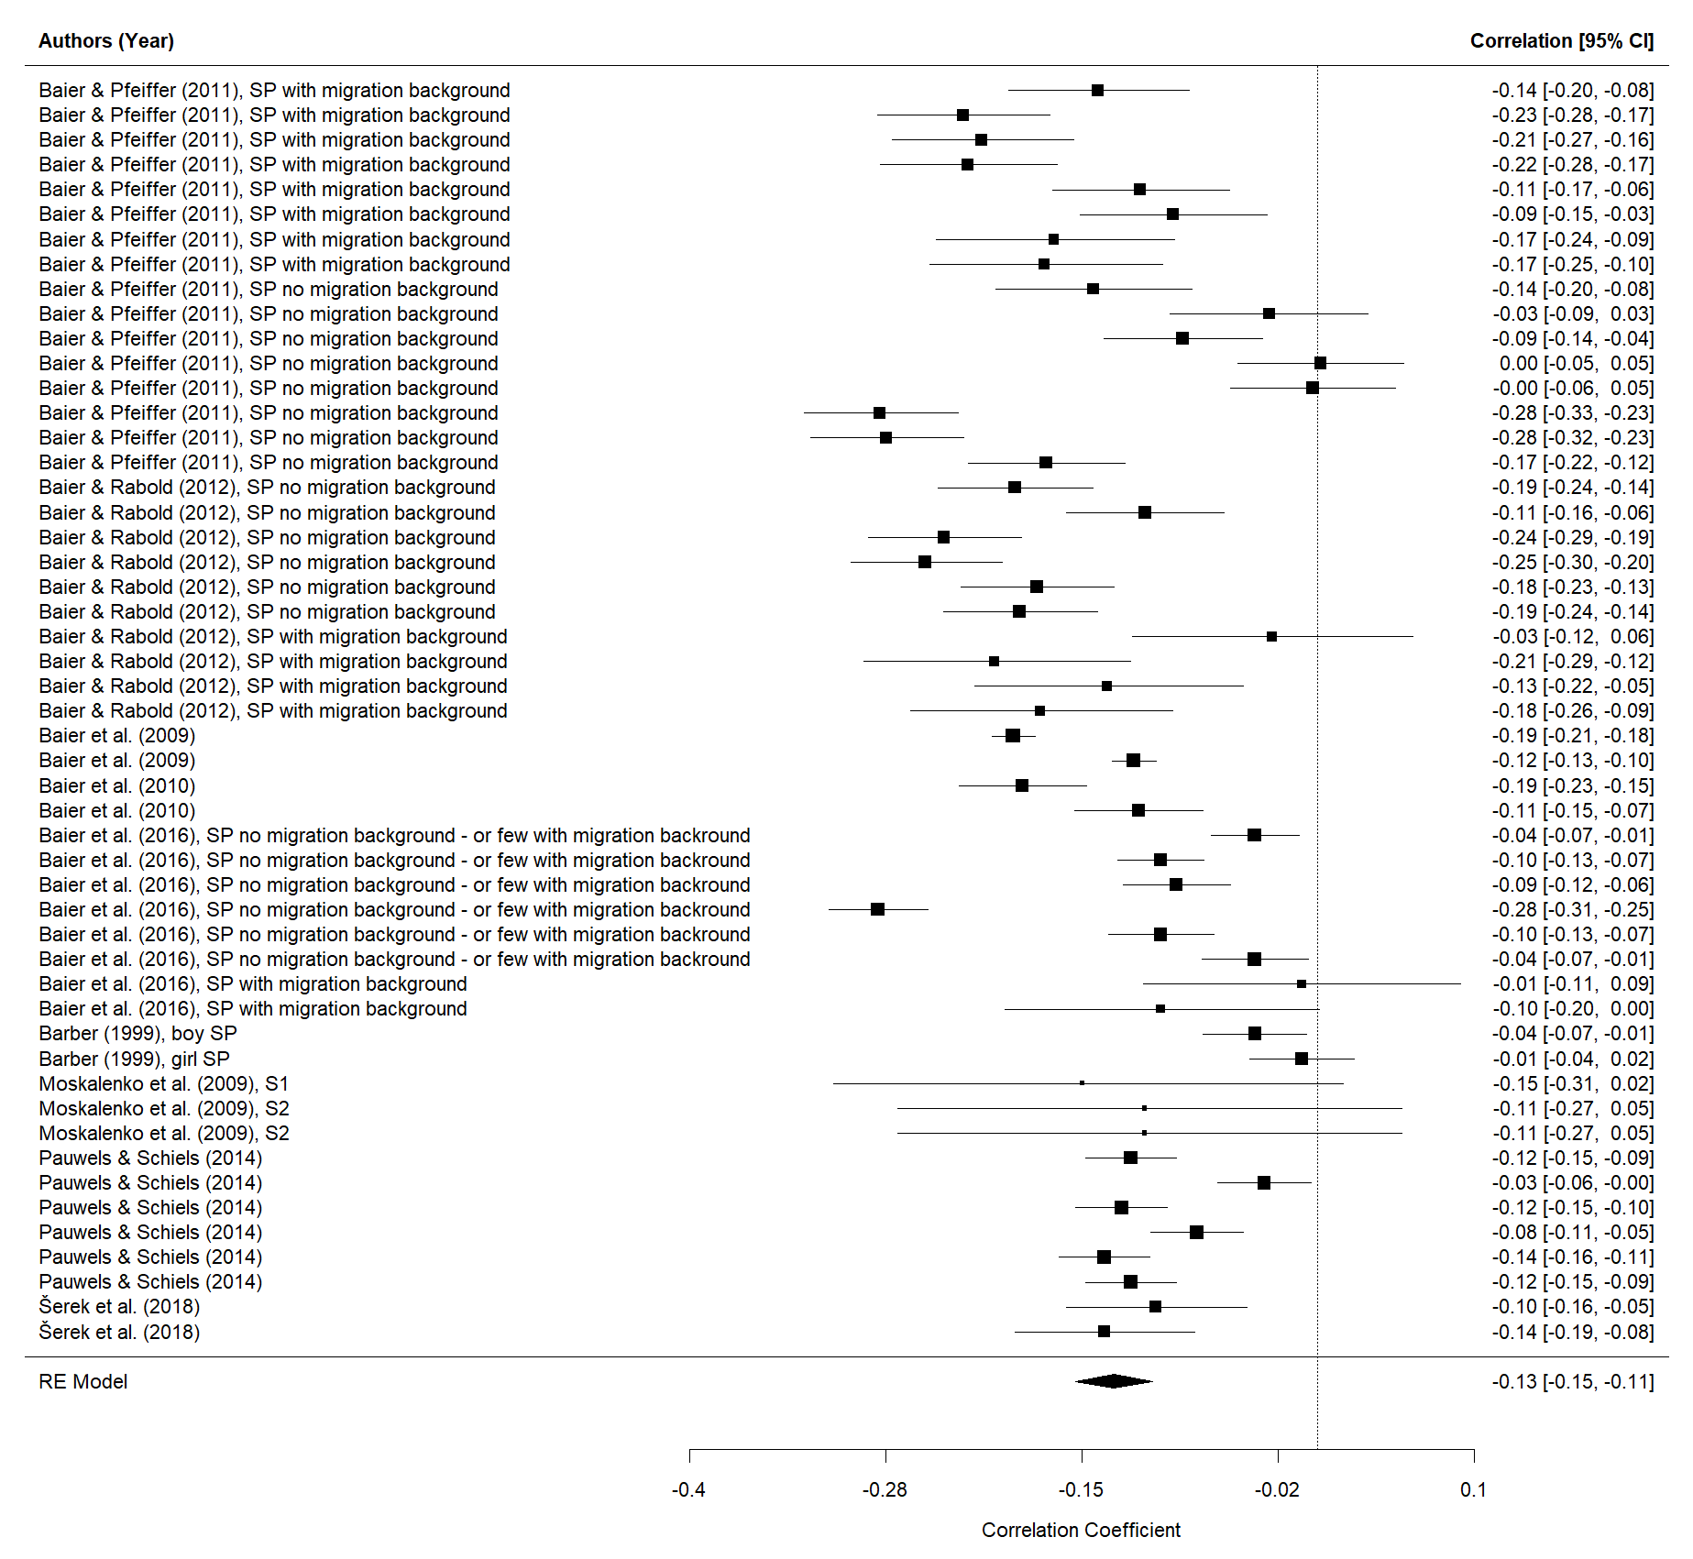
Supplementary Figure S10
Forest Plot of Effect-Sizes for School Achievement
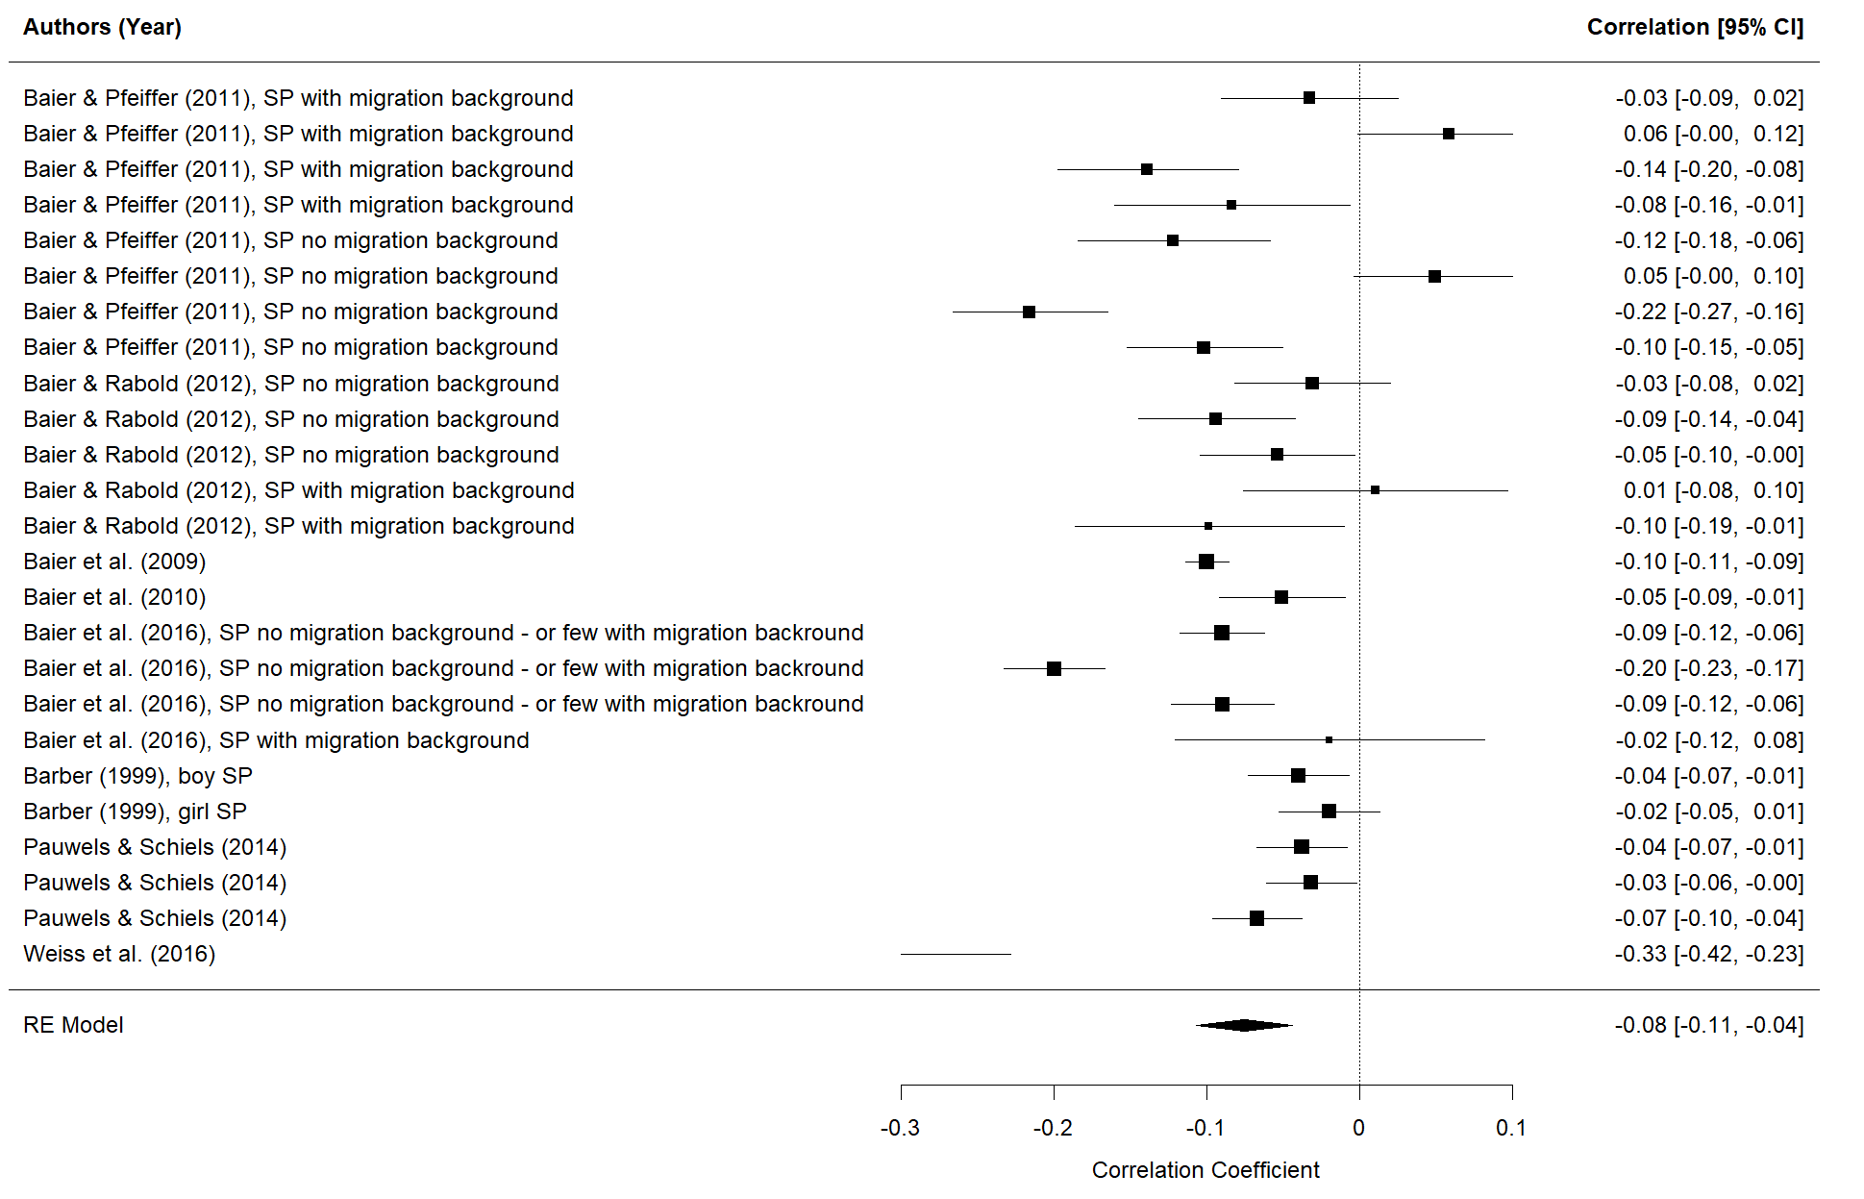

Supplementary Figure S11
Forest Plot of Effect-Sizes for Socioeconomic Status
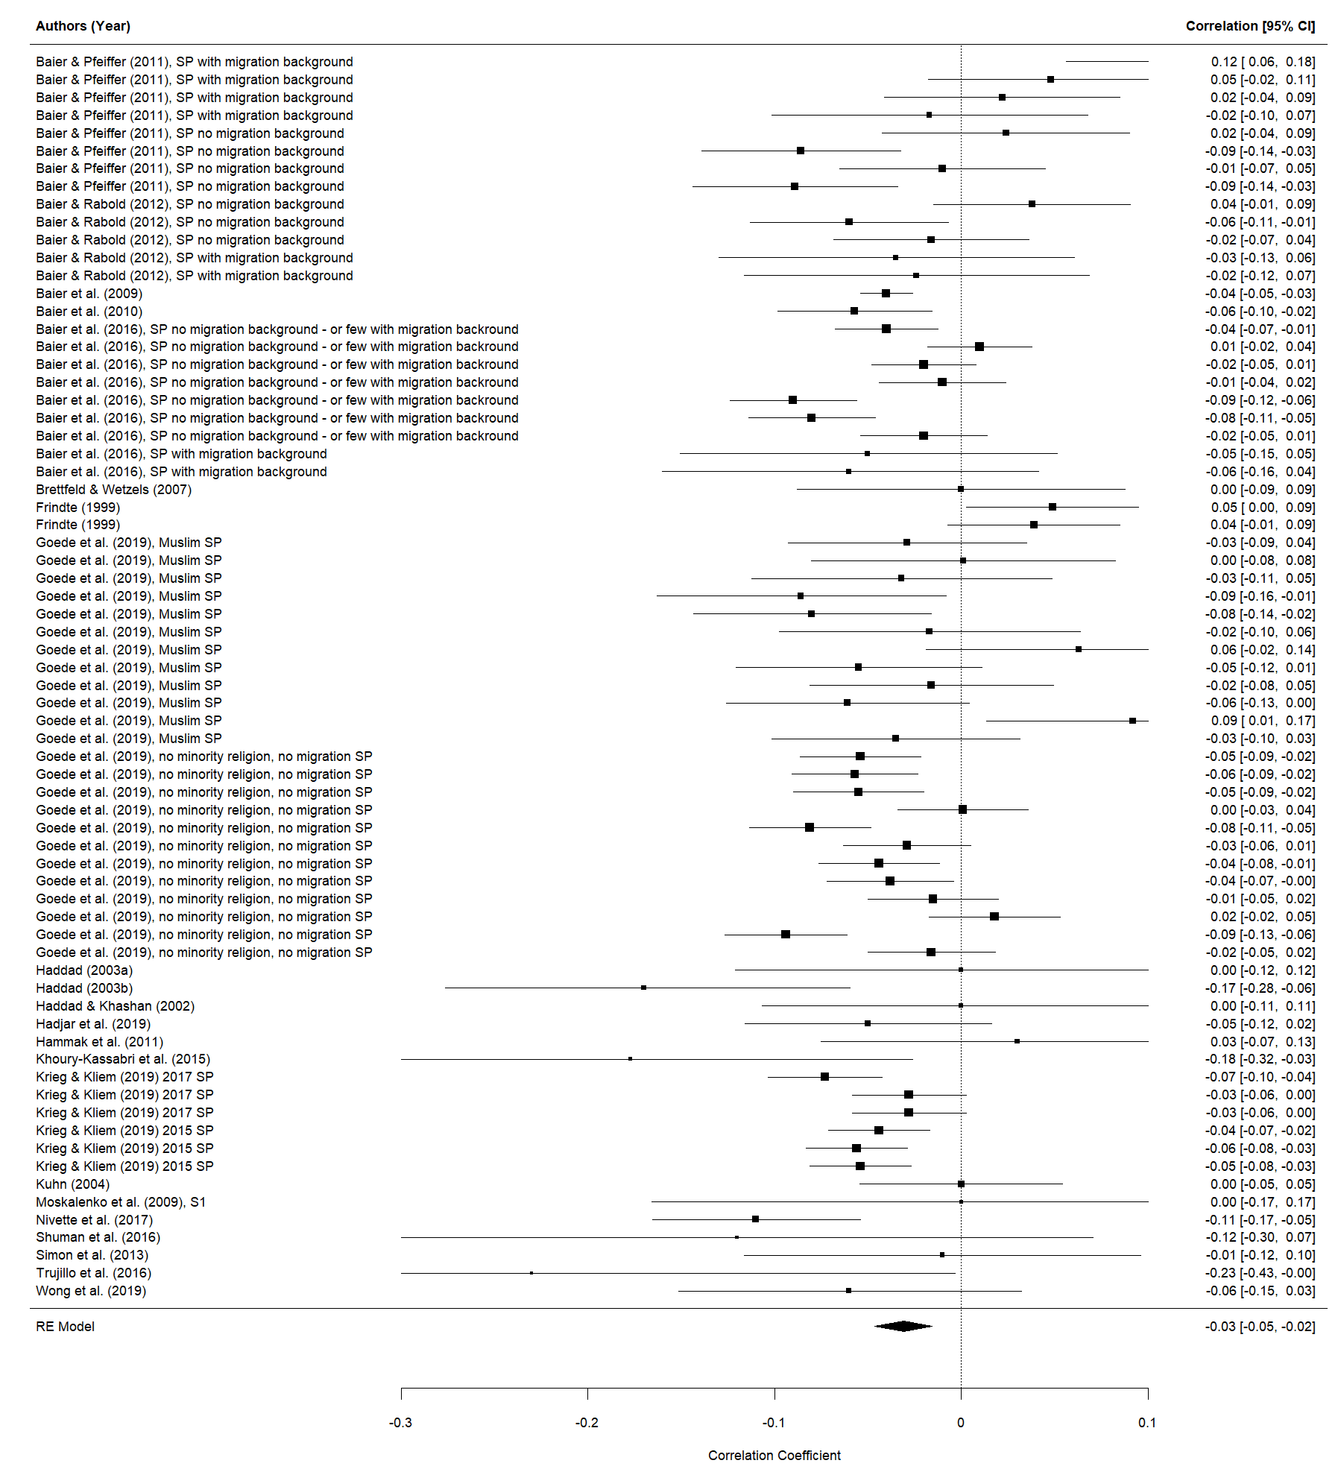
Supplementary Figure S12
Funnel Plot for Socioeconomic Status

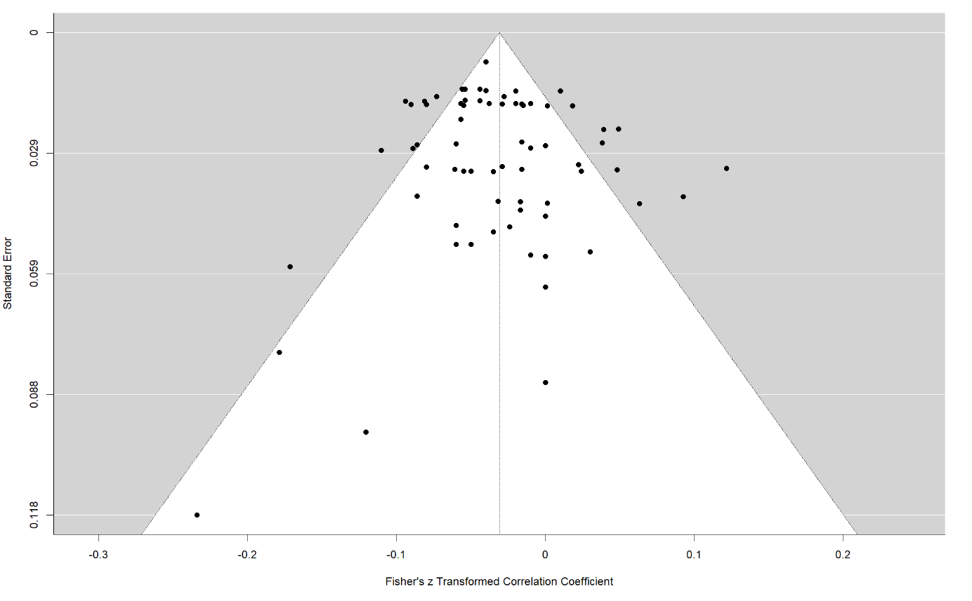

Note. The plot does not account for dependency between the effect sizes, that is, all effect sizes were treated as independent effects.

Supplementary Materials C: Reference Studies
Supplementary Table S5
Overview of Reference Studies (Full Citation) and Additional Publications/Materials
Reference Sample ª | Sources
Bélanger et al. (2019) | Bélanger, J. J., Moyano, M., Muhammad, H., Richardson, L., Lafrenière, M. A. K., McCaffery, P., ... & Nociti, N. (2019). Radicalization leading to violence: A test of the 3N model. Frontiers in Psychiatry, 10, 42.
Baier & Pfeiffer (2011), SP no migration background  Baier & Pfeiffer (2011), SP migration background | Baier, D., & Pfeiffer, C. (2011). Jugendliche als Opfer und Täter von Gewalt in Berlin [Adolescents as victims and perpetrators of violence in Berlin]. Kriminologisches Forschungsinstitut Niedersachsen.  Additional information (dataset to calculate bivariate correlations) sent to us by the authors.
Baier & Rabold (2012), SP no migration background  Baier & Rabold (2012), SP with migration background | Baier, D., & Pfeiffer, C. (2011). Jugendliche als Opfer und Täter von Gewalt in Berlin [Adolescents as victims and perpetrators of violence in Berlin]. Kriminologisches Forschungsinstitut Niedersachsen.  Additional information (dataset to calculate bivariate correlations) sent to us by the authors.
Baier et al. (2009) | Baier, D. (2009). Jugendliche in Deutschland als Opfer und Täter von Gewalt: Erster Forschungsbericht zum gemeinsamen Forschungsprojekt des Bundesministeriums des Innern und des KFN (KFN-Forschungsberichte Nr. 107). Hannover: KFN  Rabold, S., Baier, D. & Pfeiffer, C. (2009). Ausländerfeindlichkeit und Rechtsextremismus  unter deutschen Jugendlichen – Erkenntnisse einer deutschlandweiten Repräsentativbefragung. In Forum Kriminalprävention (Bd. 3, S. 2–8).  Additional information (dataset to calculate bivariate correlations) sent to us by the authors.
Baier et al. (2010) | Baier, D., Rabold, S. & Doering, B. K. (2010). Jugendliche als Opfer und Täter von Gewalt im Bundesland Sachsen-Anhalt (KFN-Forschungsberichte Nr. 110). Hannover: KFN.  Additional information (dataset to calculate bivariate correlations) sent to us by the authors.
Baier et al. (2016), SP no migration background - or few with migration backround, Baier et al. (2016), SP no migration background, Baier et al. (2016) SP with migration background | Baier, D., Manzoni, P. & Bergmann, M. C. (2016). Einflussfaktoren des politischen Extremismus im Jugendalter. Rechtsextremismus, Linksextremismus und islamischer Extremismus im Vergleich. Monatsschrift für Kriminologie und Strafrechtsreform, 99(3), 171-198. https://doi.org/10.1515/mkr-2016-0302
Barber (1999) boy SP  Barber (1999) girl SP | Barber, B. K. (1999). Political violence, family relations, and Palestinian youth functioning. Journal of Adolescent Research, 14(2), 206-230. https://doi.org/10.1177/0743558499142004
Brettfeld & Wetzels (2007) | Brettfeld, K., Wetzels, P. & Inci, R. (2007). Muslime in Deutschland: Integration, Integrationsbarrieren, Religion sowie Einstellungen zu Demokratie, Rechtsstaat und politisch-religiös motivierter Gewalt: Ergebnisse von Befragungen im Rahmen einer multizentrischen Studie in städtischen Lebensräumen. Bundesministerium des Inneren.
Frindte (1999) | Frindte, W. (1999). Fremde Freunde Feindlichkeiten Sozialpsychologische Untersuchungen (1. Aufl.). Westdeutscher Verlag. https://doi.org/10.1007/978-3-663-08042-8  Additional information (incl. correlations) sent to us by the authors.
Glatz & Dahl (2016) ^{d} | Glatz, T. & Dahl, V. (2016). The role of family experiences for adolescents’ readiness to use and participate in illegal political activity. International Journal of Behavioral Development, 40(1), 11-20. https://doi.org/10.1177/0165025414558854  Dahl, V. & Stattin, H. (2016). Beyond the limits: Involvement in illegal political activities. European Political Science Review, 8(1), 125-145. https://doi.org/10.1017/S1755773914000435  Additional information (incl. correlations) sent to us by the authors.
Goede et al. (2019), Muslim SP  Goede et al. (2019), no minority religion, no migration SP | Goede, L., Schröder, C. & Lehmann, L. (2019). Perspektiven von Jugendlichen. Ergebnisse einer Befragung zu den Themen Politik, Religion und Gemeinschaft im Rahmen des Projektes „Radikalisierung im digitalen Zeitalter (RadigZ)“. (KFN-Forschungsberichte Nr. 151). Hannover: KFN.  Jahnke, S., Schröder, C. P., Goede, L.-R., Lehmann, L., Hauff, L. & Beelmann, A. (2020). Observer sensitivity and early radicalization to violence among young people in Germany. Social Justice Research, 308-330. https://doi.org/10.1007/s11211-020-00351-y  Additional information (incl. bivariate correlations) sent to us by the authors.
Haddad & Khashan (2002) | Haddad, S. & Khashan, H. (2002). Islam and terrorism: Lebanese muslim views on september 11. Journal of Conflict Resolution, 46 (6), 812–828.  Mean age was estimated
Haddad (2003a) | Haddad, S. (2003a). Islam and attitudes toward US policy in the middle east: Evidence from survey research in Lebanon. Studies in Conflict and Terrorism, 26 (2), 135–154.  Mean age was estimated.
Haddad (2003b) | Haddad, S. (2003b). Muslim attitude towards terrorism against the US: A case study  of Lebanon. International Studies, 40 (4), 379–391.  Mean age was estimated.
Hadjar et al. (2019) | Hadjar, A., Schiefer, D., Boehnke, K., Frindte, W. & Geschke, D. (2019). Devoutness  to islam and the attitudinal acceptance of political violence among young muslims  in Germany. Political Psychology, 40 (2), 205–222.  Frindte, W., Boehnke, K., Kreikenbom, H., & Wagner, W. (2012). Lebenswelten junger Muslime in Deutschland. Berlin: Bundesministerium des Inneren.  Additional information (incl. bivariate correlations) sent to us by the authors.
Hammak et al. (2011) | Hammack, P. L., Pilecki, A., Caspi, N. & Strauss, A. A. (2011). Prevalence and correlates of delegitimization among Jewish Israeli adolescents. Peace and Conflict: Journal of Peace Psychology, 17(2), 151-178. https://doi.org/10.1080/10781919.2010.544636
Heitmeyer et al. (1997) | Heitmeyer, W., Müller, J. & Schröder, H. (1997). Verlockender Fundamentalismus. Türkische Jugendliche in Deutschland. Suhrkamp.
Hinsch & Langner (1997) | Hinsch, R. & Langner, W. (1997). "Null Bock auf Politik!"-Politische Einstellungen und Ausländerfeindlichkeit in Brandenburg. In D. Sturzbecher (Hrsg.), Jugend und Gewalt in Ostdeutschland. (S. 143-169). Verlag für Angewandte Psychologie.  Sturzbecher, D. (2001). Jugend in Ostdeutschland: Lebenssituation und Delinquenz. Leske + Budrich.
Khoury-Kassabri et al. (2015) | Khoury-Kassabri, M., Khoury, N. & Ali, R. (2015). Arab youth involvement in delinquency and political violence and parental control: The mediating role of religiosity. American Journal of Orthopsychiatry, 85(6), 576-585. https://doi.org/10.1037/ort0000079
Kliem & Krieg (2019), 2015 SP  Krieg & Kliem (2019), 2017 SP | Krieg, Y. & Kliem, S. (2019). Rechtsextremismus unter Jugendlichen in Niedersachsen. Monatsschrift für Kriminologie und Strafrechtsreform, 102(2), 135-153. https://doi.org/10.1515/mks-2019-2017  Kliem, S., Krieg, Y., Kudlacek, D., Baier, D. & Bergmann, M. C. (2018). Zur Prävalenz rechtsextremer Einstellungen bei Jugendlichen: Ergebnisse einer repräsentativen Befragung aus Niedersachsen. In O. Decker & E. Brähler (Hrsg.), Flucht ins Autoritäre: Rechtsextreme Dynamiken in der Mitte der Gesellschaft (S. 307-322). Psychosozial-Verlag.  Additional information (incl. bivariate correlations) sent to us by the authors.
Kuhn (2004)  Kuhn (2004), boy SP  Kuhn (2004), girl SP | Kuhn, H. P. (2004). Adolescent voting for right-wing extremist parties and readiness to use violence in political action: parent and peer contexts. Journal of Adolescence, 27(5), 561-581. https://doi.org/10.1016/j.adolescence.2004.06.009  Schmid, C. (2012). The value “social responsibility” as a motivating factor for adolescents' readiness to participate in different types of political actions, and its socialization in parent and peer contexts. Journal of Adolescence, 35(3), 533-547. https://doi.org/10.1016/j.adolescence.2012.03.009  Kuhn, H.-P. (2005). Ziviler Ungehorsam und politisch motivierte Gewaltbereitschaft im Jugendalter: Entwicklung und Sozialisation. Entwicklung in sozialen Beziehungen: Heranwachsende in ihrer Auseinandersetzung mit Familie, Freunden  und Gesellschaft. Lucius & Lucius, 279–304.
Miconi et al. (2019) | Miconi, D., Oulhote, Y., Hassan, G. & Rousseau, C. (2019). Sympathy for violent radicalization among college students in Quebec (Canada): The protective role of a positive future orientation. Psychology of Violence, 344-354. https://doi.org/10.1037/vio0000278  Additional information (incl. bivariate correlations) sent to us by the authors.
Moskalenko et al. (2009) S1  Moskalenko et al. (2009) S2 | Moskalenko, S. & McCauley, C. (2009). Measuring political mobilization: The distinction between activism and radicalism. Terrorism and Political Violence, 21(2), 239-260. https://doi.org/10.1080/09546550902765508
Moyano & Trujillo (2014)_Christian SP  Moyano & Trujillo (2014) Muslim SP | Moyano, M. & Trujillo, H. M. (2014). Intention of activism and radicalism among Muslim and Christian youth in a marginal neighbourhood in a Spanish city. Revista de Psicología Social, 29(1), 90-120. https://doi.org/10.1080/02134748.2013.878571
Nivette et al. (2017) | Nivette, A., Eisner, M. & Ribeaud, D. (2017). Developmental predictors of violent extremist attitudes. Journal of Research in Crime and Delinquency, 54(6), 755-790. https://doi.org/10.1177/0022427817699035  Ribeaud, D., Eisner, M., & Nivette, A. (2017). Können gewaltbereite extremistische Einstellungen vorausgesagt werden? Forschungsmemo. Jacobs Center for Productive Youth Development. Https://Jacobsfoundation. Org/App/Uploads/2017/04/UZHpub_zproso_de. Pdf.
Pauwels & Heylen (2017) | Pauwels, L. J. & Heylen, B. (2017). Perceived group threat, perceived injustice, and selfreported  right-wing violence: An integrative approach to the explanation right-wing violence. Journal of Interpersonal Violence.
Pauwels & Schiels (2014) | Pauwels, L. & Schils, N. (2014). Differential online exposure to extremist content and political violence: Testing the relative strength of social learning and competing perspectives. Terrorism and Political Violence 28(1), 1-29. https://doi.org/10.1080/09546553.2013.876414  Pauwels, L., Brion, F., Schils, N., Lafinneur, J., Verhage, A., De Ruyver, B. & Easton, M. (2014). Explaining and understanding the role of exposure to new social media on violent extremism: An integrative quantitative and qualitative approach. Academia Press.  De Waele, M. (2015). Angry white rebel? Study on the mechanisms and processes of participation in extreme-right groups (Unpublished dissertation). Ghent  University.  Pauwels, L., Brion, F. & De Ruyver, B. (2014). Explaining and understanding the role of exposure to new social media on violent extremism. An integrative quantitative and qualitative approach (RADIMED): Summary. Brussels: Belgian Science Policy, 2014.  Schils, N. & Pauwels, L. (2014). Explaining violent extremism for subgroups by gender and immigrant background, using SAT as a framework. Journal of Strategic Security, 7 (3), 27–47.  Additional information sent to us by the authors.
Schroeder & Schroeder (2003) | Schroeder, K.-H. & Schroeder, K. (2003). Rechtsextremismus und Jugendgewalt in Deutschland: Ein Ost-West-Vergleich. Ferdinand Schöningh.
Šerek et al. (2018) | Serek, J., Machackova, H. & Macek, P. (2018). Who crosses the norms? Predictors of the readiness for non-normative political participation among adolescents. Journal of Adolescence, 62, 18-26.  Additional information (incl. bivariate correlations) sent to us by the authors.
Shuman et al. (2016) | Shuman, E., Cohen-Chen, S., Hirsch-Hoefler, S. & Halperin, E. (2016). Explaining normative versus nonnormative action: The role of implicit theories. Political Psychology, 37 (6), 835–852.
Simon et al. (2013) | Simon, B., Reichert, F. & Grabow, O. (2013). When dual identity becomes a liability: Identity and political radicalism among migrants. Psychological Science, 24 (3), 251–257.
Sturzbecher et al. (1994) | Sturzbecher, D., Dietrich, P. & Kohlstruck, M. (1994). Jugend in Brandenburg 93. Staatskanzlei Brandenburg
Trujillo et al. (2016) | Trujillo, H. M., Prados, M. & Moyano, M. (2016). Psychometric properties of the Spanish version of the activism and radicalism intention scale. Revista de Psicología Social, 31 (1), 157–189.
Weiss et al. (2016) | Weiss, H., Ateş, G. & Schnell, P. (2016). Muslimische Milieus im Wandel?: Religion, Werte und Lebenslagen im Generationenvergleich. Springer.  Additional information (incl. bivariate correlations) sent to us by the authors.
Wong et al. (2019) | Wong, M. Y., Khiatani, P. V. & Chui, W. H. (2019). Understanding youth activism and radicalism: Chinese values and socialization. The Social Science Journal, 56 (2), 255–267.

