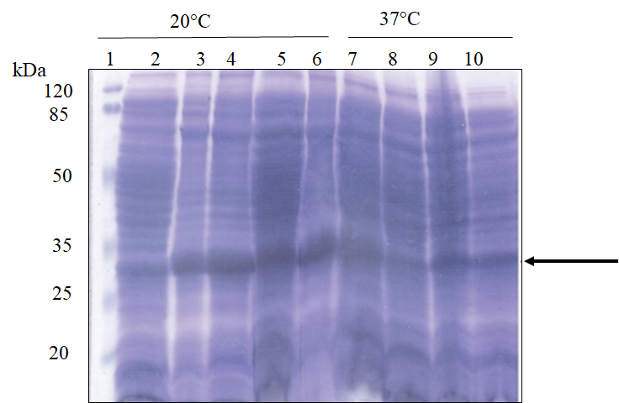

Supplementary Figure 1a: Expression of SARS-CoV-2 rRBD-6×His under different induction conditions. Various expression E. coli strains transformed with pET30b(+)-RBD were induced with 0.25 mM IPTG and incubated overnight at 20°C or 37°C. Samples from induced cultures were treated with TCA, dissolved in 1× Laemmli buffer and loaded on 15% SDS-APGE. 1- Prestained protein marker (Thermo), lanes 2, total protein of non-transformed E. coli BL21(DE3) pLys, lanes 3 and 7- total protein of E. coli BL21(DE3) pLys transformed with pET30b(+)-RBD, lanes 4 and 8- total protein of E. coli BL21(DE3) Arctic RIL transformed with pET30b(+)-RBD, lanes 5 and 9 total protein of E. coli BL21(DE3) C43 transformed with pET30b(+)-RBD, lanes 6 and 10- total protein of E. coli BL21(DE3) Rosetta Gami transformed with pET30b(+)-RBD. Black arrow points to the overexpressed 30 kD protein corresponding to the predicted molecular mass of SARS-CoV-2 rRBD-6×His.

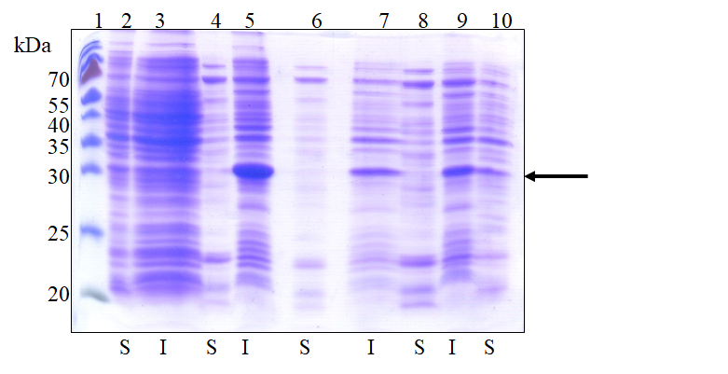

Supplementary Figure 2A: Solubility of SARS-CoV-2 rRBD-6×His in different E. coli expression hosts. The cultures were induced using 0.25 mM IPTG and incubated overnight at 20°C. Samples form induced cultures were lysed under native conditions by resuspension in phosphate buffered saline and repeated freezing-thawing cycles. 1- Prestained protein marker (Thermo), lanes 2,4, 6, 8 and 10 soluble proteins of non-transformed E. coli BL21 (DE3), E. coli BL21(DE3) pLys, E. coli BL21(DE3) Arctic RIL, E. coli BL21(DE3) Rosetta Gami and E. coli BL21(DE3) C43 transformed with pET30b(+)-RBD, respectively. Lanes 3, 5, 7 and 9- insoluble proteins of non transformed E. coli BL21(DE3) pLys, E. coli BL21(DE3) pLys, E. coli BL21(DE3) Arctic RIL and E. coli BL21(DE3) Rosetta Gami transformed with pET30b(+)-RBD, respectively. Black arrow points to the overexpressed 30 kDa protein corresponding to the predicted molecular mass of SARS-CoV-2 rRBD-6×His. S denotes soluble fraction and I denotes insoluble fractions.

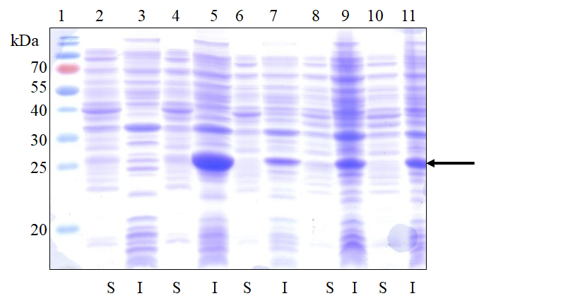

Supplementary Figure 2B: Solubility of SARS-CoV-2 rRBD-6×His in different E. coli expression hosts. The cultures were induced using 0.25 mM IPTG and incubated at 28°C for 4 hours. Samples form induced cultures were lysed under native conditions by resuspension in phosphate buffered saline and repeated freezing-thawing cycles. 1- Prestained protein marker (Thermo), lanes 2, 4, 6, 8 and 10 soluble proteins of non-transformed E. coli BL21(DE3), E. coli BL21(DE3) pLys, E. coli BL21(DE3) Arctic RIL, E. coli BL21(DE3) C43 and E. coli BL21(DE3) Rosetta Gami transformed with pET30b(+)-RBD, respectively, lanes 3, 5, 7, 9 and 11 insoluble proteins of non-transformed E. coli BL21(DE3) pLys, E. coli BL21(DE3) pLys, E. coli BL21(DE3) Arctic RIL, E. coli BL21(DE3) C43 and E. coli BL21(DE3) Rosetta Gami transformed with pET30b(+)-RBD, respectively. Black arrow points to the overexpressed 30 kDa protein corresponding to the predicted molecular mass of SARS-CoV-2 rRBD-6×His. S denotes soluble fraction and I denotes insoluble fractions.

