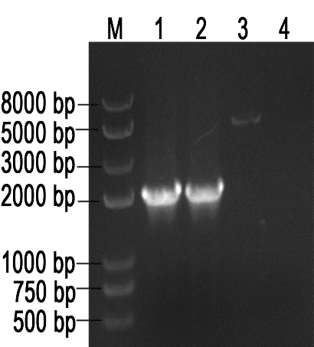
Figure S1. the identification of H. pylori ΔcagA by PCR
M：DNA marker；1,2：NCTC11637ΔcagA；3：NCTC11637；4：Control
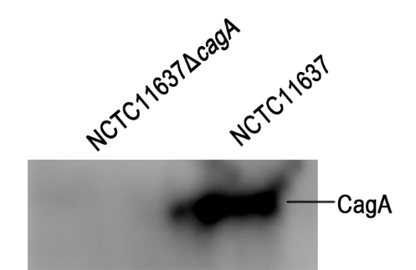
Figure S2. the Western blot NCTC11637ΔcagA protein.

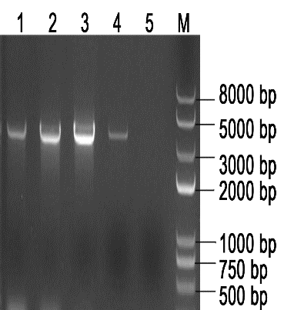
Figure S3. Construction of the eukaryotic expression vector of H. pylori cagA gene
M：DNA marker；1,2,3,4：pcDNA-cagA；5：Negetive control

