**Supplemental Tables and Figures**

**Supplementary figure 1**:

The technical roadmap for the study. The green box represents the data set. The yellow box represents the construction process of signature. The blue box represents the CRG-located DNA methylation signature. The red box represents subsequent analysis of the signature.

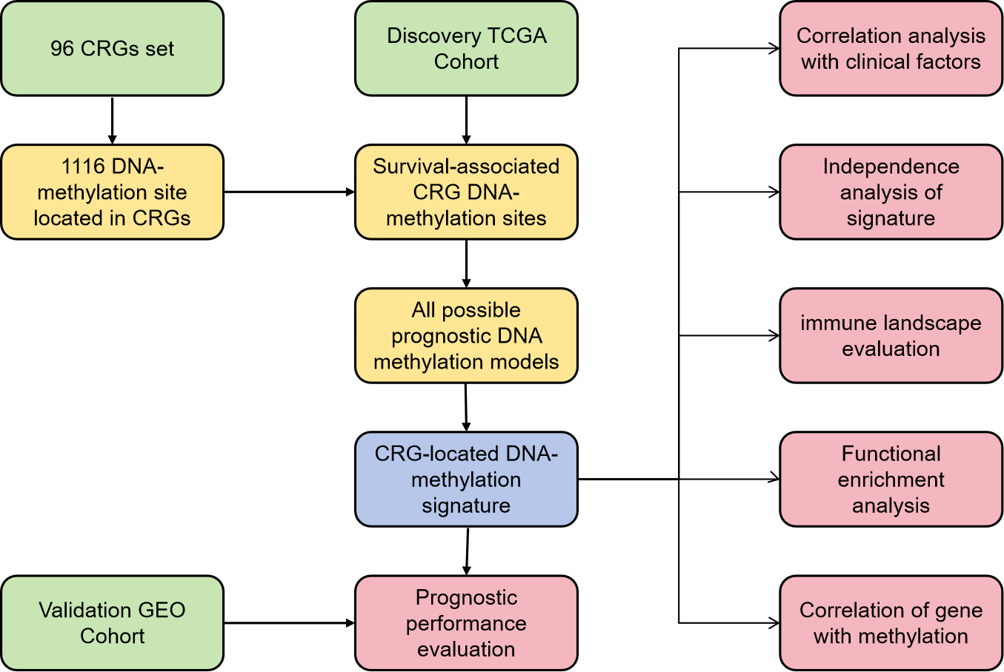

**Supplementary figure 2**:

Correlation between the expression of HSPA8 and immune cell infiltration level in LGG.

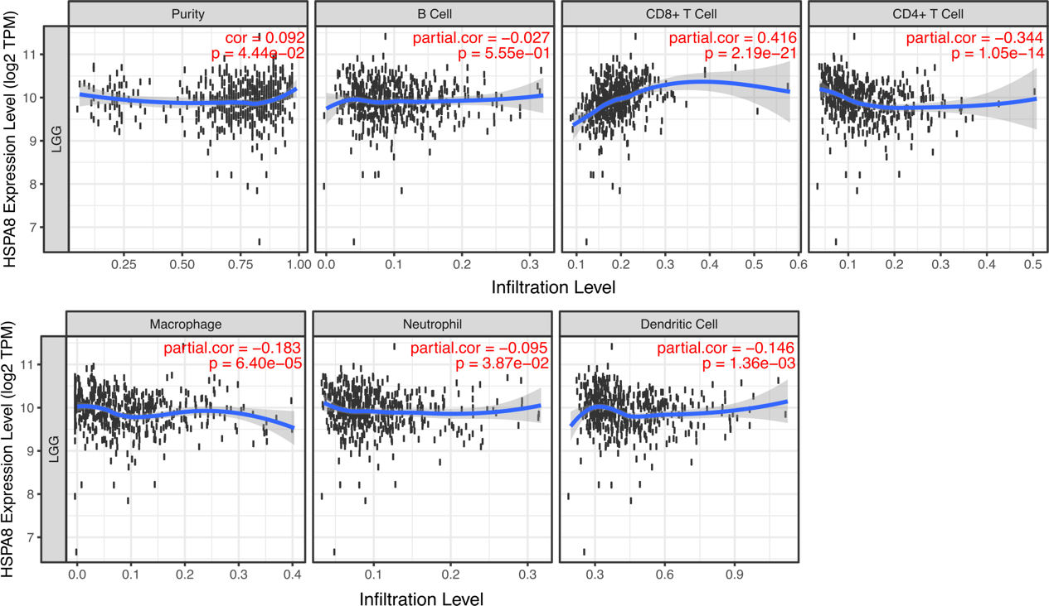

**Supplementary figure 3**:

Correlation between the expression of CDKN2A and immune cell infiltration level in LGG.

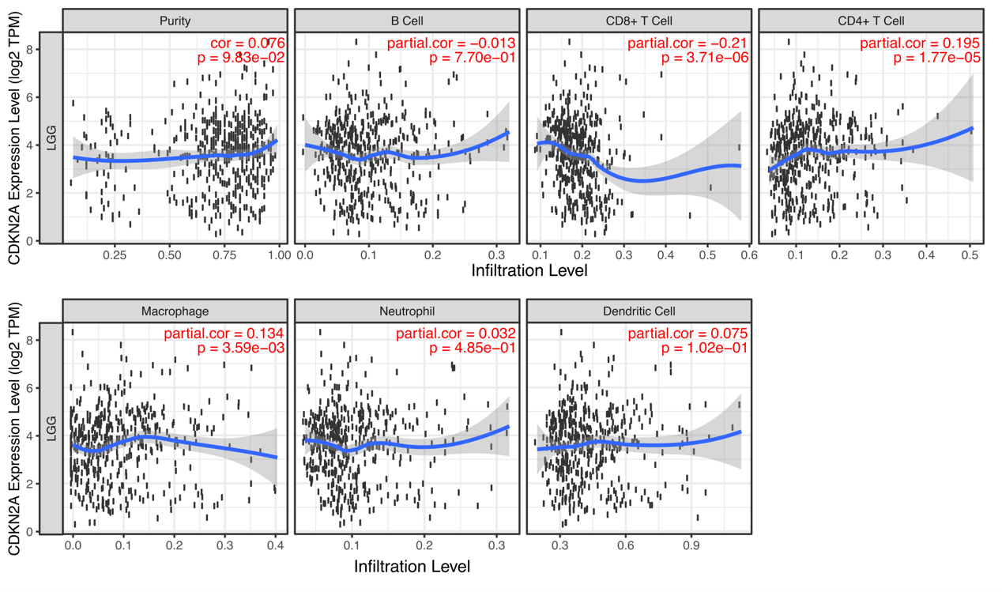

**Supplementary figure 4**:

Correlation between the expression of MT3 and immune cell infiltration level in LGG.

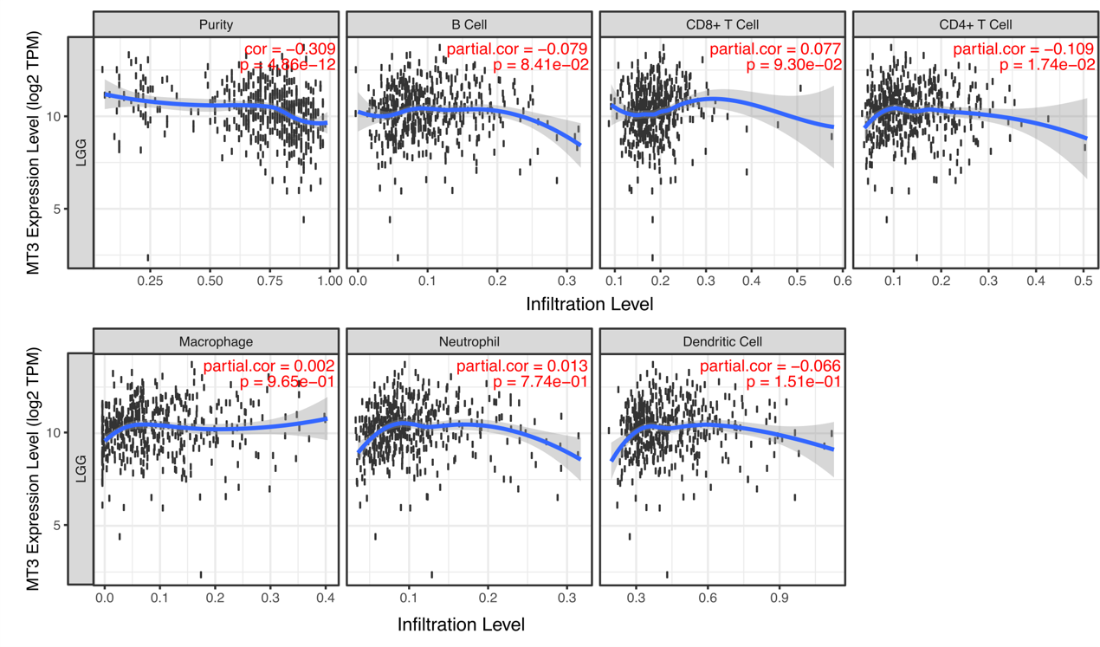

**Supplementary figure 5**:

Pathway enrichment between the high- and low-risk group. **(A)** GO terms. **(B)** KEGG pathway. **(C)** Hallmark pathway.

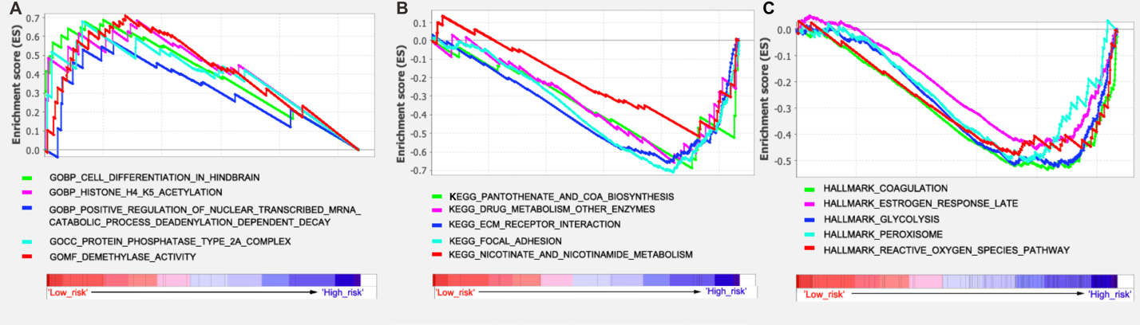

**Supplementary figure 6**:

(A-C) Correlation between the expression of the genes and their methylation levels was evaluated for each gene through the Spearman correlation test. Reported P values are two sided. (D-F) The expression of genes in LGG tumor tissues and the normal tissues. ****P < 0.0001, **P < 0.01.

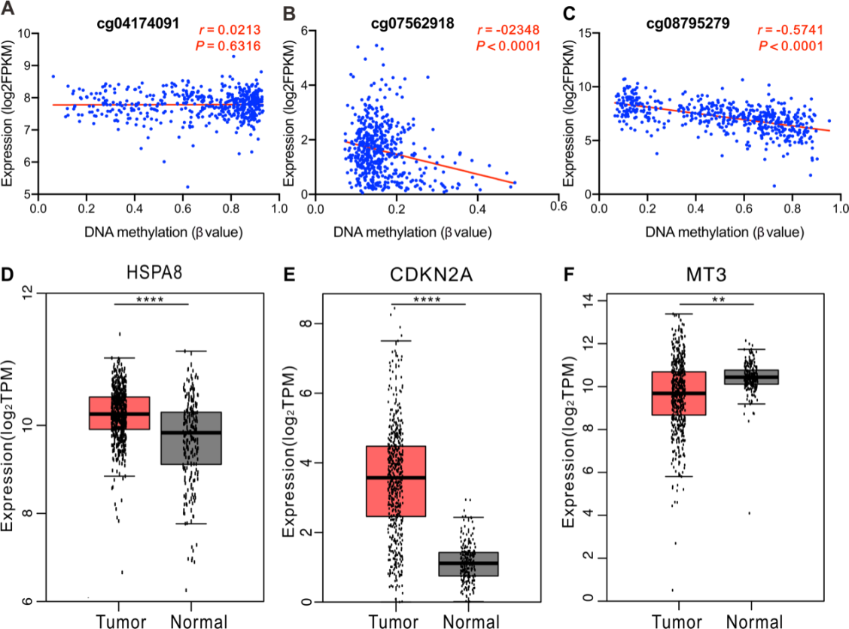

**Supplementary figure 7**:

Kaplan–Meier and ROC analyses of individual DNA methylation in the TCGA LGG cohort. (A) Kaplan–Meier analysis with Wilcoxon test were performed to estimate the differences in OS between the low- and high-risk patients. (B) ROC curves of the individual methylation signature were used to demonstrate the sensitivity and specificity in predicting the OS of patients.

