Supplementary Data
Supplementary Table 1: Protein Quantitation results for AFP and PIWIL2 by ELISA:
Marker | Control  N=10 | HCC  N=15 | P. value
AFP ng/ml | 0.65(0.35- 1.43) | 3.81(0.96- 4.84) | p<0.001**
PIWIL2 ng/ml | 2.74(1.95- 3.89) | 6.01(3.84- 8.64) | p<0.001**
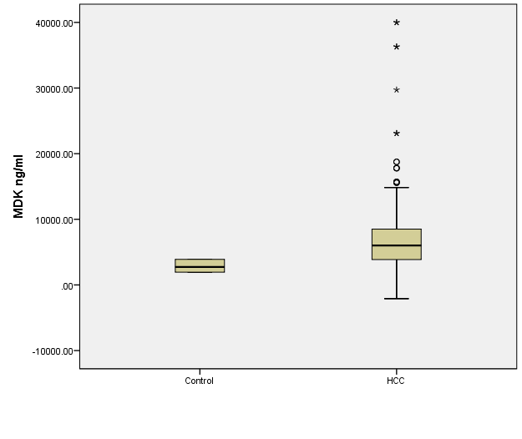
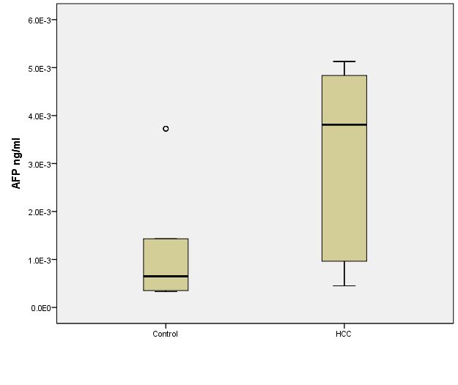

Supplementary figure 1: Measurement of Expression via ELISA for serum samples of HCC patients (n=15) and Healthy controls (n=10), in AFP (Left) PIWIL2, (right)

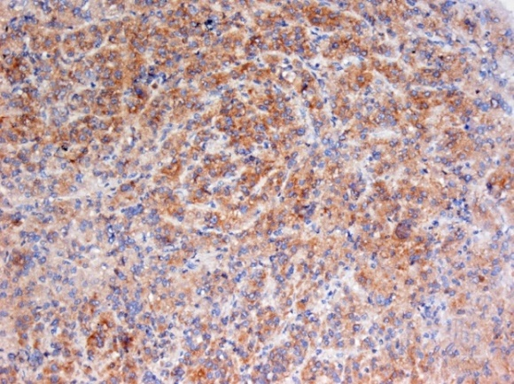
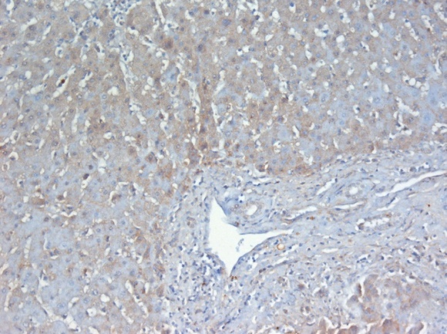

Supplementary figure 2: Immunohistochemistry (IHC) Microscopic imaging of sections in liver for chronic Hepatitis C virus tissue (Left) with weak positive staining of hepatocytes for PIWIL2 in cirrhotic nodules and diffuse positive staining HCC tissue (Right) (Light Microscope 400X magnification).

