Supplementary Figure
Supplementary Figure 1.. The correlation between ferroptosis-related genes and tumour stage in LIHC patients (GEPIA). The mRNA expression levels of these genes were not correlated with patients’ individual tumour stage.

Supplementary Figure 2. The correlation of AIFM2 expression with tumour-infiltrating lymphocytes in LIHC and STAD. A, B. The relationship of AIFM2 to immune infiltration levels in LIHC and STAD.

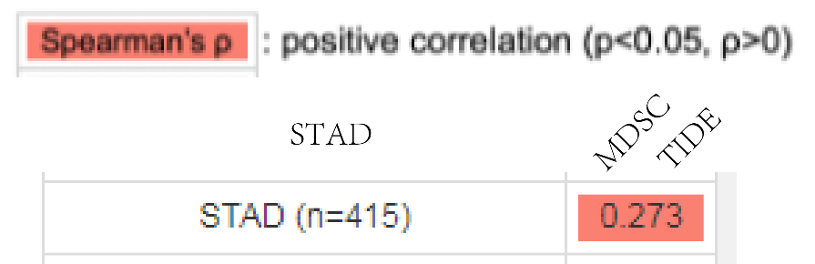
Supplementary Figure 3. The correlation of AIFM2 with STAD analysed by using TIMER.
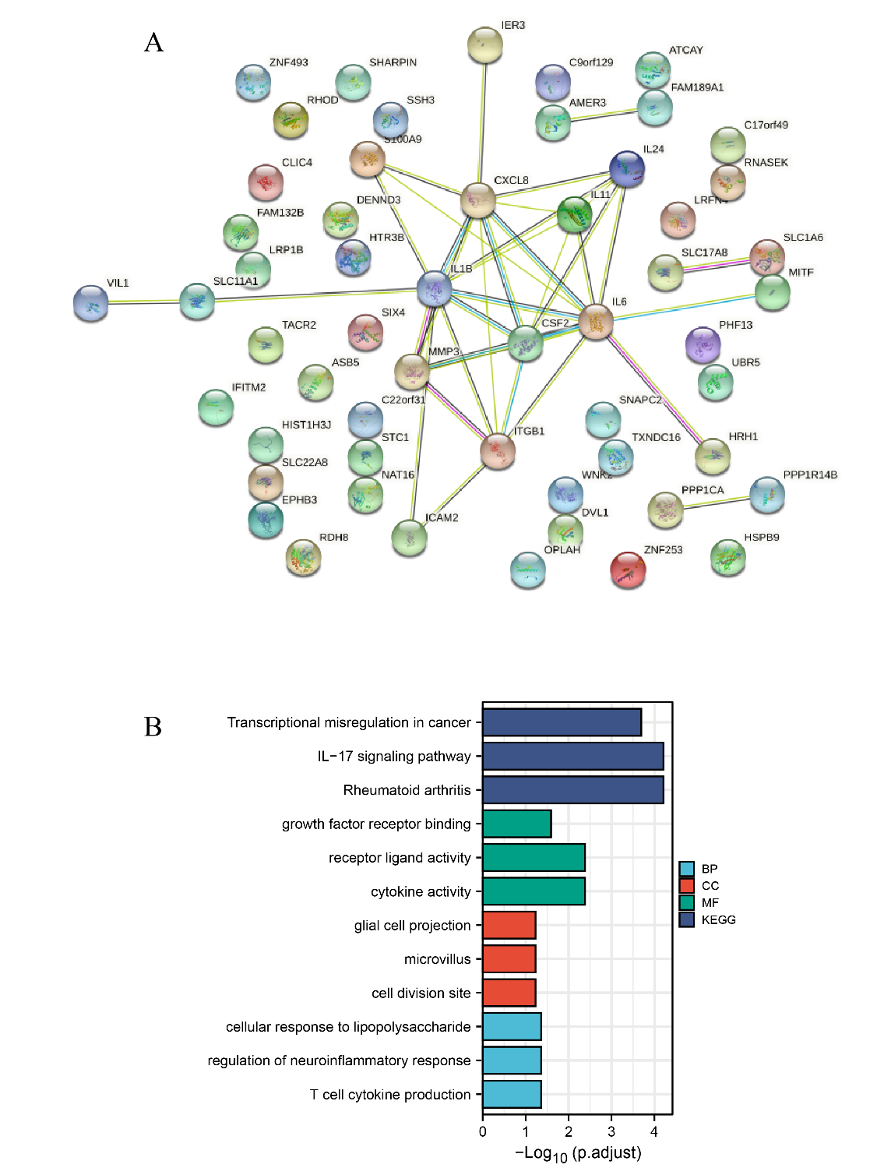
Supplementary Figure 4. GO and KEGG enrichment analyses of ferroptosis-related genes and their coexpressed genes in STAD. (STRING and DAVID). (A) PPI network. The nodes indicate proteins; the edges indicate the interaction of proteins. (B) BP, CC, MF and KEGG. Systematic Analysis of Expression Profiles and Prognostic Significance for Ferroptosis-related Genes in STAD.
Supplementary Figure 5.
A, B, the relative expression of GPX4 was shown in the graph.

