Supplementary File 1

AhRR methylation (%) distribution among invasive and non-invasive tumors.
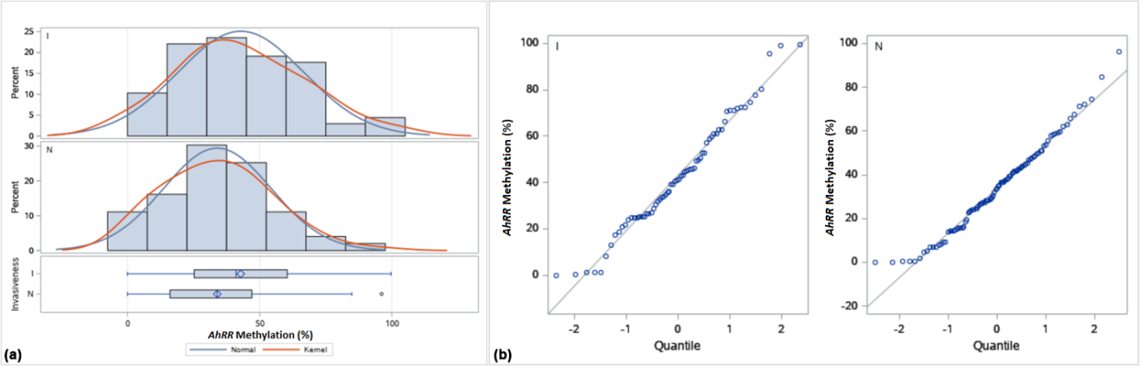
(a) Boxplot and histogram
(b) Q-Q plot (b)
(I) Invasive
(N) Non-invasive

Supplementary File 2

AhRR methylation (%) distribution among mutant and wild-type FGFR3 C248 genotypes.
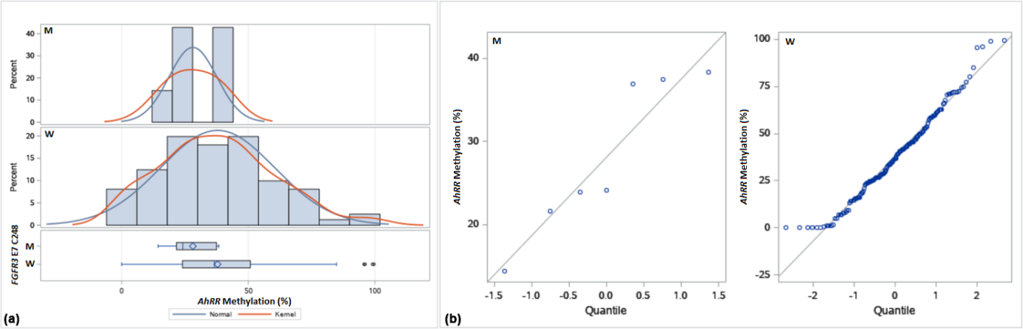
(a) Boxplot and histogram
(b) Q-Q plot (b)
(M) Mutant
(W) Wild-Type

