Supplementary Material for:
Resting-State Functional Connectivity Change in Frontoparietal and Default Mode Networks After Acute Exercise in Youth
Trevor L. Cline¹, Francesca Morfini¹, Emma Tinney¹, Ethan Makarewycz¹, Katherine Lloyd¹, Valur Olafsson ², Clemens C. C. Bauer ^{1,3}, Arthur F. Kramer^{1,5,6}, Lauren B. Raine¹, Laurel J. Gabbard-Durnam¹, Susan Whitfield-Gabrieli ^{1,3} Charles H. Hillman^{1,4}
¹Department of Psychology, Northeastern University, Boston, MA, USA
²Northeastern Biomedical Imaging Center, Northeastern University, Boston, MA, USA
³Department of Brain and Cognitive Sciences and McGovern Institute for Brain Research, Massachusetts Institute of Technology, Cambridge, Massachusetts
⁴Department of Physical Therapy, Movement, & Rehabilitation Sciences, Northeastern University, Boston, MA, USA
⁵Beckman Institute for Advanced Science & Technology, University of Illinois, Urbana, Il
⁶Center for Cognitive & Brain Health, Northeastern University, Boston, MA
Author Note
OCRID: Trevor Lee Cline https://orcid.org/0009-0003-0174-1863
The authors declare no conflict of interest.
The authors have no funding to report.
The authors have no acknowledgments to report.
The raw and processed data that support the findings of this study are available from the corresponding author upon reasonable request.
Correspondence concerning this article should be addressed to Trevor Lee Cline:
cline.t@northeastern.edu
Table of Contents
MRI acquisition details 3
Quality assurance 3
Supplementary figure 1: 5
Supplementary figure 2: 6
Supplementary figure 3: 8
Data Exclusion 9
Supplementary figure 4: 11
Procedure details and qualitative analyses 11
Supplementary figure 5. 12
Supplementary figure 6: 13
Manipulation checks, heart rate percentage 13
Covariate selection and sensitivity analysis 14
Supplementary table 1: 15
Supplementary table 2: 16
Supplementary figure 7: 17
Supplementary figure 8. 18
Supplementary table 3: 19
Multivariate factor selection and sensitivity analysis 19
Supplementary table 4 20
Supplementary figure 8: 21
Supplementary figure 9. 22
Post hoc results details 23
Supplementary figure 10. 24
Post hoc analyses, correlation of rsFC to rating of perceived exertion and feeling scale 25
Supplementary table 5: 25

MRI acquisition details
Heart rate was collected concurrently with MRI, but only as single data points before each scan; respiration and other potential physiological noise factors were not collected. Pre-intervention MRI order always followed the same format: field mapping, resting-state functional, arterial spin labeling, and structural scans, lasting ~25 minutes. Post-intervention MRI order was identical to pre-intervention but did not include a structural scan unless pre-intervention movement artifacts were observed. The full sequence parameters of the 8-minute T1-weighted MPRAGE are as follows: (TR=2500ms, TE-1=1.81ms, TE-2=3.6ms, TE-3=5.39ms, TE-4=7.18ms, TI=1000ms, flip angle=8°, matrix size=30x320). After pre- and post-intervention functional scans, we acquired an arterial spin labeling scan with a multi-delay pCASL 3D Gradient and Spin Echo pulse sequence (TR = 4100ms, TE = 36.48ms, flip angle = 120°, matrix size = 96x64, voxel size 2.5x2.5x3mm, PLD = 2s, PLD repetitions = 5). Quality assurance of arterial spin labeling suggested poor acquisition quality and no further analyzed are included in this study. Additionally, during preprocessing of T2*-weighted EPI sequence (TR=800ms, TE=37ms, flip angle=52°, matrix size=104x104, 2mm isotropic, simultaneous multiband acceleration factor=8), SPM12 slice-timing correction procedure was not used [1], because MRI acquisitions included interleaved multiband slices and short repetition time, thus minimizing the temporal misalignment between different slices of each functional volume [2].

Quality assurance
Quality control was conducted before preprocessing, denoising, and analyses [3,4]. First, raw anatomical and functional scans were examined for acquisition artifacts such as ghosting and spatial distortions. After preprocessing, CONN-based quality control plots and measures were used to verify the success of normalization, realignment, and registration (supplementary figure 1). After denoising, CONN-based quality control plots and measures were used to verify the success of denoising (supplementary figure 1 & 2). Functional connectivity distributions indicated reasonably centered distribution of voxel-to-voxel correlation values after denoising, with global correlation of all voxel pairs equal to 0.053±0.023 (average ± standard deviation across participants and sessions; supplementary figure 3). Additional quality control analyses computed the estimated strength of residual inter-participant correlations between functional connectivity strength at each edge within the same random graphs and measures of participant motion, global signal change, and scans remaining after scrubbing [5]. These plots indicate appropriate levels of denoising for mean and maximum motion, mean global signal change, and volumes remaining after scrubbing (valid scans). Distributions of connectivity correlations after denoising above 99% for maximum motion, above 95% for mean motion and global signal change (mean motion = 97.7%, mean global signal change = 96.7%), and above 90% for valid scans (supplementary figure 3).
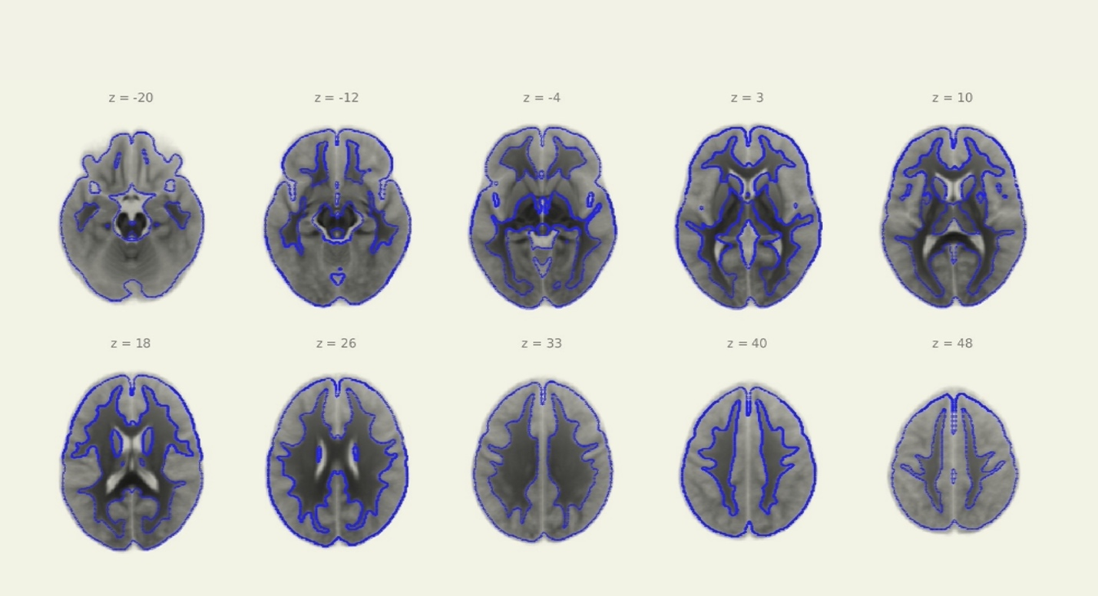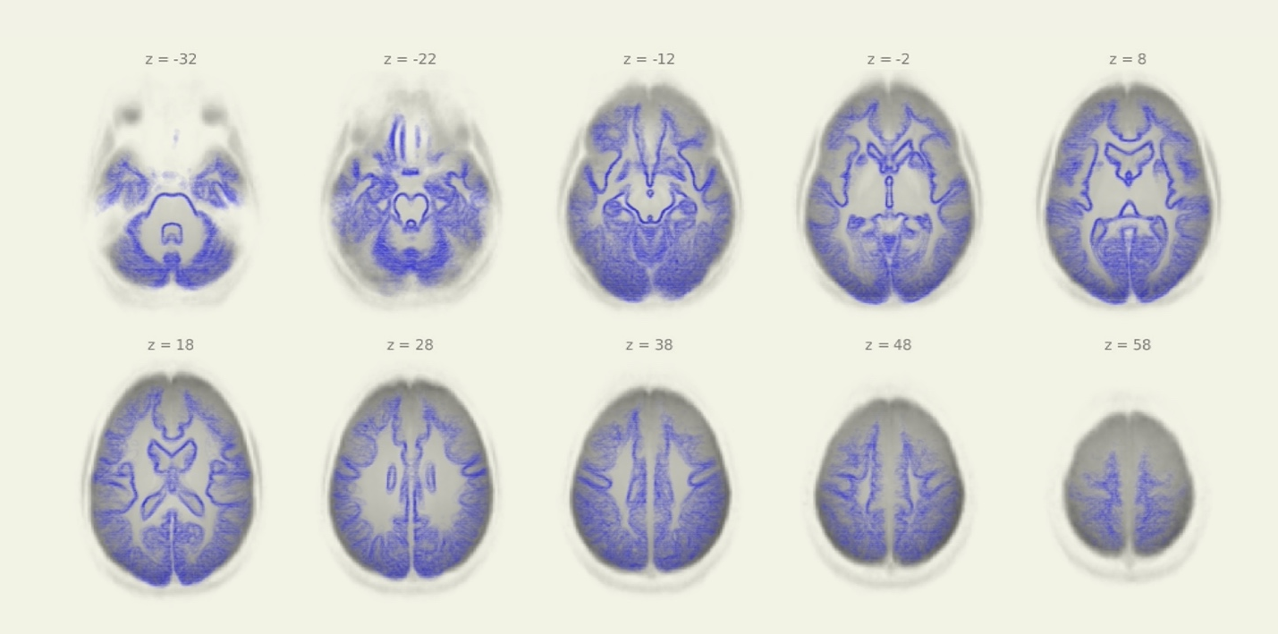
B
A

Supplementary figure 1:
Quality Assurance plots for structural normalization and registration (N=23). A) Average structural scan for all participants displayed with MNI152 gray matter overlay. B) Average functional scan for all participants displayed with structural gray matter overlay.
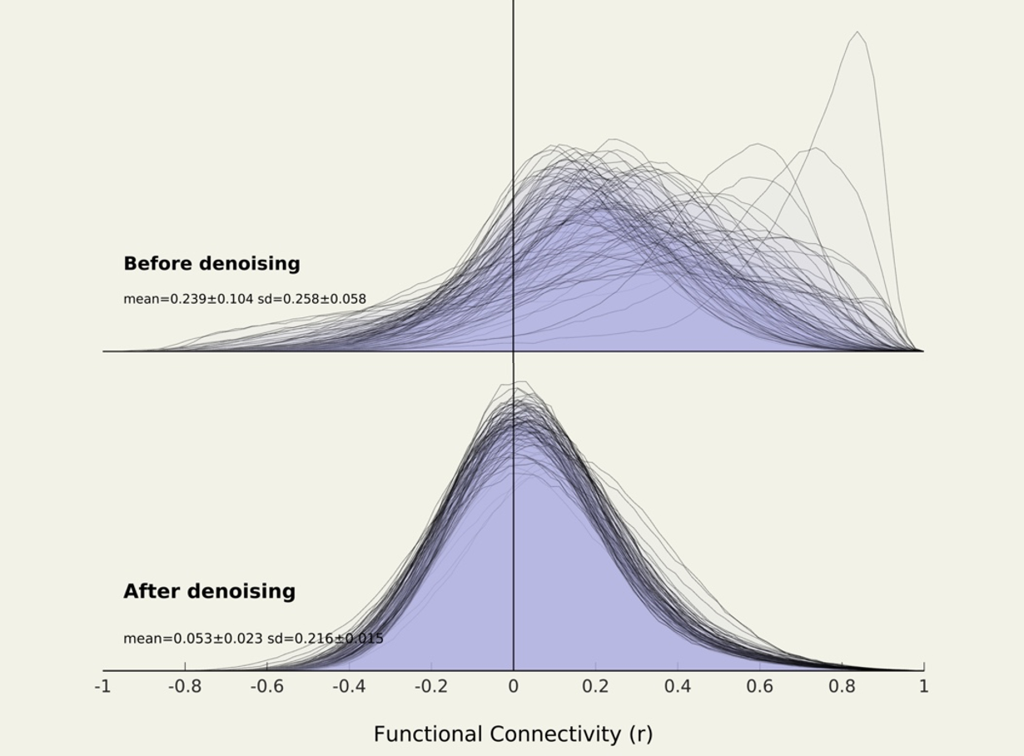
B
A

Supplementary figure 2:
Quality assurance plot for distribution of functional connectivity. A) Before denoising, global functional connectivity correlations are positively skewed, reflecting common sources of variance due to sources of noise (e.g., motion). B) After denoising, global functional connectivity correlations are normally distributed and approximately centered at 0.
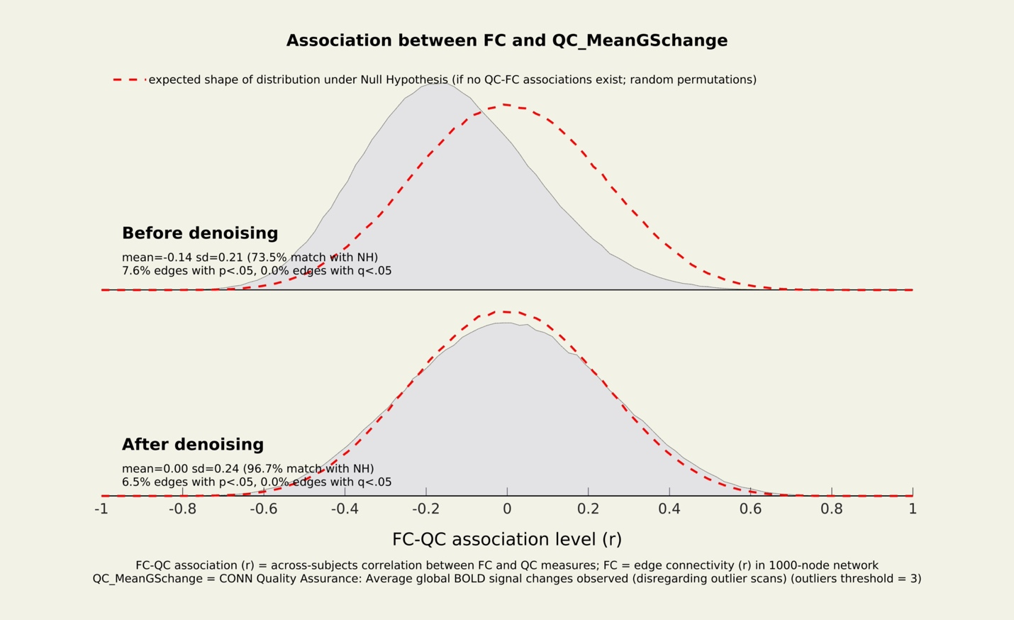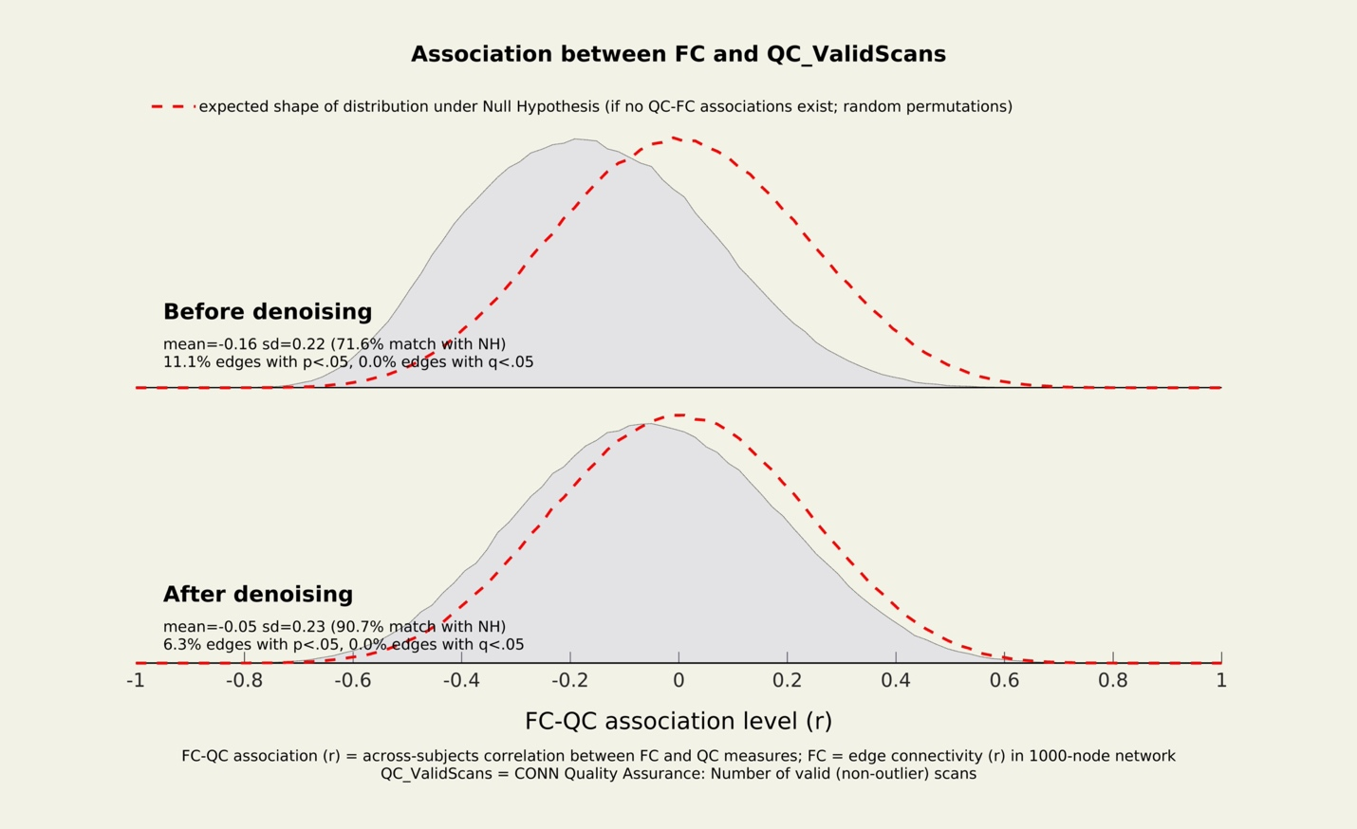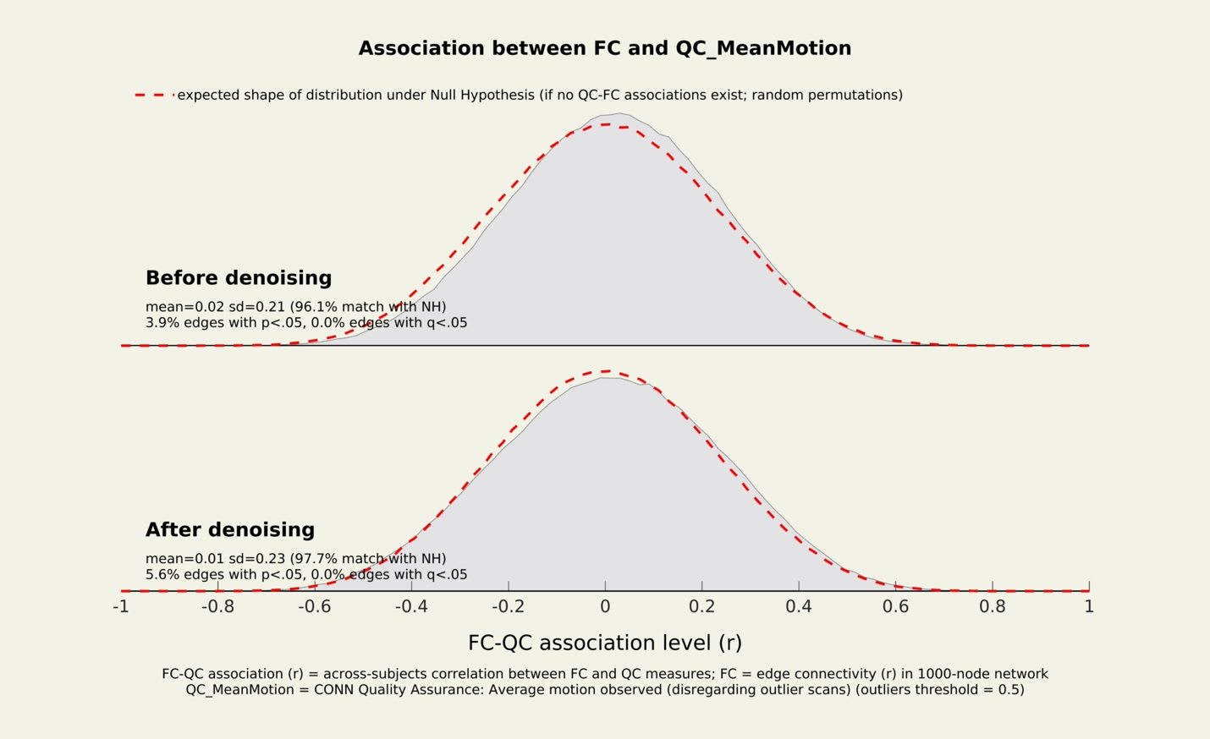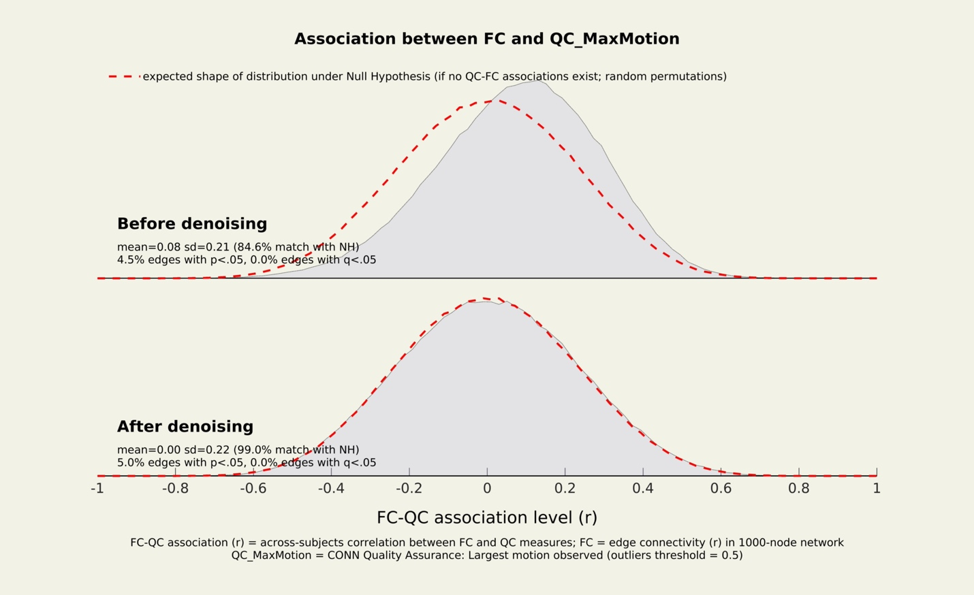
B
C
D
A
FB
E
H
G

Supplementary figure 3:
Quality assurance plot for residual inter-participant correlations. A, C, E, G) The strengths of residual inter-participant correlations between functional connectivity strength at each edge within the same random graphs and measures of participant motion, global signal change, and scans remaining after scrubbing, before denoising. B, D, F, H) After denoising, the strengths of residual inter-participant correlations are approximately centered at 0 and show close match with null distribution (> 99% maximum motion; > 95% mean motion, mean global signal change; > 90% valid scans).

Data Exclusion
Following recruitment, one participant was excluded for presence of acute claustrophobia that was not reported during recruitment screening. No data were collected for this participant. Additionally, two participants were excluded from final analysis due to persistent quality assurance issues affecting data quality or interpretation of results. Here, quality control variables were inspected for the presence of outliers potentially relevant to the analysis (supplementary figure 4).
Two participants (S16 and S20; supplementary figure 4) were identified as potential outliers for number of valid scans less than the first quartile minus 1.5 interquartile range (first quartile minus 2.71 and 2.84 interquartile range, respectively), indicating that in-scanner motion caused an abnormally high number of volumes to be scrubbed from the resting-state scanning sessions. One of these participants (S16) was further identified as an outlier for mean global signal change less than the first quartile minus 1.5 interquartile range (first quartile minus 1.88 interquartile range). Qualitative inspection of these participants revealed additional concerns. For example, one of these participants (S20) reported an inability to stay awake during one of the resting-state scanning sessions, contributing to not meeting a minimum of 5 minutes total time in the scanning session after scrubbing of outlier volumes [6]. Because these participants’ data were compromised by both artifactual difference in scanning parameters and/or cognitive differences unrelated to the study, they were removed from all analyses.
One participant (S11) was identified as a potential outlier for high maximum motion above the third quartile plus 1.5 interquartile range (third quartile plus 2.1 interquartile range). However, the distributions of connectivity correlations after denoising suggests that group-level maximum motion was adequate addressed by scrubbing outlier volumes (supplementary figure 2, H) and qualitative inspection revealed no additional concerns. Therefore, this participant was preserved in all analyses.
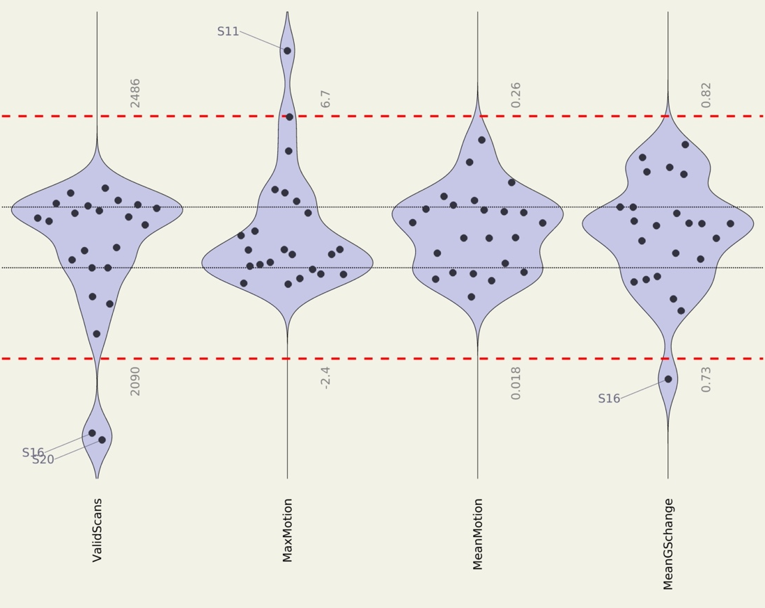
A
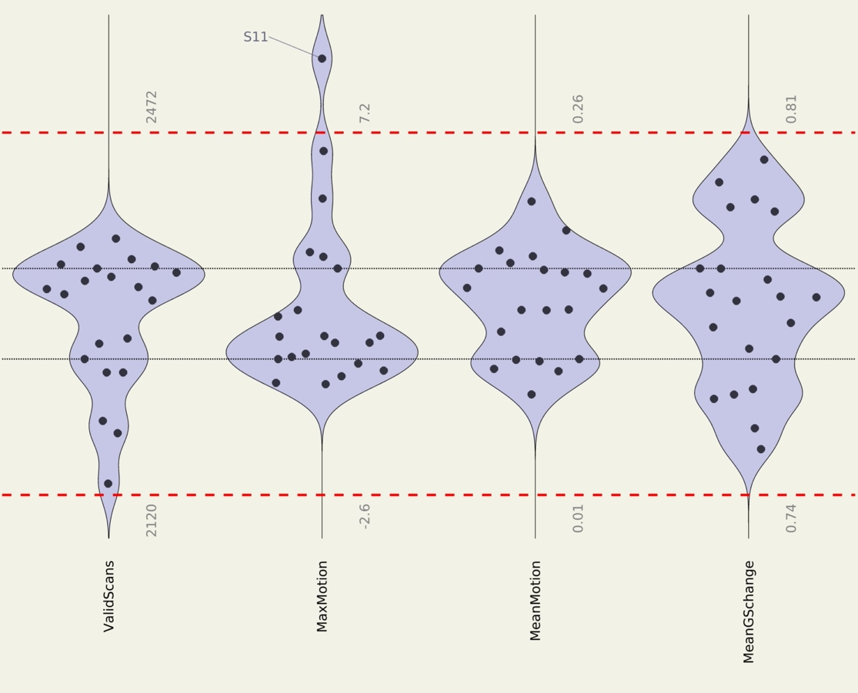
B

Supplementary figure 4:
Quality assurance plot for potential outlier variables. A) Full sample of MRI data indicate the presences of 3 potential outliers (S11, S16, S20) with values more extreme than the first and thirds quartile plus/minus 1.5 inter-quartile range. B) Following qualitative inspection of potential outlier participants and the removal of 2 participants from final analysis (S16, S20), no other potential outlier was identified. Black lines indicate first and third quartile, red lines indicate first and thirds quartile plus/minus 1.5 inter-quartile range.

Procedure details and qualitative analyses
Participants visited the lab twice, undergoing a single-blinded crossover comparison involving either a 20-minute aerobic walking exercise targeting 65-75% of their maximal heart rate or a 20-minute seated reading session.
For the acute exercise condition, an experimenter adjusted the walking speed and treadmill incline to achieve a sustained heart rate of 65-75% of participants’ own maximal heart rate. Such an intervention was thus thought to achieve the minimal “dose” of acute exercise at moderate vigorous-intensity. Qualitatively, this was achieved through sharp increases to both speed and grade with subsequent declines in both exercise parameters to HR% (supplementary figure 5). For the seated reading condition, participants were asked to engage in age-appropriate non-fiction, with similar monitoring. Qualitatively, the reading material consisted of “By-Kids, For-Kids Science” scientific readings un-related to psychology, neuroscience, or exercise. Such an intervention was thus thought to be an ecologically valid control condition for typical school-aged activities. For both interventions, an experimenter recorded heart rate every minute and asked participants to rate their perceived exertion and feelings every 2 minutes (supplementary figure 6).
Participants were informed that the study may involve exercise and were asked not to engage in any structured physical activity on the days of testing. Because all data collection occurred during the COVID-19 pandemic, MRI-safe surgical masks were worn by all experimenters and participants throughout the study. During the first visit, participants consented and underwent mock-scanning, where they became familiar with the MRI environment. During the second visit, participants completed questionnaires and performed a cognitive task that was used for purposes unrelated to this study. Common across both visits, participant moved onto pre-intervention fMRI, to an intervention, to post-intervention fMRI. Before each intervention, participants were then fitted with a heart rate monitor (Garmin HRM-DUAL) connected to a Bluetooth device (Garmin Forerunner 55) and began the experimental intervention, occurring 15 minutes after participants left the MRI scanner. At the post-intervention MRI, participants removed the HR monitor and re-entered the MRI scanner 10 minutes after intervention concluded. At the end of their participation, participants were thanked and received remuneration at a rate of $20/hour ($120).

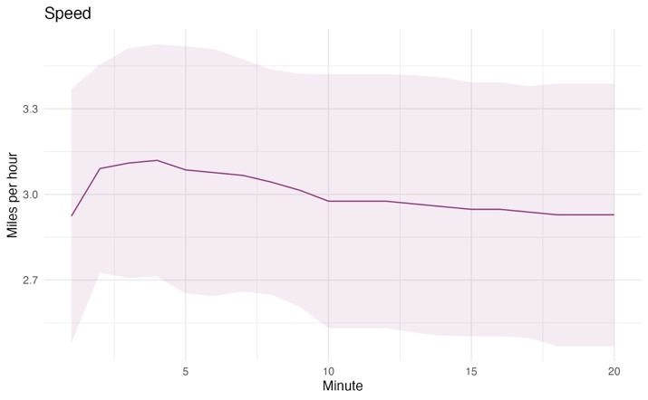
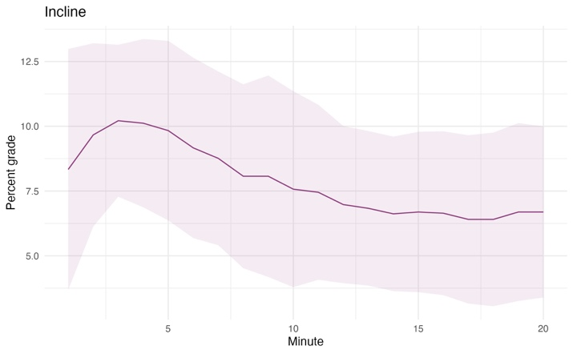
B
A

Supplementary figure 5.
Exercise parameters. The average speed was generally consistent across participants (mean=3.0mph, sd=0.43mph). The average incline was more varied both within and across participants (mean=7.9°, sd=3.4°). Colored lines represent the mean across participants, shading represents one standard deviation.
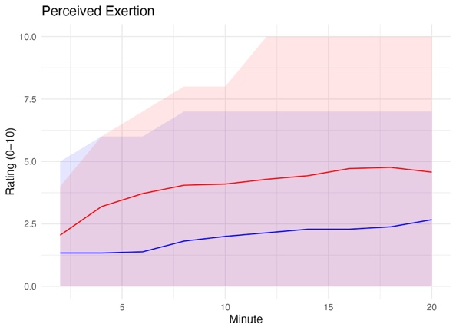
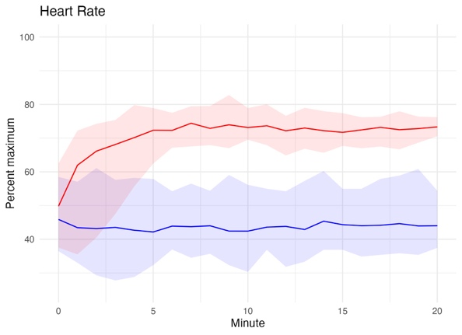

Supplementary figure 6:
Intervention effects. Heart rate percentage and ratings of perceived exertion were higher in the exercise condition than the control condition, but feeling scale ratings did not differ. However, greater variance was observed for ratings of perceived exertion and feelings in the exercise condition than the control condition, heart rate percentage was more varied in the control condition than the exercise condition. Colored lines represent the mean at each intervention timepoint; shading represents total range of scores at that timepoint.

Manipulation checks, heart rate percentage
Paired-sample t-test of HR% indicated that the acute exercise condition was significantly more physiologically demanding than seated reading control (t(20)=25.7, p<0.001). Additionally, Levene’s test revealed that HR% varied more during the seated reading control condition than during acute exercise (F(1, 880)=6.6, p<0.05), indicating a higher degree of interindividual variability in HR% was achieved during seated reading than with a dose of acute exercise. Interindividual differences in HR% between conditions suggests more uniform physiological response to acute exercise than seated reading. This is indicative of HR% being used as metric for exercise intensity, constraining HR% in the exercise condition; whereas in the control condition, participant’s HR% was not manipulated. Thus, the acute exercise condition successfully achieved 65-75 HR%, while HR% during the seated reading control condition remained constant resting heart rate.

Covariate selection and sensitivity analysis
Because multivariate pattern analysis is optimized to find variance in rsFC, we chose a stringent strategy of variance attribution guided by theoretical and quantitative approaches. First, a theory-derived confound diagram was used to select covariates a priori to MVPA [7]. The goal of this diagram was to identify a plausible casual structure including all potentially relevant variables whereby the experimental manipulation induces a change in rsFC (supplementary figure 7). Exercise and developmental neuroimaging literatures were queried to identify a comprehensive list of potentially relevant variables. These variables generally clustered into participant characteristics (i.e., age, sex, socioeconomic status, aerobic fitness, IQ, and body mass index), quality control variables (i.e., mean in-scanner motion, mean global signal change, valid scans), and a manipulation variable (i.e., day-one intervention condition). Theoretical relationships were used to connect these variables in a plausible casual structure. A subset of these variables was then identified as key confounders that would a) parsimoniously block the effect of other confounds (i.e., confound blockers), and b) not likely to be proxies, colliders, or mediators of interest. This subset of variables (i.e., age, sex, socioeconomic status, aerobic fitness, intervention order, and in-scanner motion).
Variance inflation factor (VIF) was then used to evaluate the adequacy of collinearity a priori by multiple regression of all covariates; because VIF was low for all covariates (supplementary table 1), we retained all covariates to serve as the main analysis in this study. These analyses therefore indicate how rsFC changed due to the experimental manipulation uninfluenced by characteristics that could differentially affect rsFC.
Post hoc bivariate analyses compared a priori covariates and rsFC change in both acute exercise and seated reading control conditions. Results showed that only relative VO2 max, socioeconomic statis, and mean motion significantly correlated with any rsFC change. Of these, only mean motion was consistent across functional network and remained significant after correction for multiple comparisons (supplementary table 2). From a qualitative perspective, this implies that only mean motion provided a plausible rsFC change confound in the main analysis. Therefore, all subsequent sensitivity analyses retained only mean motion as a covariate of no interest (supplementary figure 8). Of these three covariate sensitivity clusters only the left inferior frontal gyrus pars opercularis extending into middle frontal gyrus (cluster one) of the FPN survived Bonferroni correction for exploratory models (p<0.05). These sensitivity results support the multivariate pattern analysis in the main analysis, resulting in significant rsFC change differences in the left lPFC.

Supplementary table 1:
Variance inflation factors for all covariates regressed on all other covariates.
Age:
Relative VO2 | SES | Sex | Condition order | Mean motion
1.55 | 1.21 | 1.23 | 1.06 | 1.6
Relative VO2:
Age | SES | Sex | Condition order | Mean motion
1.32 | 1.24 | 1.08 | 1.11 | 1.55
SES:
Age | Relative VO2 | Sex | Condition order | Mean motion
1.3 | 1.55 | 1.23 | 1.1 | 1.52
Sex:
Age | Relative VO2 | SES | Condition order | Mean motion
1.33 | 1.36 | 1.24 | 1.11 | 1.79
Condition order:
Age | Relative VO2 | SES | Sex | Mean motion
1.27 | 1.56 | 1.24 | 1.23 | 1.78
Mean motion:
Age | Relative VO2 | SES | Sex | Condition order
1.19 | 1.34 | 1.05 | 1.24 | 1.1
Values of variance inflation factors (VIF) below 10 indicate adequate inclusion in multivariate analyses.

Supplementary table 2:
Covariates significantly correlated with rsFC change in each condition.
Covariate | rsFC change | r value | p value
SES | Seated Reading Cluster 1-1a | -0.48 | 0.03
Relative VO2 | Seated Reading Cluster 1-1b | -0.44 | 0.04
Mean motion | Seated Reading Cluster 1-1a | 0.70 | < 0.001*
Mean motion | Seated Reading Cluster 1-1b | 0.81 | < 0.001*
Mean motion | Acute Exercise Cluster 2-2a | 0.53 | 0.01
Mean motion | Acute Exercise Cluster 3-3a | 0.72 | < 0.001*
Mean motion | Acute Exercise Cluster 3-3a | -0.46 | 0.03
Post hoc covariate analysis. * Indicates that the covariate remained significantly correlated with rsFC change after FDR-correction for multiple comparisons (p<0.05)

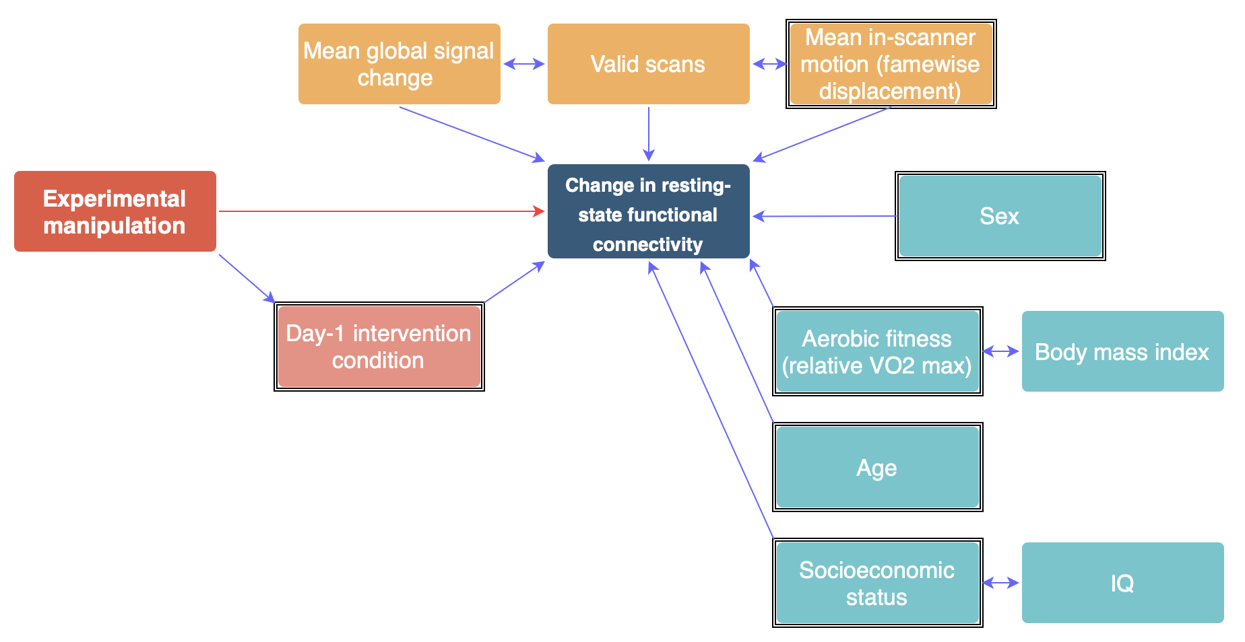

Supplementary figure 7:
Diagram of plausible casual structure for how the experimental manipulation induces a change in RS-FC. Red arrow signifies relationship of interest and blue arrows signify relationships between variables of no interest. Colored boxed signify variables by grouping (blue: participant characteristics; yellow: quality control variables; pink: manipulation variable) and black borders signify confounds controlled for in subsequent analyses.

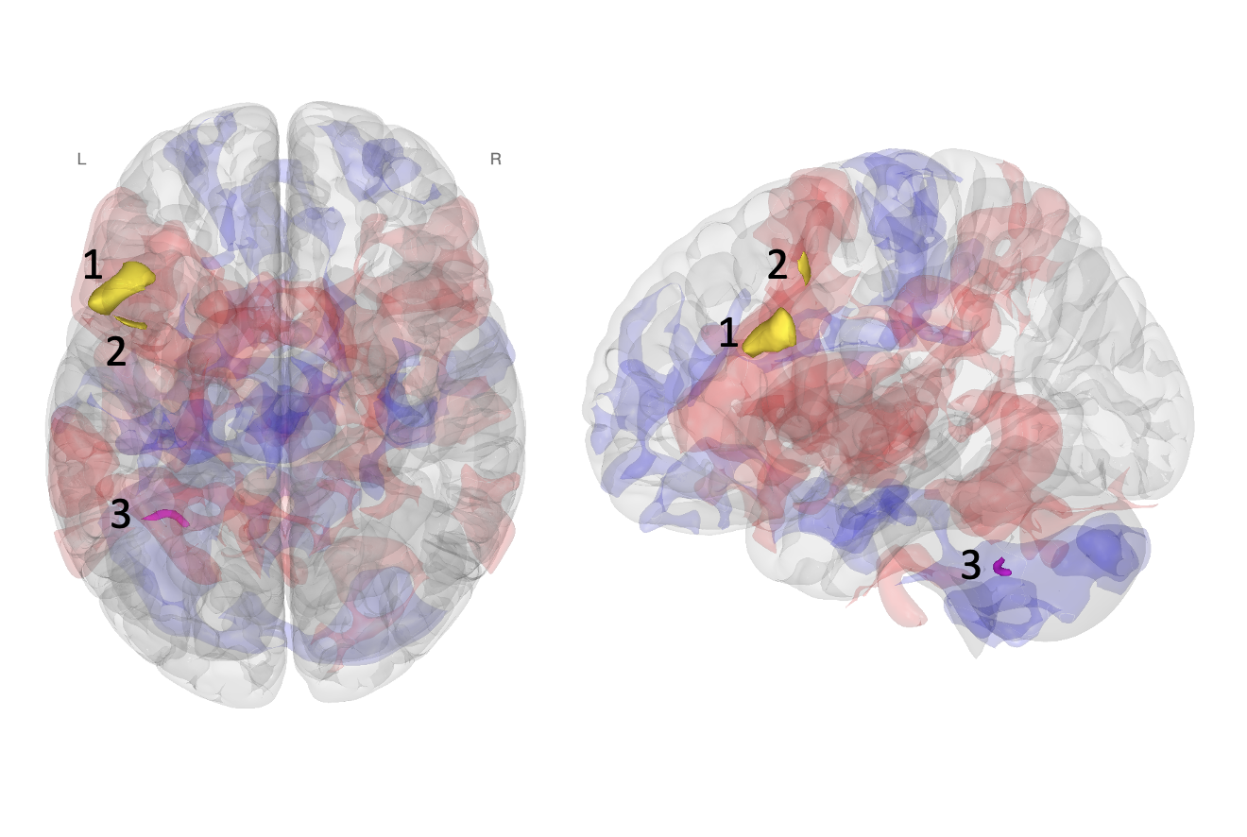

Supplementary figure 8.
Sensitivity multivariate pattern analysis controlling for only mean motion. While significant clusters (voxel p < 0.001; FDR-corrected cluster threshold p < 0.05; k ≥ 50) were more widespread in this post-hoc model than the main analysis, the pattern of rsFC change is consistent with the main analysis. We thus interpret our main results as a conservative representation with respect to this quantitatively parsimonious model with fewer covariates of no interest (compare to main text, figure 1).

Supplementary table 3:
Results of sensitivity analysis controlling for only mean motion (framewise displacement).
Cluster | Peak Coordinate (MNI) | Anatomical Region | Network | Cluster Size | T Value
Cluster 1 | -44, +16, +32 | Left inferior frontal gyrus pars opercularis extending into middle frontal gyrus | FPN | 272 | 5.88*
Cluster 2 | -50, +16, +24 | Left cerebellum | - | 64 | 5.19
Cluster 3 | -16, +6, +70 | Left middle frontal gyrus | FPN | 53 | 5.79
Covariate sensitivity analysis rsFC results * Indicates that the covariate remained significantly correlated with rsFC change after additional Bonferroni correction for multiple comparisons (p<0.05)

Multivariate factor selection and sensitivity analysis
To decide on the optimum number of factors for the GLM, we calculated the percentage of explained variance in the connectivity between each voxel and the rest of the brain that is explained by each N multivariate pattern analysis factor. The percent variance values represent the component of the covariance matrix. This choice is a trade-off, where too few components will explain an insufficient amount of the observed data, and where too many components will include variance in white matter voxel connectivity (which is considered a representation of noise in functional connectivity data). Ideally, factors explain about 80% of the variance in grey matter, where additional variance indicates potential inclusion of noise components in the data. Additionally, the choice in components is guided by A) preexisting research rsFC [8-13], standards in the literature (where a subject-to-factor ratio of 20:1 is most conservative and 5:1 is most liberal) and. How the first factor is interpretable as the pattern that most effectively describes the observed variations in rsFC across all participants and conditions. Sensitivity analyses additionally explored the effects of 2 (10:1 ratio) and 4 factors (5:1 ratio) on whole brain rsFC patterns (supplementary figure 8).

Supplementary table 4
MVPA component | Individual variance (%) | Cumulative variance (%)
1 | 89.16 | 89.16
2 | 3.96 | 93.12
3 | 1.85 | 94.97
4 | 1.12 | 96.09

Individual and cumulative explained gray matter variance of MVPA factors. The first component successfully explained over 80% of the variance in grey matter and is interpretable as the principal pattern best characterizing the observed rsFC variance across participants and conditions [12]. After the first factor, less than 5% of explained variance is being accounted for by including additional components. After the fourth factor, less than 1% of explained variance is being accounted for by including additional components.
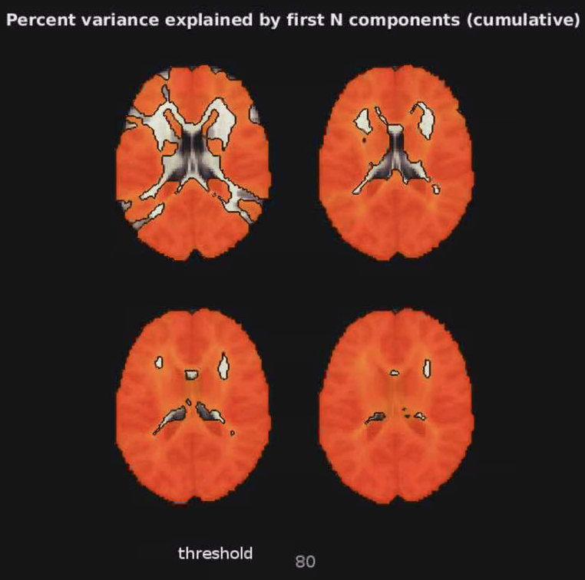
A
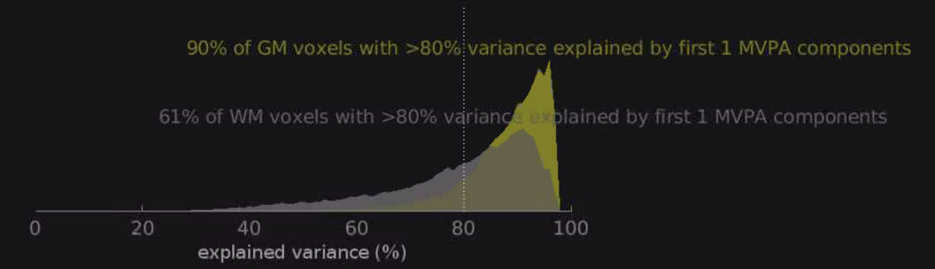
B

Supplementary figure 8:
Cumulative explained variance of voxel-to-voxel rsFC by each N multivariate pattern analysis factor (MVPA component). A) Visual depiction of variance explained by components. That is, the top left slice illustrates in which voxels would the first component explain above 80% of the variance in connectivity between a given voxel and the rest of the brain. For each image thereafter (left-to-right) the cumulative explained variance is depicted. Beyond the first component, little additional variance is being explained by additional components; further, white matter and cerebrospinal fluid voxels begin to be included (which represents noise). B) The graph below illustrates the variance explained by the first components.

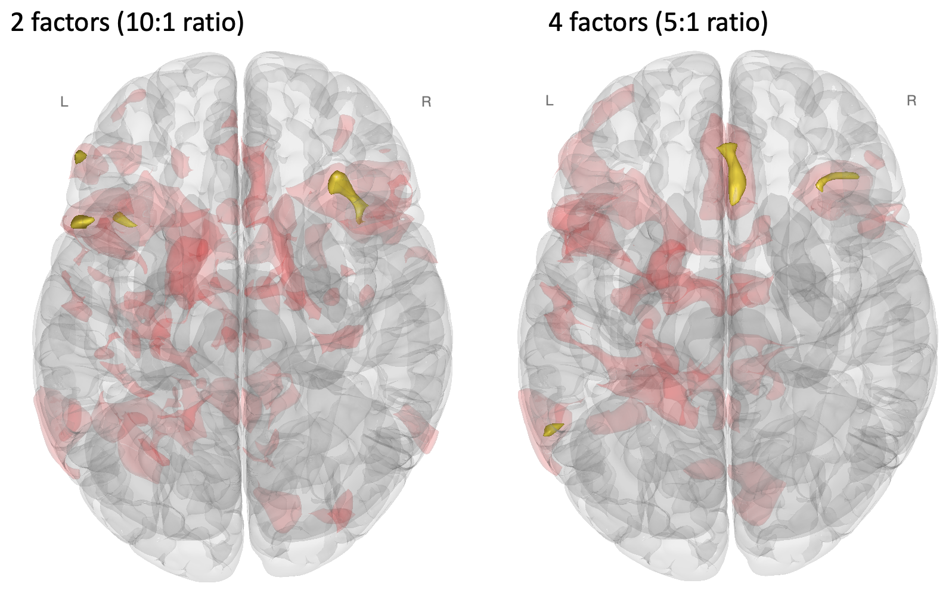

Supplementary figure 9.
Sensitivity factor-wise multivariate pattern analysis. Note that because sequent factors are orthogonally constructed after the first, all voxel report “positive” change in whole-brain rsFC variance. While significant clusters for the 2 factors model (voxel p < 0.001; FDR-corrected cluster threshold p < 0.05; k ≥ 50) yielded a pattern most to the main analysis, both sensitivity analyses of factor-wise options (2 and 4 factors), displayed unthresholded voxels overlapping those in the main analysis. This indicated a consistent pattern. We thus interpret our main results as a conservative representation with respect to a factor choice in multivariate pattern analysis of rsFC (compare to main text figure 1).

Post hoc results details
The full patterns of unthresholded rsFC change from the main analyses provide a detailed report of the full pattern of rsFC change in the whole-brain associated with each intervention (supplementary figure 9) Unthresholded results are shown in coronal slices for difference of rsFC change between conditions, represented as Fischer Z-transformed regressor coefficients (compare to main text, figure 2 B, C).
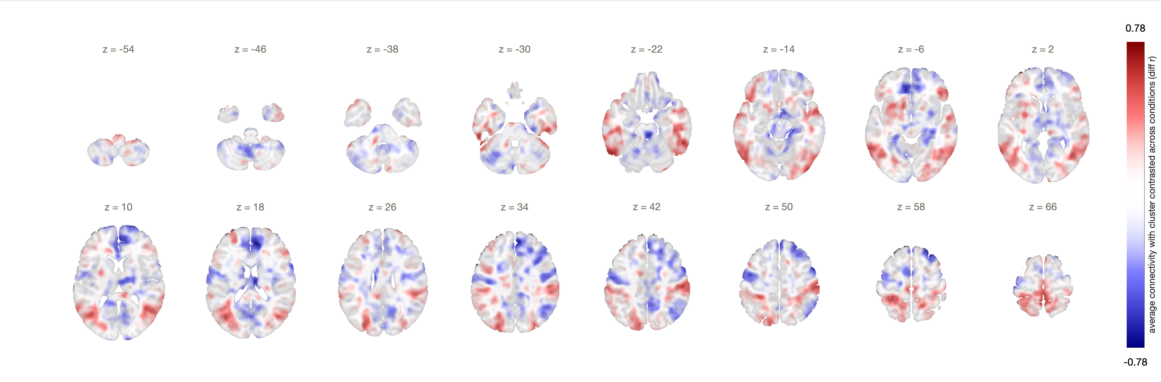
A
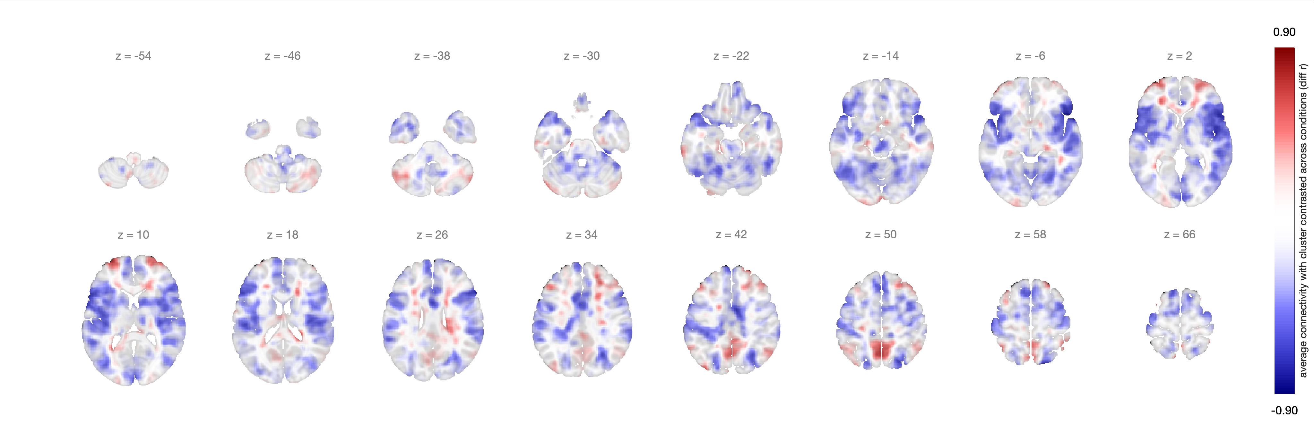
B
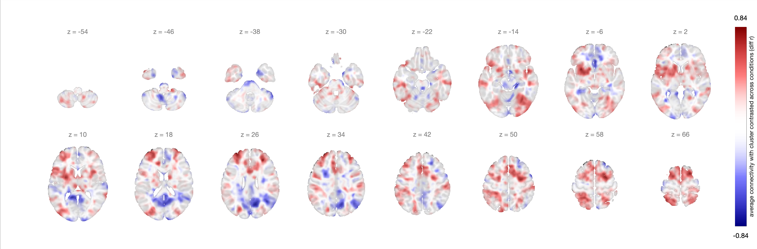
C
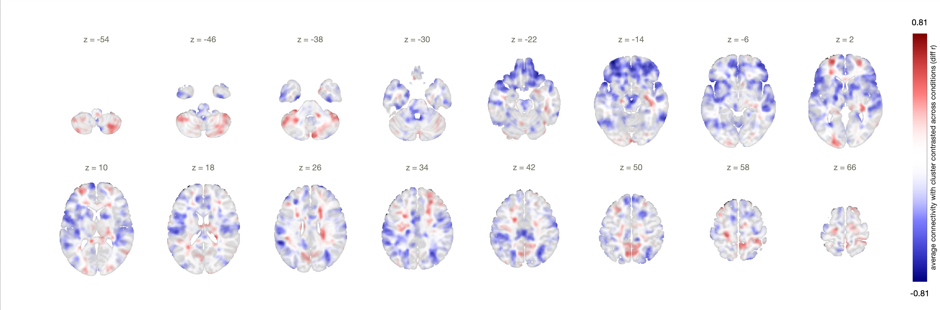
D
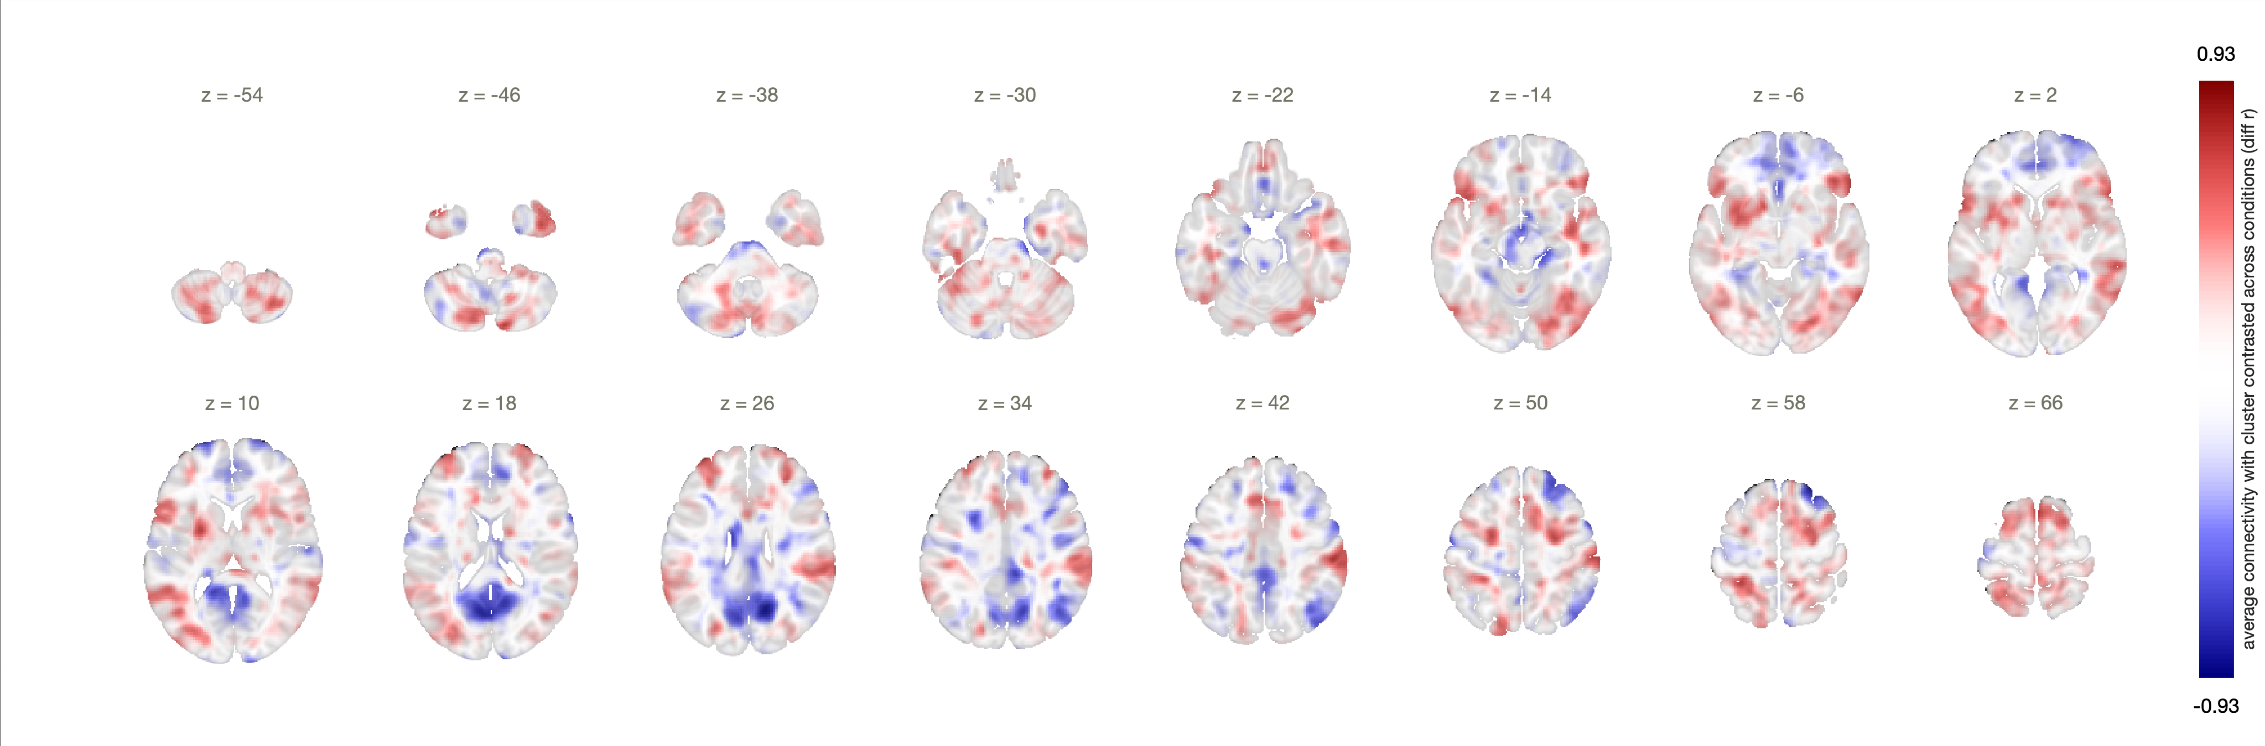
E
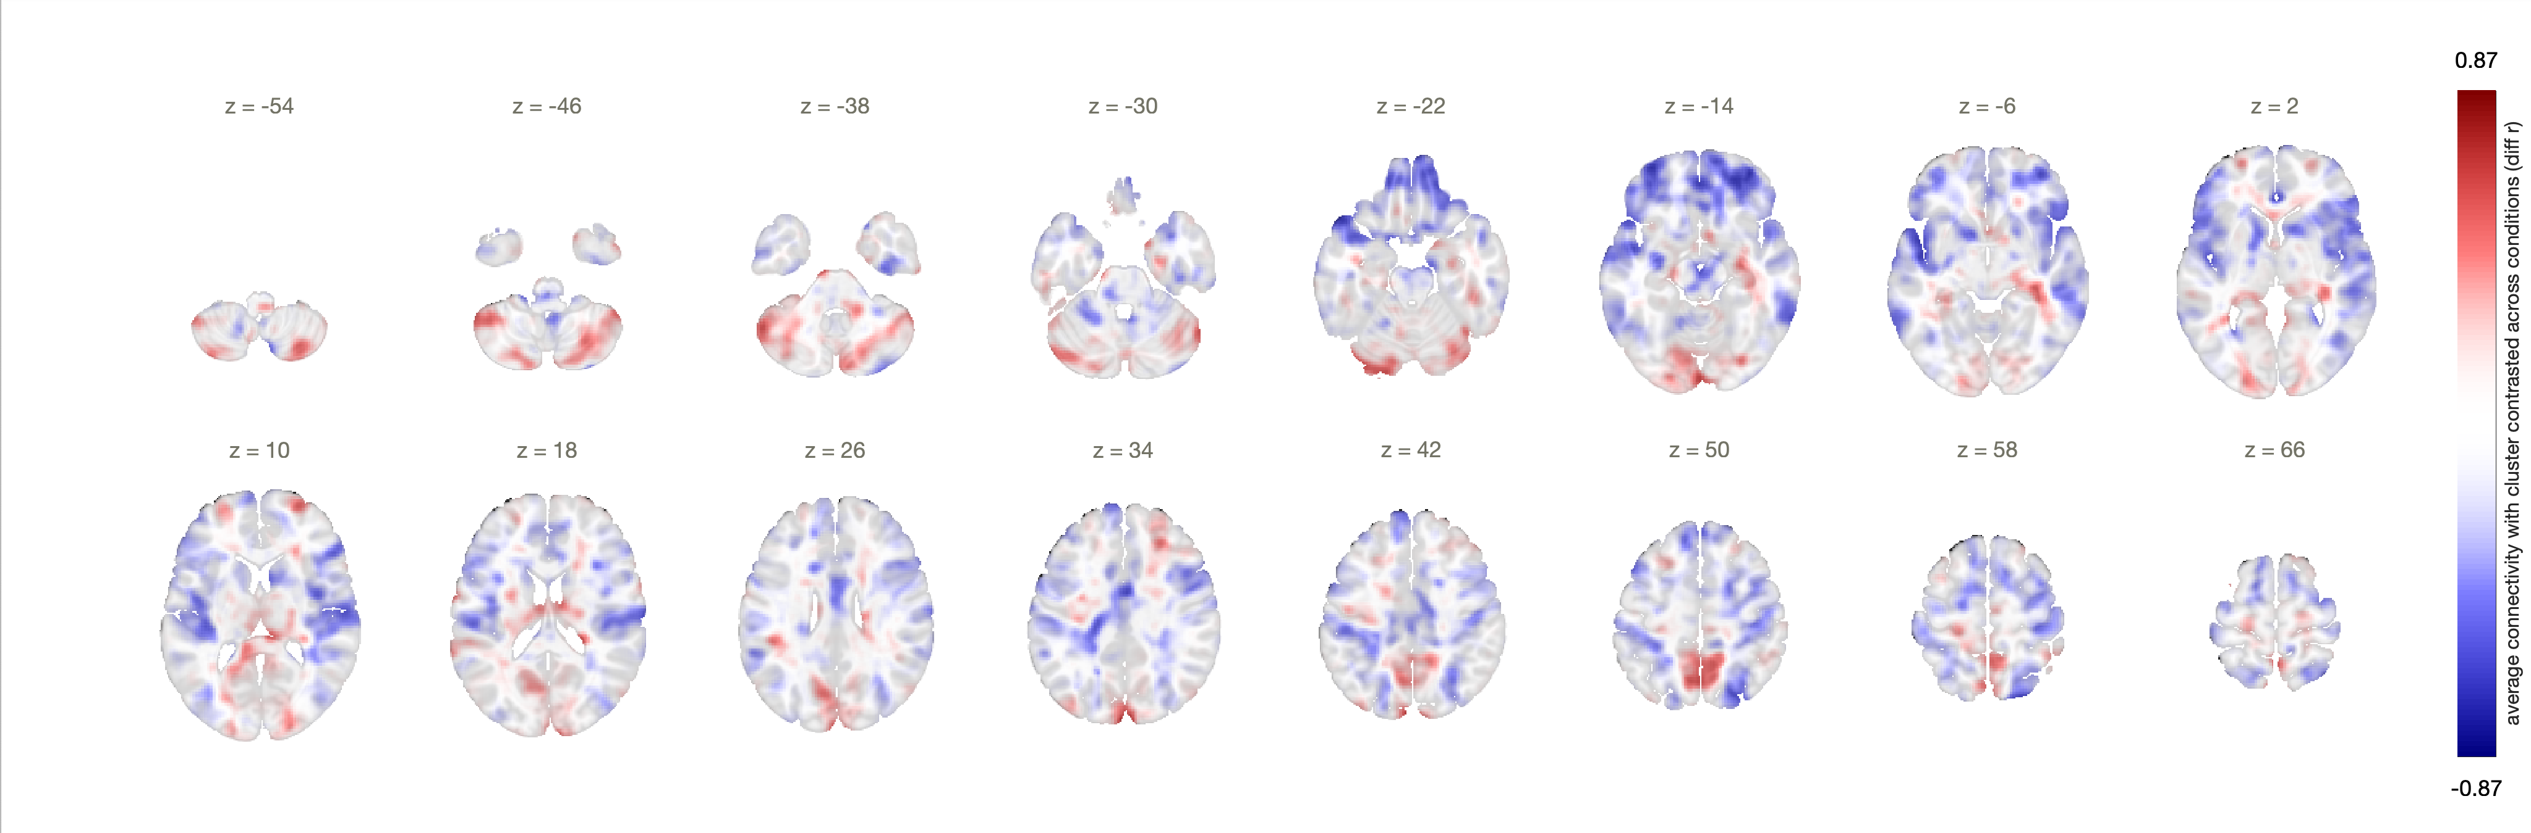
F

Supplementary figure 10.
Unthresholded post hoc seed-to-voxel results. A) Cluster 1 post hoc seed to voxel analysis (post acute exercise > pre acute exercise). B) Cluster 1 post hoc seed to voxel analysis (post seated reading > pre seated reading). C) Cluster 2 post hoc seed to voxel analysis (post acute exercise > pre acute exercise). D) Cluster 2 post hoc seed to voxel analysis (post seated reading > pre seated reading).E) Cluster 3 post hoc seed to voxel analysis (post acute exercise > pre acute exercise). F) Cluster 3 post hoc seed to voxel analysis (post seated reading > pre seated reading).

Post hoc analyses, correlation of rsFC to rating of perceived exertion and feeling scale
We used Pearson-product moment correlations to assess the relationships between (post > pre) changes in rsFC across clusters and changes in FS and RPE under both intervention conditions. This resulted in 20 independent analyses (supplementary table 5). It was found that none of the observed relationships remained statistically significant after applying FDR correction with a threshold of q=0.05. This suggests that changes in FS and RPE were not meaningfully related to rsFC change.

Supplementary table 5:
Results of Pearson correlation between changes in cognitive measures and rsFC change in each condition.
Cognitive measure | rsFC change | r value | p value
RPE | Seated Reading Cluster 1-1a | -0.07 | 0.75
RPE | Seated Reading Cluster 1-1b | 0.07 | 0.75
RPE | Seated Reading Cluster 2-2a | -0.22 | 0.34
RPE | Seated Reading Cluster 3-3a | -0.07 | 0.76
RPE | Seated Reading Cluster 3-3b | -0.16 | 0.48
RPE | Acute Exercise Cluster 1-1a | 0.23 | 0.32
RPE | Acute Exercise Cluster 1-1b | 0.35 | 0.12
RPE | Acute Exercise Cluster 2-2a | 0.23 | 0.32
RPE | Acute Exercise Cluster 3-3a | -0.22 | 0.34
RPE | Acute Exercise Cluster 3-3b | 0.3 | 0.19
FS | Seated Reading Cluster 1-1a | -0.1 | 0.68
FS | Seated Reading Cluster 1-1b | 0.07 | 0.77
FS | Seated Reading Cluster 2-2a | -0.09 | 0.71
FS | Seated Reading Cluster 3-3a | -0.15 | 0.52
FS | Seated Reading Cluster 3-3b | 0.16 | 0.5
FS | Acute Exercise Cluster 1-1a | 0.09 | 0.69
FS | Acute Exercise Cluster 1-1b | -0.05 | 0.83
FS | Acute Exercise Cluster 2-2a | -0.49 | 0.02
FS | Acute Exercise Cluster 3-3a | 0.26 | 0.25
FS | Acute Exercise Cluster 3-3b | -0.19 | 0.4
Correlation between change in cognitive measures and rsFC change. * Note that no result survived FDR-correction for multiple comparisons (p<0.05)

References (Supplementary Material)
1. Henson RNA, Buechel C, Josephs O, Friston KJ. The slice-timing problem in event-related fMRI. NeuroImage 1999;9
2. Wu CW, Chen CL, Liu PY, et al. Empirical evaluations of slice-timing, smoothing, and normalization effects in seed-based, resting-state functional magnetic resonance imaging analyses. Brain Connect 2011;1:401-410
3. Morfini F, Whitfield-Gabrieli S, Nieto-Castañón A. Functional connectivity MRI quality control procedures in CONN. Frontiers in Neuroscience 2023;17
4. Nieto-Castanon A. Preparing fMRI Data for Statistical Analysis. arXiv preprint 2022
5. Ciric R, Wolf DH, Power JD, et al. Benchmarking of participant-level confound regression strategies for the control of motion artifact in studies of functional connectivity. Neuroimage 2017;154:174-187
6. Van Dijk KR, Hedden T, Venkataraman A, et al. Intrinsic functional connectivity as a tool for human connectomics: theory, properties, and optimization. J Neurophysiol 2010;103:297-321
7. Wysocki AC, Lawson KM, Rhemtulla M. Statistical Control Requires Causal Justification. Advances in Methods and Practices in Psychological Science 2022;5:1-19
8. Morris TP, Chaddock-Heyman L, Ai M, et al. Enriching activities during childhood are associated with variations in functional connectivity patterns later in life. Neurobiol Aging 2021;104:92-101
9. Westfall DR, Anteraper SA, Chaddock-Heyman L, et al. Resting-State Functional Connectivity and Scholastic Performance in Preadolescent Children: A Data-Driven Multivoxel Pattern Analysis (MVPA). Journal of Clinical Medicine 2020;9
10. Whitfield-Gabrieli S, Ghosh SS, Nieto-Castanon A, et al. Brain connectomics predict response to treatment in social anxiety disorder. Mol Psychiatry 2016;21:680-685
11. Anteraper SA, Collin G, Guell X, et al. Altered resting-state functional connectivity in young children at familial high risk for psychotic illness: A preliminary study. Schizophr Res 2020;216:496-503
12. Nieto-Castanon A. Brain-wide connectome inferences using functional connectivity MultiVariate Pattern Analyses (fc-MVPA). PLoS Comput Biol 2022;18:e1010634
13. Logan NE, Westfall DR, Raine LB, et al. The Differential Effects of Adiposity and Fitness on Functional Connectivity in Preadolescent Children. Med Sci Sports Exerc 2022;54:1702-1713

