Supplementary Figure Legend
Supplementary Figure 1:
A-C) Cerebellar organotypic slices from P9 mouse, were maintained in culture and submitted to LPC treatment at DIV6 for 16-17 h. At DIV9 (i.e., peak of demyelination) immunostaining was performed for BTK (Red) and either CC1 (oligodendrocyte, green in A) or Olig2 (oligodendrocyte precursor cell, green in B) or NeuN (neurons, green in C).

Supplementary Figure 1
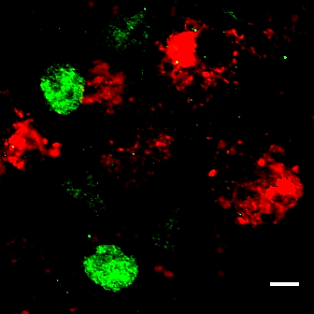
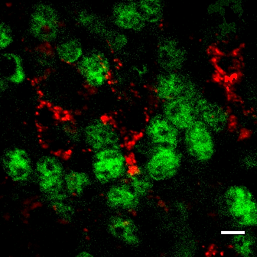
CC1 BTK
Olig2 BTK
NeuN BTK
A
B
C

