Supplementary Methods

Methods

Inclusion and exclusion criteria
Inclusion was based on key term searches in PubMed to find potentially relevant publications. The terms were ‘Alzheimer’s Disease’ (and equivalent), ‘mice’ and/or ‘rodents’, and a lifestyle intervention key word (e.g., ‘environmental enrichment’; see Table 1). Any study that used a familial AD animal model (that is, contained at least one mutation found in familial AD human patients) in conjunction with either exercise, EE or a cognitive training method (in this case, defined as repeated training in a cognitive task) was included. Any title and abstract that clearly delineated a AD model and the use of either exercise, EE or a cognitive training method were automatically included for full text eligibility. For studies that indicated one of those two conditions, studies were opened and methods examined to ascertain if both conditions were met. One study was not available in English, so just the abstract was examined. Studies were then excluded if they did not have the appropriate groups to be able to compare a transgenic standard housed and the transgenic intervention (for example, all animals in EE were on a high fat diet). At the end of this process, 119 studies were included in the systematic review; see Figure 1 for PRISMA diagram.

Search term 1 | Search term 2 | Search term 3
Environmental enrichment | Alzheimer's | Mice
Enriched environment | Alzheimer's disease | Rodents
Cognitive training | Alzheimer disease
Brain training
Cognitive stimulation
Repeated training
Overtraining
Operant
Physical+activity
Exercise
Treadmill
Running wheel
Supplementary table 1. Search terms used to identify potential studies for screening and inclusion
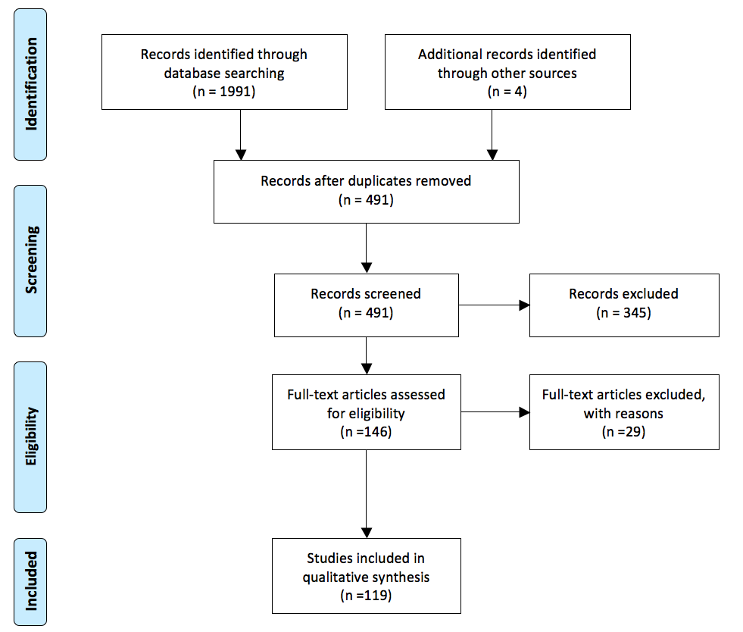

Supplementary Figure 1. Summary of study identification and inclusion
Inclusion was based on key term searches in PubMed to find potentially relevant publications. The terms were ‘Alzheimer’s Disease’ (Alzheimer’s, Alzheimer), ‘mice’ and/or ‘rodents’, and a lifestyle intervention key word (e.g., ‘environmental enrichment’; ‘enriched environment’, ‘cognitive training’, ‘brain training’, ‘cognitive stimulation’, ‘repeated training’, ‘overtraining’, ‘operant’, ‘physical + activity’, ‘exercise’, ‘treadmill’ ‘running wheel’). Any study that used a familial AD animal model (that is, contained at least one mutation found in familial AD human patients) in conjunction with either exercise, EE or a cognitive training method (in this case, defined as repeated training in a cognitive task) was included. Any title and abstract that clearly delineated a AD model and the use of exercise or EE were automatically included for full text eligibility. For studies that indicated one of those two conditions, article methods were examined to ascertain if both conditions were met. One study was not available in English, so just the abstract was examined. Studies were then excluded if they did not have the appropriate groups to be able to compare a transgenic standard housed and the transgenic intervention (for example, all animals in environmental enrichment were also on a high fat diet). At the end of this process, 119 studies were included in the systematic review. Studies were then classified into ‘preventative’ and ‘therapeutic’ (See supplementary table 2).

Classification of studies
For this review, we classified studies into ‘preventative’ and ‘therapeutic’ (see supplementary table 2). We defined ‘preventative interventions’ as interventions that began at an age before cognitive deficits are commonly seen to occur in each respective mouse model. Each mouse model progresses at different rates and therefore, each study was treated as an individual case to categorise into preventative or therapeutic based on the model used. To classify whether a study was preventative (prior to cognitive deficits) or therapeutic (after onset of cognitive deficits), authors went back to the original generation of that model to look at the original characterisation. If there was no characterisation of cognitive deficits in the original generation nor intervention studies, authors found a third study that characterised cognitive deficits to estimate the approximate age of cognitive deficits. Additionally, the studies with the oldest-preventative and youngest-therapeutic groups were read to ascertain if authors used other studies to estimate cognitive deficits, or to see if there was a characterisation of cognitive deficits in that study. Once a cut-off point was determined, studies were classified into ‘preventative’ and ‘therapeutic’ (See supplementary table 2).

Data Extraction
Due to the large number of variables and the extreme variability in measurement techniques, changes in behaviour or molecular correlates were not examined statistically but were categorised as increased, no change, or decreased, consistent with article reporting. Relevant measures were clumped together to allow identification of trends (for example various pro-inflammatory cytokines, AB degrading enzymes etc); these are summarised in Table 1 in the main text, and broken up further in into preventative and therapeutic.

Animal model | Earliest cognitive deficits identified? | Oldest Preventative cohort | Youngest Therapeutic cohort | Generated, information about plaques and/or cognitive deficits | Plaques develop
3xTg-AD | 6 months | 3 (138) | 6 (94) | (180) | 6 months
5 x FAD | 4-5 months | 2.5 (46) | - | (181) | 2 months
APP(751SL)PS1KI | 6 months | 2 (90) | - | (182) | 6 months
APP23 | 3 months | 3 (37) | 6 (95) | (183,184) | 6 months
APPsw,ind | 6-7 months | 4 (44) | - | (185,186) | 6 months
APPswe/PS1 (L166P) | 8 months | 0 (39) | - | (187) | 8 months
APPswe/PS1dE9 | 7 months | 3 (48) | 4-5 (137) | (188) | 6 months
PDAPP/ PS1 (APPswe+PS1 (M146V)) | 4.5-6 months | 1.5 (36,41,141) | - | (41) | 6–7.5
PDAPP-J20 | 6-7 months | - | 5 (94) | (185,189) | 6 months
PS1 (M146V) Het | 3 months | 1 (135) | - | (190,191) | Never
PS1 (M146V) Homo | 3 months | 1 (135) | - | (190,191) | Never
PS1 (P117L) | Unclear | 2 (140) | - | Generated for these studies | Unclear
TASTSPM (APPswe/PS1 (M146V)) | 6 months | 4 (85) | - | (192) | 4 months
Tg2576 | 9-10 months | 3 (43,45,193) | 10 (45) | (194) | 11-13 months
Tg4-42 Het | 12 months | 2 (42) | - | (97) | 2 months
Tg4-42 Hom | 6 months | 2 (42) | - | (97) | 2 months
TgCRND8 | 2.5 months | 1 (86,91,93,142,145) | 3 (93) | (195) | 3 months
NSE/PS2 | 12 months | - | 12 (50) | (196) | 12 months
NSE/APPswe | 12 months | - | 12 (51) | (196) | 12 months

Supplementary table 2. Preventative and Therapeutic cut off times in various AD models
Preventative interventions were defined as interventions that began at an age before cognitive deficits are reported to occur in each respective mouse model. Each mouse model progresses at different rates and therefore, each study was treated as an individual case to categorise into preventative or therapeutic based on the model used. To classify whether a study was preventative (prior to cognitive deficits) or therapeutic (after onset of cognitive deficits), authors went back to the original generation of that model to look at the original characterisation. If there was no characterisation of cognitive deficits in the original generation nor intervention studies, authors found a third study that characterised cognitive deficits to estimate the approximate age of cognitive deficits. Additionally, the studies with the oldest-preventative and youngest-therapeutic groups were read to ascertain if authors used other studies to estimate cognitive deficits, or to see if there was a characterisation of cognitive deficits in that study. Once a cut-off point was determined, studies were classified into ‘preventative’ and ‘therapeutic’.

