STANDARDIZED ACUTE EXERCISE DATA COLLECTION FORM
Name/Subject ID: ________________________________________
Date of Testing: ________________________________________
Person(s) Administering: ________________________________________
Age: _________________ Weight (lbs): _________________ Height (inches): _________________
BMI [(weight / height²)*703]: _________________
Gender: Male / Female
Health status: Healthy / Other: _________________
VO₂ Max/Peak value of individual: _____________ Corresponding maximal heart rate (MHR): _____________
- Note: If VO₂ max data is not available, calculate maximal heart rate by: 208 – (0.7*age) (Tanaka et al., 2001)
Fitness level: _________________ (see table below for reference)
Acute exercise type:
- Walking / Running / Cycling / Swimming / Elliptical / Step machine /
Other: _____________________
- Continuous / High-intensity intervals / Maximal graded exercise test
- Protocol description:
1) Exercise duration (provided in % of 1 hour):
% of hour = (minutes / 60) * 100
Warmup: _____________________ minutes
Session: _____________________ minutes = _____________________ % of hour
Cooldown: _____________________ minutes
Category: SHORT / MODERATE / LONG (see duration category below for reference)
2) Exercise intensity (provided in % of VO₂ max):
% VO₂ max = (Average HR / MHR) * 100
Average HR should be calculated by averaging HR data taken at each minute during the exercise session.
Warmup: _____________________ average HR
Session: _____________________ average HR = _____________________ % of VO₂ max
Cooldown: _____________________ average HR
Category: LOW / MODERATE / HIGH (see intensity category below for reference)
3) Perceived exertion (provided in % of scale)
To be measured immediately after the exercise session by the Borg Ratings of Perceived Exertion Scale (see below for reference)
Value: _____________________ = _____________________ % of scale
4) Exercise Index: _____________________
Calculation: (% of hour for session + % of VO₂ max for session + % of scale) / 3

DURATION CATEGORY INTENSITY CATEGORY
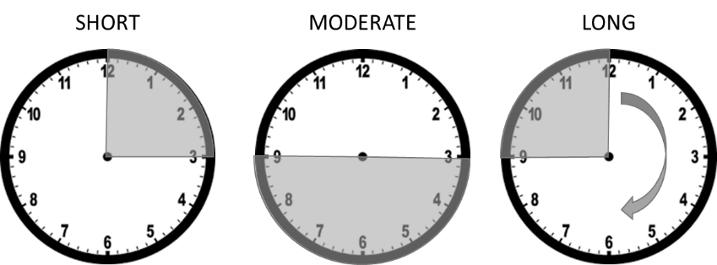

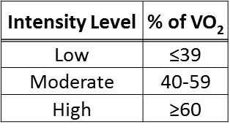

Please note minute-by-minute heart rate data here: Borg Ratings of Perceived Exertion Scale
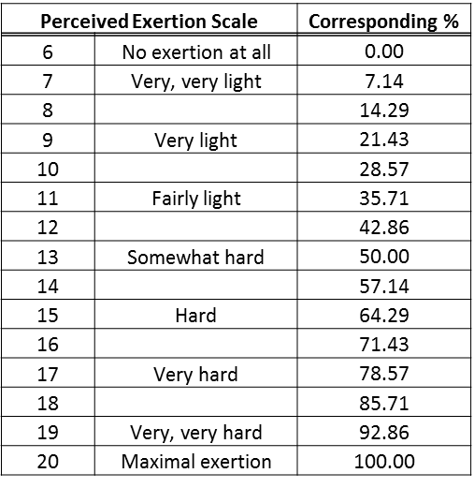
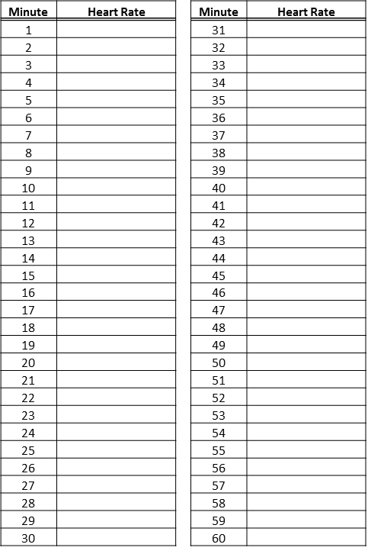
To be administered immediately after the exercise session. How hard was the exercise session? Think about your breathing, your muscles, you whole body. (Borg, 1982)

Normative values for VO₂ max
Values in ml O₂/kg/min (Heyward, 1998)
