SUPPLEMENTARY FIGURES
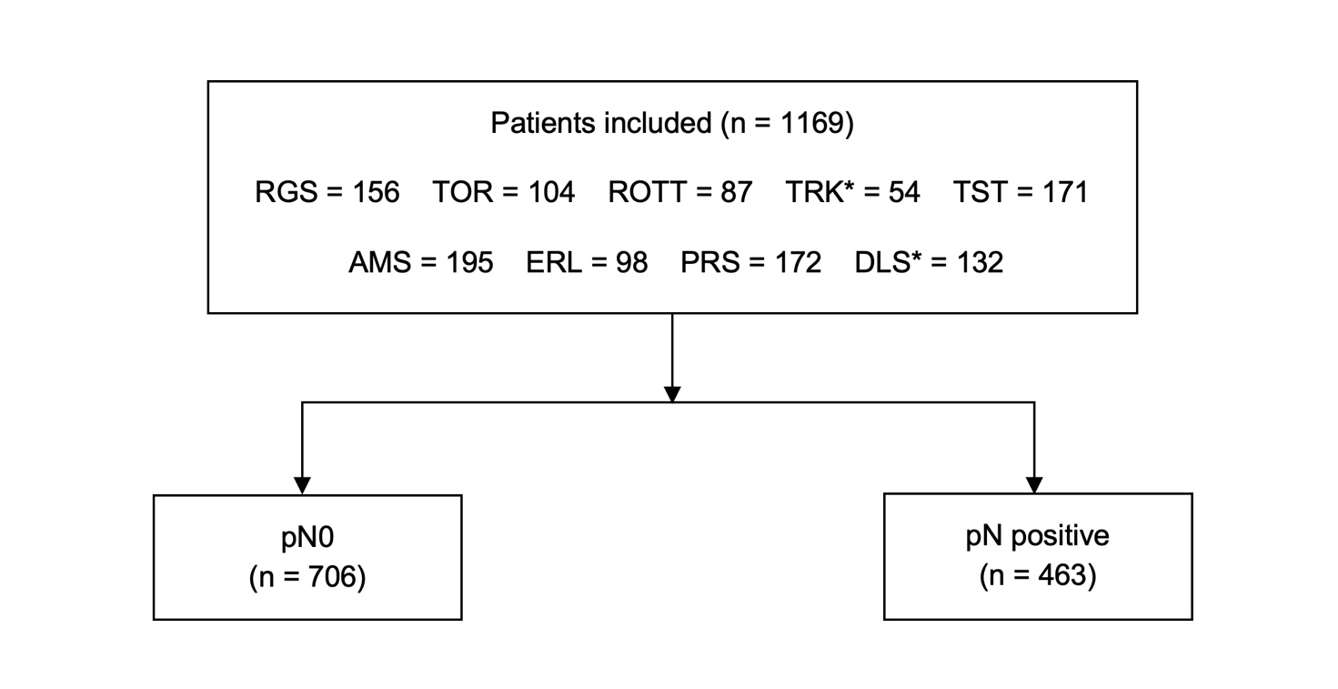

Figure S1. Consort flow diagram. A total of 1169 patients were eligible for the current study, of whom 463 (39.6%) with lymph-node involvement at time of radical cystectomy. The breakdown of patients from each center is shown per city and country: Regensburg (Germany); Toronto, ON (Canada); Turku (Finland); Trieste (Italy); Amsterdam (The Netherlands); Erlangen (Germany); Rotterdam (The Netherlands); Paris (France) and Dallas, TX (United States of America).
* Pathology review of the cases from Turku and Dallas was done in Toronto.
Abbreviations are as follows: pN: pathological nodal stage; RGS: Regensburg; TOR: Toronto; TRK: Turku; TST: Trieste; AMS: Amsterdam; ERL: Erlangen; ROTT: Rotterdam; PRS: Paris; DLS: Dallas.

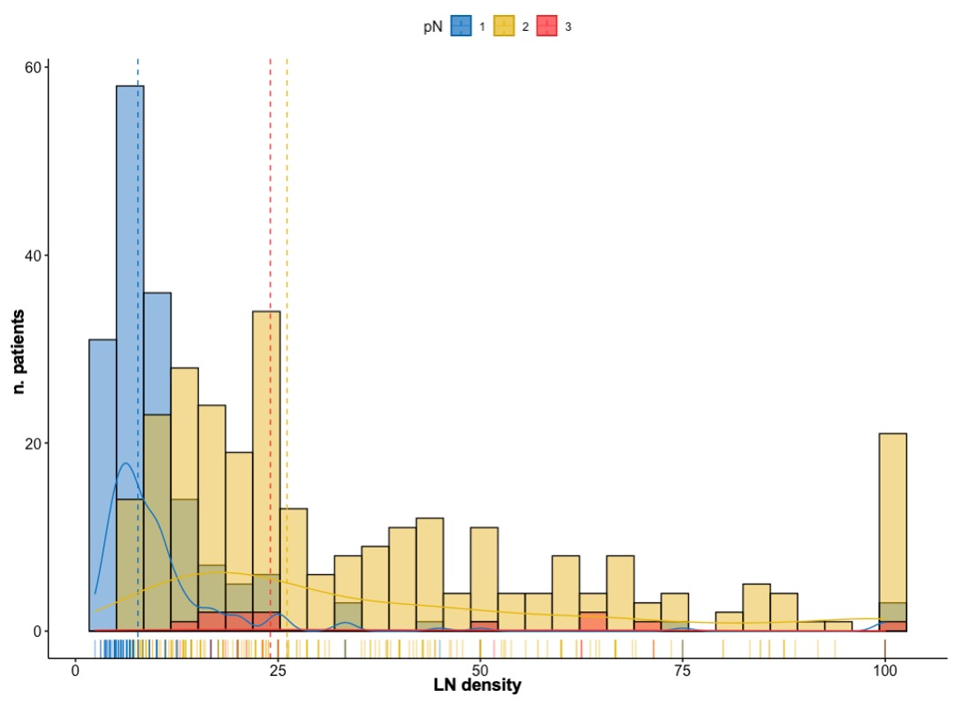
Figure S2. Histogram with kernel density plot depicting the mutual relationship between pN stage and LN density and their distribution in the pN positive cohort.
Abbreviations are as follows: pN: pathological nodal; LN: lymph node.

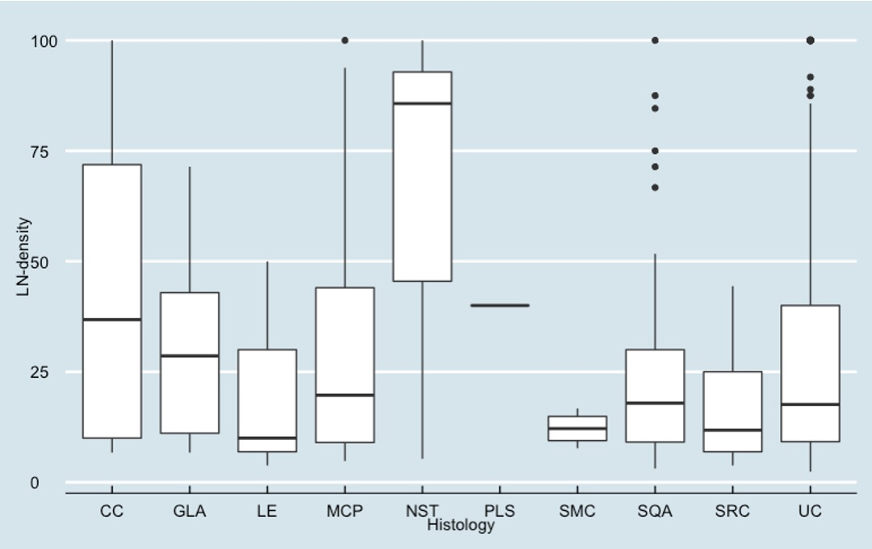

Figure S3. Whisker plots depicting the median value and interquartile range of LN density stratified by histological group among the node-positive cohort. CC (n=4) median LN-density 36.8 (IQR 10.0-71.9), GLA (n=5) median LN-density 28.6 (IQR 11.1-42.9), LE (n=3) median LN-density 10.0 (IQR 6.9-30.0), MCP (n=26) median LN-density 19.7 (IQR 9.0-44.0), NST (n=3) median LN-density 85.7 (IQR 45.5-92.9), PLS (n=1) median LN-density 40.0 (IQR 40.0-40.0), SMC (n=4) median LN-density 12.2 (IQR 9.4-14.9), SQA (n=58) median LN-density 17.9 (IQR 9.1-30.0), SRC (n=13) median LN-density 11.8 (IQR 6.8-25.0), UC (n=346) median LN-density 17.6 (IQR 9.2-40.0). ANOVA test for statistical significance (p=0.17).
Abbreviations are as follows: LN: lymph node; CC: clear cell; GLA: glandular diff.; LE: lymphoepithelioma-like; MCP: micropapillary; NST: nested; PLS: plasmacytoid; UC: pure urothelial carcinoma; SRC: sarcomatoid; SMC: small cell; SQA: squamous diff; IQR: interquartile range.
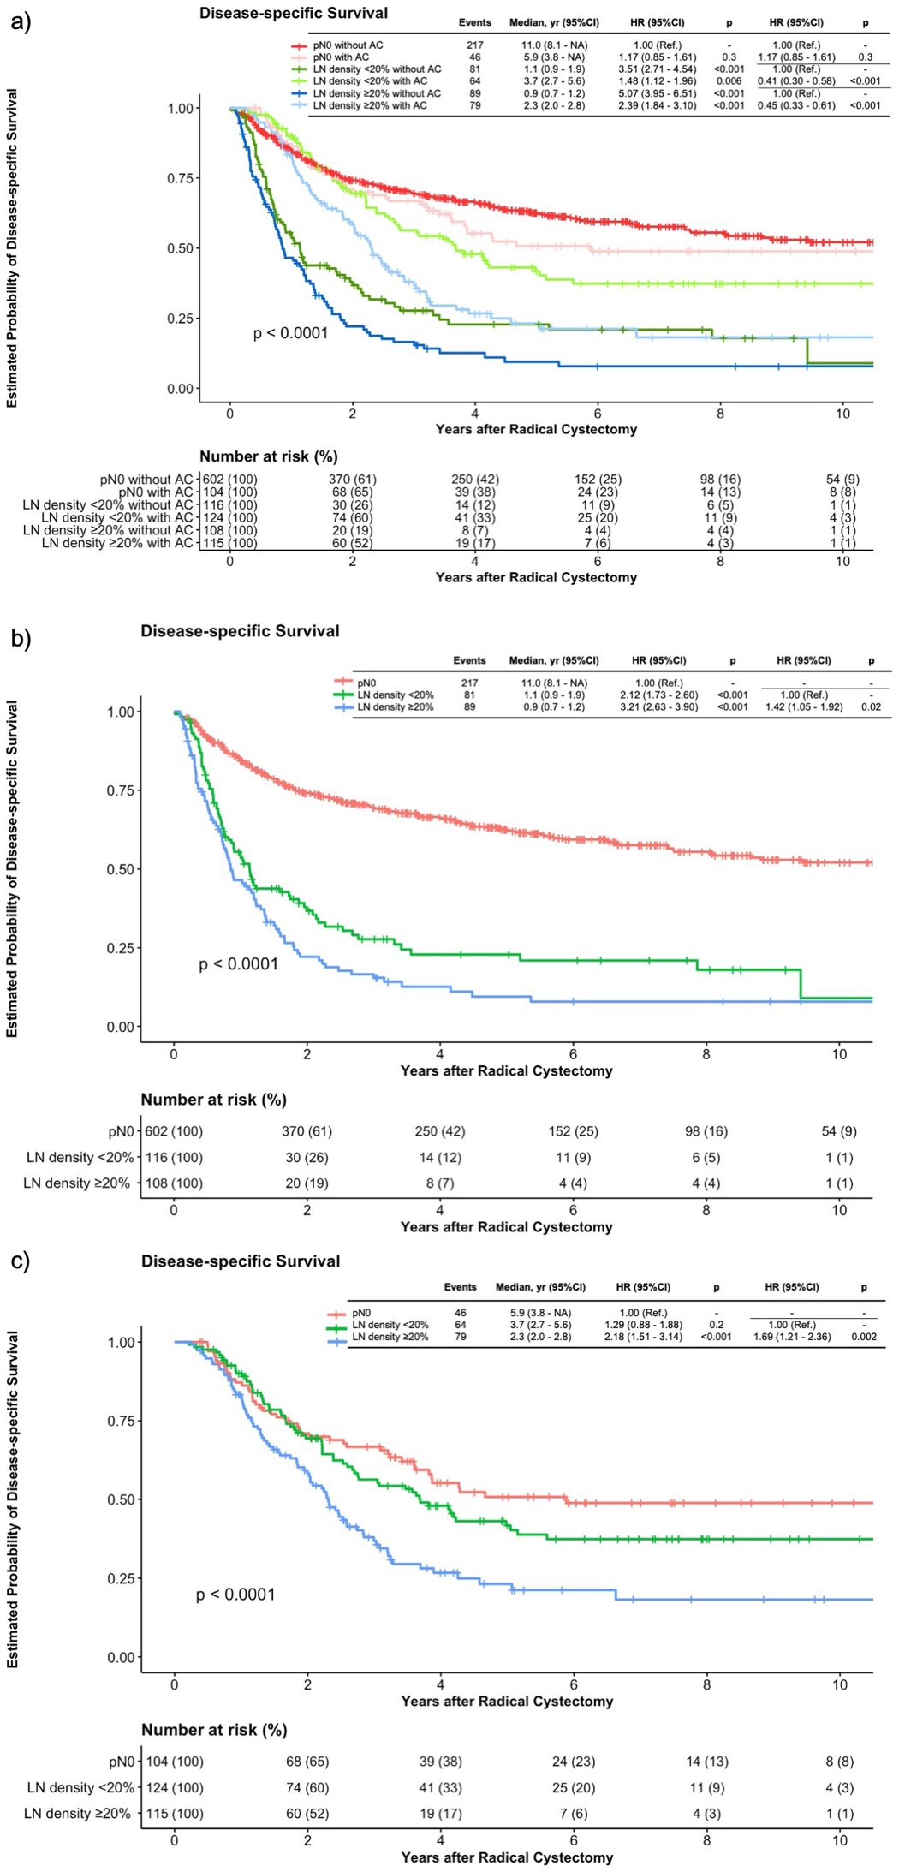
Figure S4
Figure S4a. Cumulative Kaplan-Meier survival curves of disease-specific survival (log-rank, p < 0.0001) stratified by LN-density groups and adjuvant chemotherapy administration among 1169 patients with non-metastatic bladder cancer undergoing radical cystectomy and pelvic lymph node dissection are shown.
Figure S4b. Kaplan-Meier survival curves of disease-specific survival (log-rank, p < 0.0001) stratified by LN-density groups among 826 patients with non-metastatic bladder cancer undergoing radical cystectomy and pelvic lymph node dissection who did not received adjuvant chemotherapy are shown.
Figure S4c. Kaplan-Meier survival curves of disease-specific survival (log-rank, p < 0.0001) stratified by LN-density groups among 343 patients with non-metastatic bladder cancer undergoing radical cystectomy and pelvic lymph node dissection who received adjuvant chemotherapy are shown.
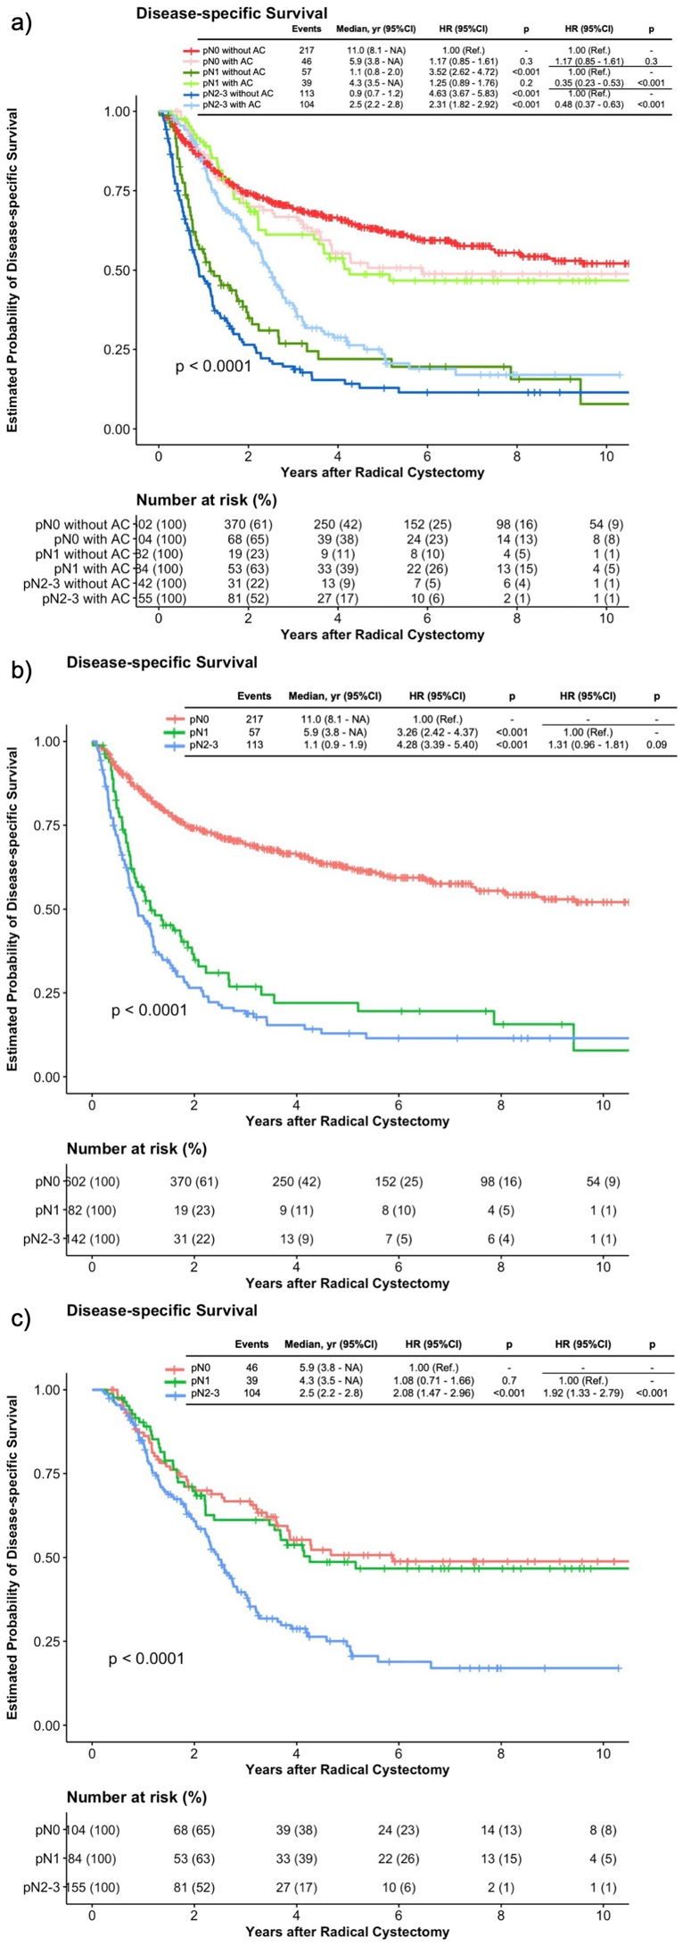
Figure S5
Figure S5a. Cumulative Kaplan-Meier survival curves of disease-specific survival (log-rank, p < 0.0001) stratified by pN-stages and adjuvant chemotherapy administration among 1169 patients with non-metastatic bladder cancer undergoing radical cystectomy and pelvic lymph node dissection are shown.
Figure S5b. Kaplan-Meier survival curves of disease-specific survival (log-rank, p < 0.0001) stratified by pN-stages among 826 patients with non-metastatic bladder cancer undergoing radical cystectomy and pelvic lymph node dissection who did not received adjuvant chemotherapy are shown.
Figure S5c. Kaplan-Meier survival curves of disease-specific survival (log-rank, p < 0.0001) stratified by pN-stages among 343 patients with non-metastatic bladder cancer undergoing radical cystectomy and pelvic lymph node dissection who received adjuvant chemotherapy are shown.

