Supplementary Material

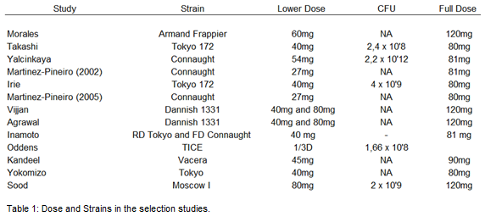
Table 1. Dose and strains in the included studies.

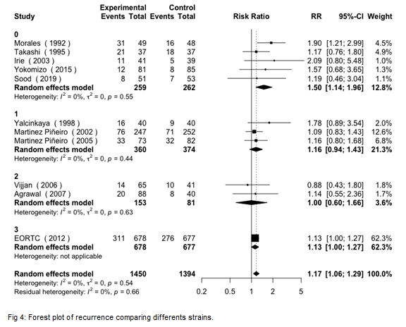
Figure 1. Recurrence using different BCG strains.

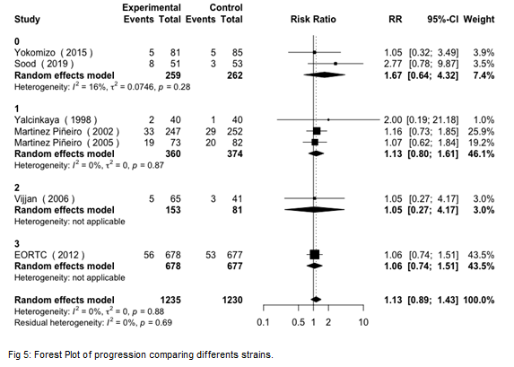
Figure 2. Progression using different BCG strains.

