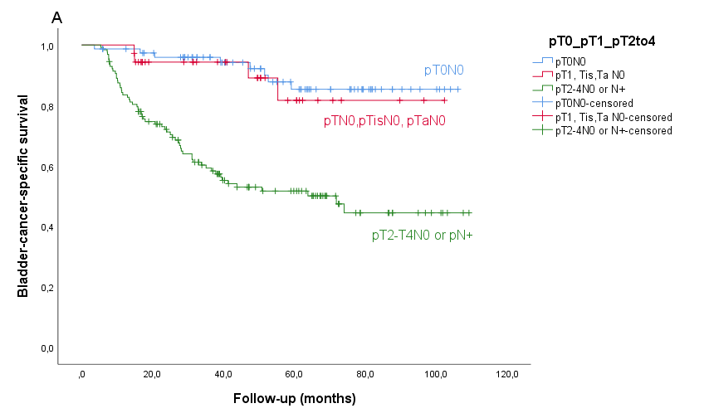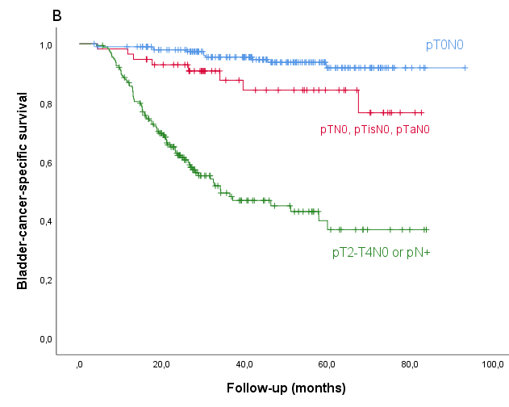

Supplementary Fig. 2. Bladder-cancer-specific survival by pathological response in GC-4w (A), and in GC-3w (B).

