Supplementary Material
Included in this document are the following supplementary materials:
Supplementary Fig. S1: Disease courses of the four patients.
Supplementary Fig. S2: UMI-based read collapsing.
Supplementary Fig. S3: Filtering of mutations.
Supplementary Fig. S4: Comparison of variant allele fractions obtained from the sequencing of normal and tumor samples using cancer panel targeted sequencing and from WES of tumor samples and recurrences from patients 3 and 4.
Supplementary Table S1: Clinical and pathological information.
Supplementary Table S2: Overview of samples, cancer panel targeted sequencing, and WES
Supplementary Table S3: Primers and probes for ddPCR analyses
Primer sequences for detection of tumor mutations in normal samples by ddPCR

Supplementary Figures
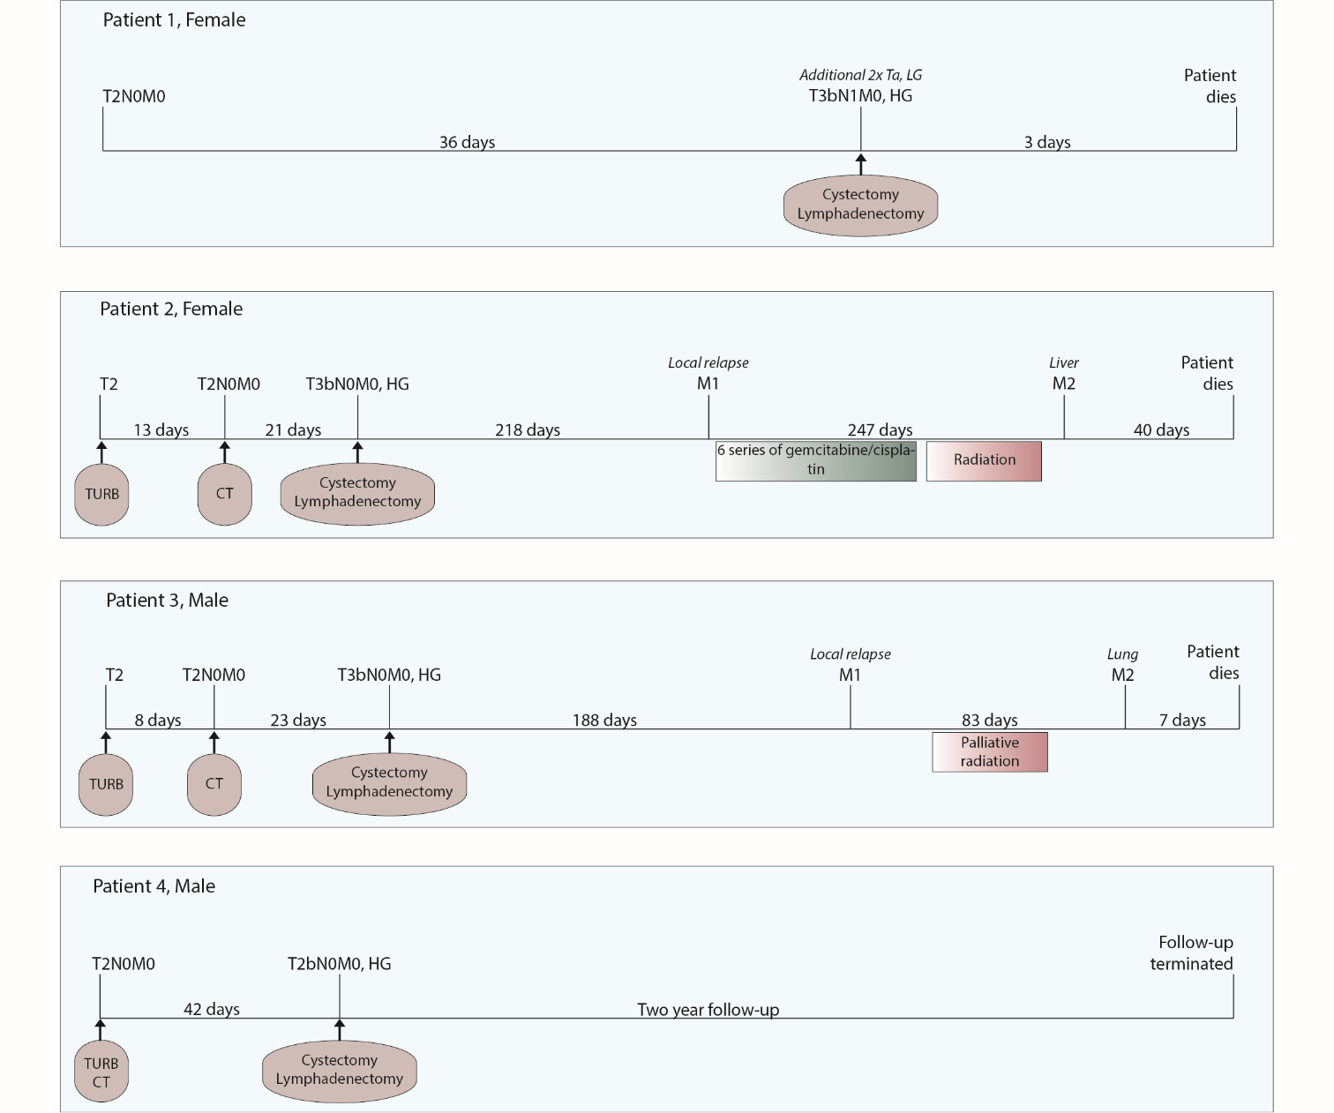
Supplementary Fig. S1: Disease courses of patients 1-4. TNM-stage for tumors at diagnosis as well as for tumors detected at follow-up visits and after cystectomy is indicated. Number of days between follow-up visits is annotated. Different treatments and examinations, including transurethral resection of bladder tumor (TURB), CT scans, cystectomy and lymphadenectomy, radiation, and chemotherapy are noted.

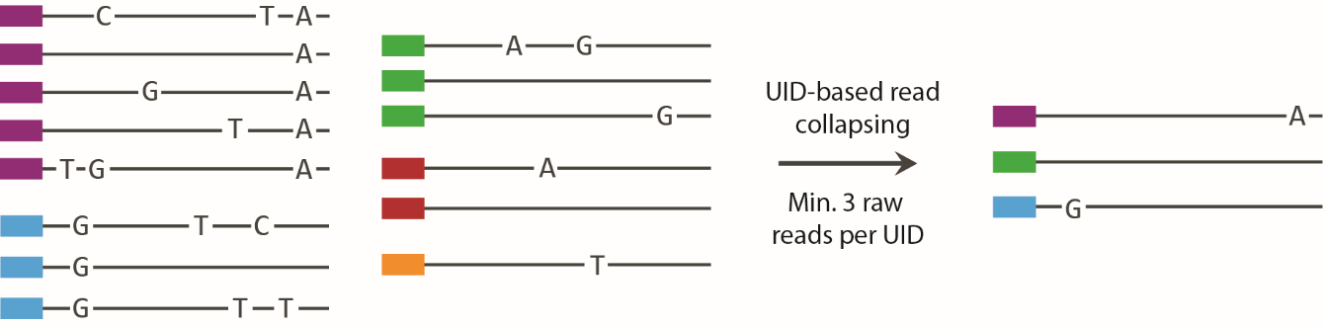
Supplementary Fig. S2: UMI-based read collapsing for reducing error-rates. Reads with identical mapping positions and UMIs are grouped and colored accordingly. Only alternate bases present in the majority of reads within a group are carried over to the final collapsed read. At least three reads were required per group to create a collapsed high confidence read.

Supplementary Fig. S3: Filtering of mutation calls. Only mutations that pass the MuTect2 filter were considered for validation and analysis. Mutations were assessed in previously generated WES data and data obtained from the targeted sequencing of tumor and normal samples to ensure the presence and/or absence in other samples. Required number of reads for different groups is indicated. All mutations were evaluated manually using Integrative Genomics Viewer (IGV). Finally, mutations were grouped into N-Mutations, S-Mutations, and T-Mutations, N-Mutations being specific for normal samples, S-Mutations being shared between normal and tumor samples, and T-Mutations being exclusive for tumor samples. Numbers of mutations from the four patients are indicated at each relevant step.

Supplementary Fig. S4: Comparison of variant allele fractions obtained from the sequencing of normal and tumor samples using cancer panel targeted sequencing and from WES of tumor samples and recurrences from patients 3 and 4. All mutations were evaluated in previously generated WES data from tumors and recurrences from patients 3 and 4. Obtained variant allele fractions are marked (yellow to red ranging from >0 to 0.6/0.7). For WES data, a minimum of five reads were required and positions not fulfilling this indicated in grey. Dark blue indicates no alternate alleles on the position. Targ. seq. = Targeted sequencing.

Supplementary Tables
Supplementary Table S1: Clinical and pathological information.
 | Patient 1 | Patient 2 | Patient 3 | Patient 4
Gender | Female | Female | Male | Male
Age at Diagnosis | 70 | 69 | 73 | 86
T Stage (Clinical) | 3b | 3b | 3b | 2b
Grade | High | High | High | High
N Status | 1 | 0 | 0 | 0
Focality | Multifocal | Multifocal | Unifocal | Unifocal
Treatment | Cystectomy + Lymphadenoectomy | Cystectomy + Lymphadenoectomy | Cystectomy + Lymphadenoectomy | Cystectomy + Lymphadenoectomy
Neo adj. Chemotherapy | - | - | - | -
Follow up (days) | 4 | 506 | 279 | 731
Relapse | - | Yes (Vagina) | Yes (Pelvis) | -
Adj. Chemotherapy | - | Gemcitabine/  Cisplatin | - | -
Time to Relapse | - | 218 | 142 | -
Died of Disease | Yesª | Yes | Yes | No
ªPatient died from complications following surgery

Supplementary Table S2: Overview of samples, cancer panel targeted sequencing, and WES
Samples | Patient 1 | Patient 2 | Patient 3 | Patient 4
Germline DNA | Leukocytes | Leukocytes | Leukocytes | Leukocytes
Samples in Normal Pool | 10 | 9 | 6 | 11
Samples in Tumor Pool (T) | 4 (2)¹ | 7 | 4 | 2
Lymph Node Metastasis (N) | 1 | No | No | No
Recurrence (M) | No | Local | Local | No
Type (T/N/M) | FF/FFPE/-² | FF/-/FFPE | FF/-/FFPE | FF/-/-

Targeted sequencing (NuGEN)
Number of Samples | 3 | 3 | 3 | 3
Bait set | NuGEN Ovation® Cancer Panel 2.0 | NuGEN Ovation® Cancer Panel 2.0 | NuGEN Ovation® Cancer Panel 2.0 | NuGEN Ovation® Cancer Panel 2.0
Mean Target Coverage (Normal Pool) (Raw/3UMI) | 1065/79 (32-116) ³ | 1036/47 (18-70)³ | 511/36 (15-53) ³ | 500/43 (18-63) ³
Mean Target Coverage (Tumor Pool)  (Raw/3UMI) | 360/47 (19-67) ³ | 483/76 (27-104) ³ | 459/64 (25-93) ³ | 526/79 (27-110) ³
Mean Target Coverage (Germline)  (Raw/3UMI) | 707/105 (49-152) ³ | 1073/129 (58-187) ³ | 442/52 (21-77) ³ | 445/70 (31-102) ³
Total Mutations | 29 | 34 | 50 | 93
Normal Mutations | 13 | 9 | 2 | 5
Tumor Mutations | 8 | 14 | 42 | 75
Shared Mutations | 8 | 11 | 6 | 13
WES (pileup)
Number of Exomes | 3 | 8 | 5 | 3
Bait set | Nextera | SeqCap_EZ | Nextera | SeqCap_EZ
Mean Target Coverage (Tumor) | 86-107x | 31-82x | 52-113x | 62-65x
Mean Target Coverage (Germline) | 109x | 55x | 52x | 72x
¹For WES (previous study), two tumor samples were pooled into Tumor Pool 1, and two other tumor samples were pooled into Tumor Pool 2.
²FF = Fresh frozen tissue, FFPE = Formalin fixed paraffin embedded tissue
³Mean (lower quartile-upper quartile)

Supplementary Table S3: Primers and probes for ddPCR analyses
Primer sequences for detection of tumor mutations in normal samples by ddPCR
Target Gene | Forward primer (5’-3’)  (Sigma Aldrich) |  | Reverse primer (5’-3’) (Sigma Aldrich) | Dual-labelled probe (5’-3’) (BioSearch) | Tm (ºC)
FGFR3 |  | CTGGTGGAGGCTGACGAG | AAGAAGCCCACCCCGTAG | FAM-AGTGTGTGTGCAGGCATCCTCA-BHQ | 61.2
PIK3CA |  | TGGAATGCCAGAACTACAATCTT | TCCAAAGCCTCTTGCTCAGT | FAM_TGACATTGCACACATTCGAAAGAC_BHQ1 | 59
CDKN1A |  | GTCCGTCAGAACCCATGC | GCCATTAGCGCATCACAGT | FAM_TCTTCGGCCCCAGTGGAC_BHQ1 | 59
STAG2 |  | CAATTGTCATTAGGCTTAGCTTTTT | GGCATGTCTCCATTTTCGAT | FAM-CCCATGACCTTTGAAAGTGGGA_BHQ | 59
RBM10 |  | CTTCAGGCCTCCCAAGGT | CATAGCCCTCATCCTGTTGG | FAM-TCCGAGGAGCGCCGGTC_BHQ1 | 59
C11orf70 |  | AGCCCCCAGATGATTTCTTT | GGACTGAAAGGTCTGGTCAAA | FAM-CCCAGGTCCAGGCAGAATCAA_BHQ1 | 59
PFKP |  | TTCTCCCCTAGGGCTACCAG | ACCTACCACTTGCAGGATGC | FAM-AGAGGCCGACTGGGAAAGTG_BHQ | 61.2
CDH11 |  | CCACCCCCTTCATCATCATA | GTGACCCTGAGAAGGCAAAA | FAM-TGATGTTCTCATGGACATCTTCTTCC_BHQ | 61.2
Chr16 |  | GGTACAAGTTGGTGTTCTGAG | GCCCAAGTGCAATCACAG | FAM-CTCTCTCAGTGGGTAGATTTGTTATCC-BHQ | -
Chr16 |  | GGTACAAGTTGGTGTTCTGAG | GCCCAAGTGCAATCACAG | HEX-CTCTCTCAGTGGGTAGATTTGTTATCC-BHQ | -
Chr3 |  | CTAGAAGATCTACCTCCAAGAGG | CCAGGCTGAAGCTATTCCAG | HEX-CTCATACATCTGGCATATGGGCTGG-BHQ | -

Primers for validation of N-Mutations by ddPCR
Target gene | Forward primer  (5’-3’)(Sigma Aldrich) | Reverse primer  (5’-3’)(Sigma Aldrich) | Dual-labelled probe  (5’-3’)(Sigma Aldrich) | Amplicon size | Tm (ºC)
EPHB4 | GAAGCCACTCGCCCACAG | GTACTCAGCATTCCTCCCCAT | FAM-TGGTCCAGGAGAGGGTGTCAGGCCC_BHQ | 105 | 65
DDB2 | GCAGGTCCTAGCAGAAGATG | TTATGCTGGTGGAGGGTCC | FAM-AGATCCTGCCACAATGCCGCAGC_BHQ | 107 | 65
EPHB2 | ATTGTCATGTGGGAGGTGAT | GATCTTCCCTCTCCCATCTG | FAM-CCTACTCGGACATGACCAACCAGGATG_BHQ | 123 | 63
Sequences for positive controls
Target gene | Forward primer (5’->3’) (Sigma Aldrich) | Amplicon size
EPHB4 | GAAGCCACTCGCCCACAGAGCCAAAAGCTGAGTAGTGAGGCTGCCGCTGGTCCAGGAGAGGGTGTCAGGCCCTAGGGGGCAAGGATGGGGAGGAATGCTGAGTAC | 105
DDB2 | GCAGGTCCTAGCAGAAGATGTGACTCAGACTGCCTCTGGGTGGGGCTGGCTGGCCCACAGATCCTGCCACAATGCCGCAGCATCGTCAGGACCCTCCACCAGCATAA | 107
EPHB2 | TTGTCATGTGGGAGGTGATGTCCTATGGGGAGCGGCCCTACTCGGACATGACCAACCAGGATGTAAGTCTCCAAGGGGATAGGCAAGGCCTCTCTGGCCCACCAGATGGGAGAGGGAAGA | 120

