SUPPLEMENTARY TABLES

Table S1: Characteristics of the full and reduced cohorts of patients
 | Full cohort (981) | Reduced cohort (586)
Age
Mean | 65.6 | 65.8
Median | 68 | 68
Min | 22 | 22
Max | 80 | 80
Gender
Male | 857 (87%) | 517 (88%)
Female | 124 (13%) | 69 (12%)
Area
1 | 222 (23%) | 116 (20%)
2 | 161 (16%) | 97 (17%)
3 | 83 (8%) | 56 (10%)
4 | 150 (15%) | 117 (20%)
5 | 363 (37%) | 199 (34%)
TG
1 (PUNLMP/TaG1) | 424 (43%) | 179 (31%)
2 (TaG2) | 292 (30%) | 214 (37%)
3 (TaG3) | 102 (10%) | 74 (13%)
4 (T1G2) | 28 (3%) | 13 (2%)
5 (T1G3) | 129 (13%) | 102 (17%)
6 (Tis) | 6 (1%) | 4 (1%)
Risk
High | 340 (35%) | 250 (43%)
Low | 641 (65%) | 336 (57%)

Table S2: Cox regression analysis results displaying association of CD8 infiltration with risk of recurrence in the T1 cohort with 2 spots available (N=67). Reduced number of events (11 recurrences) only allowed adjustment for 3 variables.

 | HR | p-value |  | lower 95 | upper 95
Number of CD8
<35/mm² | Ref
≥ 35 /mm² | 0.36 | 0.13 |  | 0.07 | 1.40
Multiplicity
1 tumor | Ref
≥ 2 tumors | 3.70 | 0.06 | . | 0.95 | 14.47
Missing | 1.15 | 0.92 |  | 0.11 | 11.79
Size
< 3cm | Ref
≥ 3cm | 4.40 | 0.06 | . | 0.90 | 21.51
Missing | 1.71 | 0.52 |  | 0.33 | 8.95

SUPPLEMENTARY FIGURES
Figure S1: Correlation between maunal and automated counting of lymphocytes in the tumor compartment
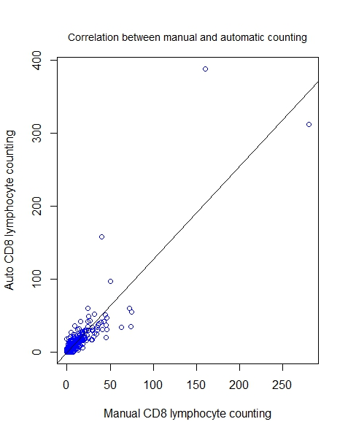

Figure S2 : Boxplots figuring CD8+ count Interquartile range in the stroma compartment in Ta and T1 tumors.

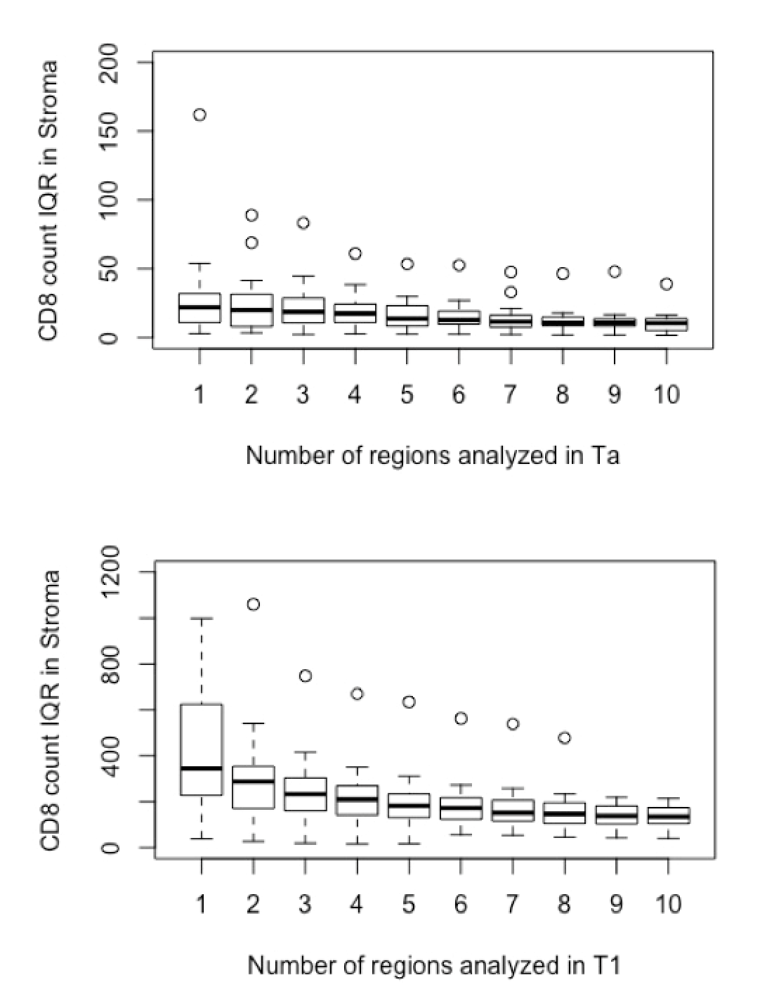

Figure S3 : Histograms showing the distribution of GATA3, FGFR3 and CK5/6 expression in the EPICURO cohort.

