**ELECTRONIC SUPPLEMENTARY INFORMATION AND DATA**

## *Xcalibur applicationfor TS-MS data analysis, expanded methods section*

Xcalibur (Thermo Fisher Scientific, Waltham Massachusetts) software was used to process data from each touch. Mass spectral selection from each total ion current (TIC) was performed as follows. The TIC maximum normalized peak was first evaluated. Each mass spectrum within the TIC maximum peak was individually evaluated for an abundance of 103 instrument counts or greater. If no mass spectral signal was detected, or if the mass spectral signal intensity was not greater than three times the noise qualitatively determined from the baseline of the spectrum or did not include mass spectral peaks in the phospholipid region, the mass spectrum was rejected. If each mass spectrum of the TIC maximum peak were rejected, each peak in the TIC was evaluated in a similar fashion. If all evaluated TIC peaks were rejected, the data for this touch were excluded. If more than one mass spectrum of a touch was accepted, TIC adjacent mass spectra were averaged and the average mass spectrum was exported to Excel (Microsoft, Spokane, WA USA). TIC non-adjacent mass spectra were individually exported to Excel.

Xcalibur was used to export average mass spectrum for each grouping of mass spectra. Each average mass spectrum (list of *m/z* values and ion abundances) was imported into Excel. Each average mass spectrum was subjected to standard normal variate (SNV) transformation in MATLAB (The MathWorks, Inc., Natick, MA USA). SNV transformation calculates the average and standard deviation of all data points in a mass spectrum and subtracts each data point from the mean and divides each data point by the standard deviation. All spectra were mean-centered for the same *m/z* value across all mass spectra.

## *Principal Component Analysis (PCA), expanded methods section*

An in-house program was used to convert Xcalibur MS data files (*.raw) into ASCII files (*.txt). ASCII files were imported into Excel spreadsheets which were used to import the data into MATLAB. For TIC normalization, in-house scripts or Excel were used to normalize each average mass spectrum by the spectrum’s total ion current. All spectra for each DESI and TS dataset were mean-centered (i.e., column centered) for the same *m/z* value across all mass spectra. PCA was performed on TIC normalized, mean-centered data for DESI datasets. In other analyses, as an alternative to TIC normalization, DESI datasets were pretreated by standard normal variate (SNV) transformation and provided similar results. PCA was performed on SNV, mean centered data for TS datasets.

## *Principal Component Analysis - Linear Discriminant Analysis (PCA-LDA), expanded methods section*

Models were built using all of the objects based on each analyzed target set. Linear Discriminant Analysis (LDA) was applied to the DESI target datasets of TIC normalized, mean centered mass spectra after compression by PCA, thereby using as variables the principal components instead of the original mass spectral data. LDA was performed as a supervised discriminant classification technique. Discriminant methods look for a delimiter that divides the global domain into a number of regions, each assigned to one of the classes. This delimiter identifies an open region for each class and such regions determine the assignment of the data (mass spectra) to one of the classes [12]. Model validation, specifically evaluation of the predictive ability of the model, was performed by means of cross-validation (CV) [12]. For this study, a selected number of cross-validation deletion groups were utilized, meaning that all of the mass spectra (DESI dataset n=50 and TS dataset n=151) were divided systematically and by a selected number of times into a deletion group and retained group, with each mass spectrum being in the deletion group only once. A deletion group involves selecting a portion of the dataset. The retained group is used to cross validate the deletion group. This process is performed the selected number of times.

LDA models used for supervised discriminant classification were built using two to six principal components. The models were chosen to provide the least number of false results (e.g., highest prediction rates) in cross validation and where the cumulative variance of the number of chosen principal components (PCs) suggests inclusion of substantially signal and not substantially noise.

*PCA-LDA on DESI-MSall samples, expanded methods and results*

PCA-LDA was also performed on the same dataset of DESI-MS average mass spectra to quantify the separation between normal urothelium, high-risk breed InvUC and low-risk breed InvUC. The dataset including distinct InvUC and distinct urothelial average mass spectra from DESI-MS negative mode *m/z* range 277 – 286 and 557 – 568. By “distinct” we mean that histopathology characterized each averaged mass spectrum as including only InvUC or normal urothelial tissue. For this DESI three class model, high InvUC risk breeds’ averaged mass spectra included fourteen averaged mass spectra (n=14). Low InvUC risk breeds’ averaged mass spectra and normal urothelial average mass spectra each included nine averaged mass spectra (n=9). We recognize the limited number of data points used as the basis for PCA-LDA and hypothesize that larger data sets and more detailed pathological evaluation could improve classification of InvUC and normal average mass spectra. The first four PCs were used for classification. The first four PCs provided 90% of the cumulative variance. More than four PCs did not substantially increase the prediction rates for any class. Four cross-validation deletion groups were used. Four or more cross validation deletion groups did not substantially increase the prediction rates for any class.

*PCA-LDA of TS-MS data, expanded methods*

PCA-LDA was performed on the selected dataset of TS-MS mass spectra to quantify the separation between normal urothelium and InvUC. The selected dataset included homogeneous InvUC and normal urothelial mass spectra using selected peaks from TS-MS negative mode *m/z* range 277 – 286 and 557 – 568. By homogeneous we mean that histopathology characterized the touch including only InvUC or normal urothelial tissue. For this TS two-class model, normal urothelial mass spectra included fifty-one mass spectra (n=51) and InvUC mass spectra included one hundred mass spectra (n=100). The first five PCs were used for classification. More than five PCs did not substantially increase the prediction rates for both classes (normal urothelium and InvUC). Five cross-validation deletion groups were used. The first five PCs provided 77.4% of the cumulative variance. Five or more cross validation deletion groups did not substantially increase the prediction rates for either class (normal urothelium or InvUC).

PCA-LDA was performed on the same dataset of DESI-MS average mass spectra including unknown breeds to quantify the separation between normal urothelium and InvUC. The dataset included homogeneous InvUC and normal urothelium average mass spectra from DESI-MS negative mode *m/z* range 277 – 286 and 557 – 568. For this DESI two class model, InvUC averaged mass spectra included forty-one averaged mass spectra (n=41). Normal urothelium average mass spectra included nine averaged mass spectra (n=9). We recognize the limited number of data points used as the basis for PCA-LDA and hypothesize that larger data sets and more detailed pathological evaluation might improve classification of InvUC and normal average mass spectra. The first four PCs were used for classification. The first four PCs provided 87.4% of the cumulative variance. More than four PCs did not substantially increase the prediction rates for any class. Five cross-validation deletion groups were used. Four or more cross validation deletion groups did not substantially increase the prediction rates for any class.

# *Supplementary data - progression of analysis of TS-MS data*

PCA of TS-MS data was first performed on the entire mass spectral range (*m/z* 200 – 1000) (Supplemental Fig. S1). Although there was not a clear distinction between InvUC and normal urothelium using this broad range, peaks of interest emerged.1 In the next step in the progression of the analysis, the data range was narrowed to focus on areas where the peaks (*m/z* values)[1] substantially contributed to the separation (as characterized by *m/z* peak loops emanating from the origin in the same orientation as the axis of separation between InvUC and normal urothelium). For example, *m/z* 281.5 (oleic acid) and *m/z* 563.5 (oleic acid dimer) for abundance in InvUC were selected, among others. PCA was performed on TS-MS data using selected peaks within negative mode *m/z*range 252 – 888[2], as illustrated by Supplemental Fig. S2. A combination of principal components were identified in Supplemental Fig. S2 score plot that substantially increased separation of InvUC and normal urothelial average mass spectra relative to Supplemental Fig. S1. As *m/z* 281.5 (oleic acid) and *m/z* 563.5 (oleic acid dimer)were the principal *m/z* values substantially contributed to separation between InvUC and normal, only ranges including those peaks were used providing the results shown in Fig. 2 in the main body of the paper. For convenience, this same figure (Fig. 2, body of the paper) is also included as Supplemental Fig. S3 along with an expanded loading plot.



**S1B**

**S1A**

Supplemental Fig. S1.In A, the PCA score plot (PC1 vs. PC5) displays little separation of InvUC from normal urothelial tissue using m/z range 200 – 1000 acquired by TS-MS negative mode. Normal urothelial mass spectra are represented by green circles; InvUC mass spectra are represented by red triangles. In B, the PCA loading plot (PC1 vs. PC5) shows minimal differentiation based on m/z 563 (oleic acid dimer) (shown in negative PC1 and near zero PC5 coefficients) and m/z 281.d (oleic acid) (shown in negative PC1 and positive PC5 coefficients) when data from the entire range (m/z 200 – 1000) were included. Please note that m/z 311, 325, and 339 (positive PC1 and negative PC5 coefficients) are background peaks.

**S2BB18**

**S2A7**

**S2A S2B**

Supplemental Fig. S2.A. PCA score plot (PC1 vs. PC4) displays substantial separation of InvUC from normal urothelial tissue using selected peaks from TS-MS negative mode m/z range 252 – 888[3]. Normal urothelial mass spectra are represented by green circles; InvUC mass spectra are represented by red triangles. In B, the PCA loading plot (PC1 vs. PC4) shows substantial differentiation based on m/z 563 (oleic acid dimer) (shown in negative PC1 and PC4 coefficients) and m/z 281 (oleic acid) (shown near zero PC1 coefficients and positive PC2 coefficients).



**S3B20**

**S3A19**

Supplemental Fig. S3.A. PCA score plot (PC1 vs. PC4) displays substantial separation of InvUC from normal urothelial mass spectra using selected peaks from TS-MS negative mode m/z range 277 – 268 and 557 - 568. Normal urothelial mass spectra are represented by green circles; InvUC mass spectra are represented by red triangles. B. The PCA loading plot (PC1 vs. PC4) distinguishes InvUC from normal urothelium based on m/z 563 (oleic acid dimer) (shown in negative PC1 and PC2 coefficients) and m/z 281 (oleic acid) (shown positive PC1 coefficients and positive and negative PC4 coefficients).

# *TS-MS supplementary data analysis*

Supplemental Fig. S4 and S5 illustrate the different values obtained between InvUC and normal urothelial mass spectra for values around *m/z* 281.5 and *m/z* 563. One Way ANOVA of summed *m/z* 562 to 564.5 for TIC normalized and mean centered normal urothelial and InvUCmass spectra yielded a p value of 4 * 10-14. One Way ANOVA of the maximum value within the range of *m/z* 281 to 283 for TIC normalized and mean centered normal urothelial and InvUCmass spectra yielded a p value of 4 * 10-10. One Way ANOVA of integrated *m/z* 281 to 283 for TIC normalized and mean centered normal urothelial and InvUCmass spectra yielded a p value of 1.1 * 10-6.

**S4**

Supplemental Fig. S4. The plot displays averaged InvUC and normal urothelial mass spectra from m/z 557 to m/z 568.

**S5**

Supplemental Fig. S5. The plot displays averaged InvUC and normal urothelial mass spectra from m/z277 to m/z285. Note the peak at 281.5 in InvUC and the peak of 283.5 in the normal urothelium. As noted in the Figure 2 legend, m/z 283.5 was particularly high in two samples from normal urothelium, and not as high in other normal samples. This plot excludes those two samples “DN” and “EA”.

# *DESI-MS supplementary data analysis*

In the analysis of the DESI-MS data, a trend was observed for differences between the InvUC spectra in dogs in high-risk breeds compared to dogs in low-risk breeds. The trend was for *m/z* 281.5 and *m/z* 563.5 to be even more abundant in high-risk breeds than in low-risk breeds (Fig S6). This finding was in addition to the finding of *m/z* 281.5 and *m/z* 563.5 being more abundant in InvUC (across all breeds) than in normal urothelium. The differences in the spectra between breeds was not observed in TS-MS data. This is not unexpected because TS-MS analysis is based on less data than DESI-MS analysis.

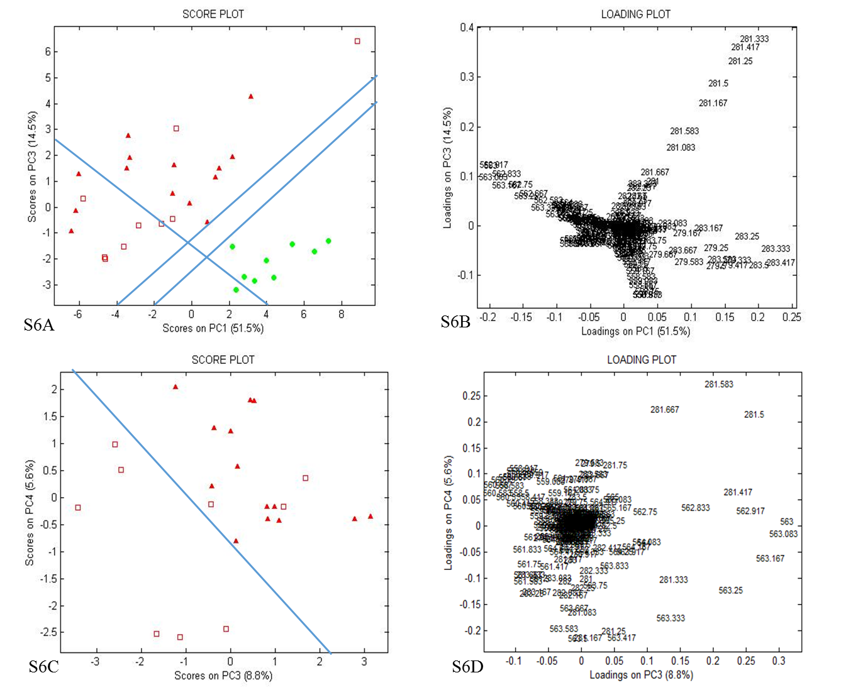

Supplemental Fig. S6. PCA score plot and loading plot for DESI-MS negative mode data *m/z* range 277 – 286 and 557 – 586, from canine InvUC from high-risk breeds (solid red triangles), low-risk breeds (open red squares), and from normal urothelium (green circles). A. PCA score plot (PC1 vs. PC3) demonstrates the separation between the average mass spectra from InvUC vs normal urothelium. There is a possible trend towards separation of the InvUC spectra based on high-risk vs low-risk breed dogs. An InvUC / normal urothelium dividing region consisting of a pair of dividing lines runs from Cartesian coordinates -2,-4 to 10,4 and -4,-4 to 10,5. An InvUC subgroup (high-risk breed / low-risk breed) dividing line runs substantially orthogonal to the InvUC / normal dividing line, 4,-4 to -8,4. In B, the PCA loading plot (PC1 vs. PC3) substantially distinguishes disease state (tumor vs normal) based on *m/z* 283.5 (shown in positive PC1 and near zero PC3 coefficients) and based on *m/z* 563.5 (shown in negative PC1 and near zero PC3 coefficients). C. PCA score plot (PC3 vs. PC4) correlates well to distinguish samples from high-risk breeds from low-risk breeds. A breed risk dividing line runs from Cartesian coordinates (-4,2.5) to (2,-3). D. PCA loading plot (PC3 vs. PC4) distinguishes high-risk breed InvUC from low-risk breed InvUC based on *m/z* 281.5 (shown in positive PC3 and positive PC4 coefficients) and on *m/z* 563 (shown in positive PC3 and negative to near zero PC4 coefficients).

1. Selected *m/z* values included 252 – 258, 262 – 268, 277 – 286, 294 – 300, 301 – 314, 322 – 328, 336 – 342, 532 – 542, 557 – 568, 580 – 590, 604 – 610, 726 – 734, 750 – 762, 770 – 776, 785 – 791, 807 – 816, 835 – 847, 860 – 866, and 882 – 888.
2. Selected *m/z* values included 252 – 258, 262 – 268, 277 – 286, 294 – 300, 301 – 314, 322 – 328, 336 – 342, 532 – 542, 557 – 568, 580 – 590, 604 – 610, 726 – 734, 750 – 762, 770 – 776, 785 – 791, 807 – 816, 835 – 847, 860 – 866, and 882 – 888.
3. Selected *m/z* values included 252 – 258, 262 – 268, 277 – 286, 294 – 300, 301 – 314, 322 – 328, 336 – 342, 532 – 542, 557 – 568, 580 – 590, 604 – 610, 726 – 734, 750 – 762, 770 – 776, 785 – 791, 807 – 816, 835 – 847, 860 – 866, and 882 – 888.