SUPPLEMENTARY INFORMATION

Improved Stroke Onset Time Determination Using MRI Relaxation Times without Non-Ischaemic Reference Data in a Rat Model of Focal Brain Ischaemia

Terence J T Norton, Marcelo Pereyra, Michael J Knight, Bryony McGarry, Kimmo Jokivarsi, Olli HJ Gröhn and Risto A Kauppinen

Estimators using signal intensities
An investigation into using the distributional parameters of echo and spin-lock -summed signal intensities of $T_{2}$ and $T_{1ρ}$ within ischaemic tissue as predictors of stroke onset was also considered. As indicated by Figure S1A-S1B, the empirical distributions display a significant lack of time-dependence, i.e. little or no drift and spread between time-points. As a result, the corresponding multiple linear regressions were found to be too insensitive in predicting stroke onset (Figures S1C-S1D).

Alternative reference region selection
In order to demonstrate the potential pitfalls associated with reference-dependent methods, and the impact these have on designing robust estimators, we also considered the design of $ΔT_{2}$ and $ΔT_{1ρ}$ estimators that use a ‘randomly-shifted’ contra-lateral reference region (see Figure S2), i.e. taking the original reference and randomly shifting its centre-of-mass (ignoring any ischaemic tissue overlap and voxels outside of the brain).
The differences between the empirical distributions (and consequently the fitted log-logistic distributions) of $T_{2}$ and $T_{1ρ}$ within the original and randomly shifted references were found to be quite pronounced (cf. Figures S3A and S3B).
In particular, the shift and spread behaviour appears to change dramatically between time-points leading to highly variable estimates for the MR parameters of healthy tissue (which should otherwise be effectively constant).
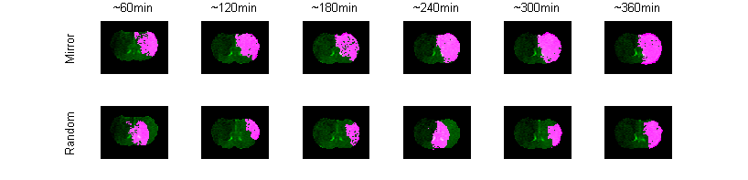
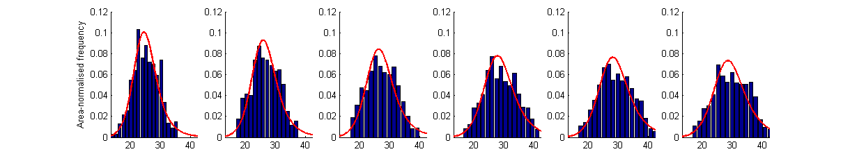
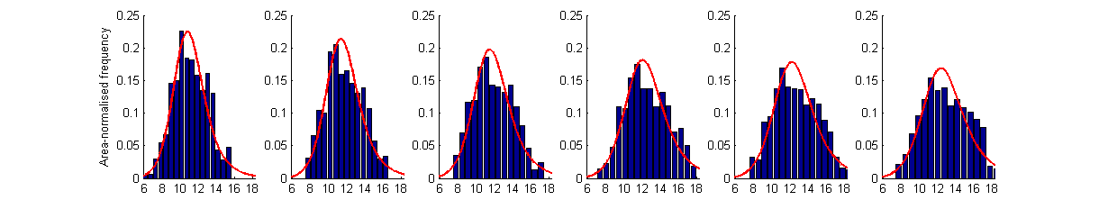
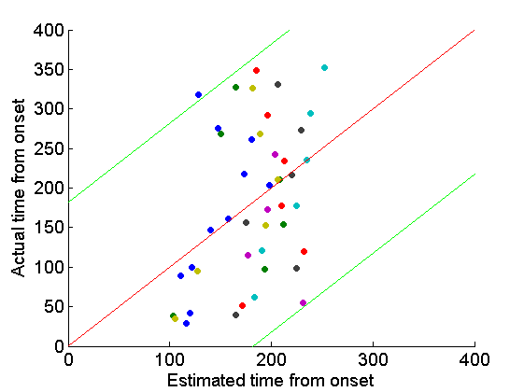
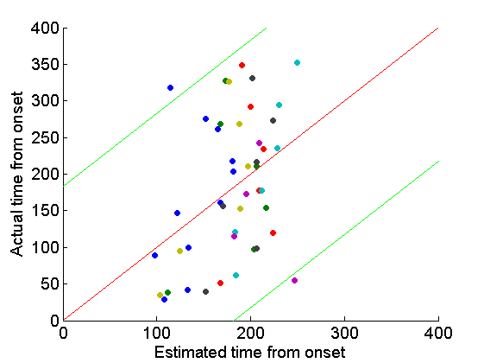
Figure S2: Reference region masks. (TOP) Original contra-lateral reference. (BOTTOM) Randomly shifted reference.
Figure S1: Distributions of (A) $T_{2}$ echo-summed signal intensities and (B) $T_{1ρ}$ spin-lock-summed signal intensities within ADC lesion of a typical rat (cf. Figure 1A) across multiple time-points. The corresponding regression estimators are shown in (C)-(D). $T_{2}$ echo-summed regression is given in (C) and $T_{1ρ}$ spin-lock-summed regression is given in (D). 95% prediction intervals are given by green curves. Zero residual error is indicated by red curves. Coloured dots correspond to estimates from individual rats.
(A)
(B)
(C)
(D)
A direct consequence of having an unreliable average estimator of the reference region is a poor predictor for stroke onset as indicated in Figures S3C and S3D where RMSEs for $ΔT_{2}$ and $ΔT_{1ρ}$ were reported (for this specific case) as ±79mins and ±64mins respectively.

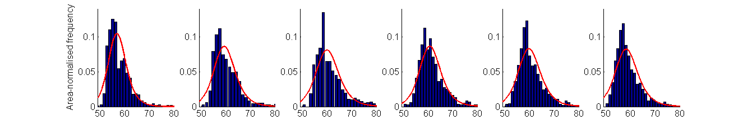
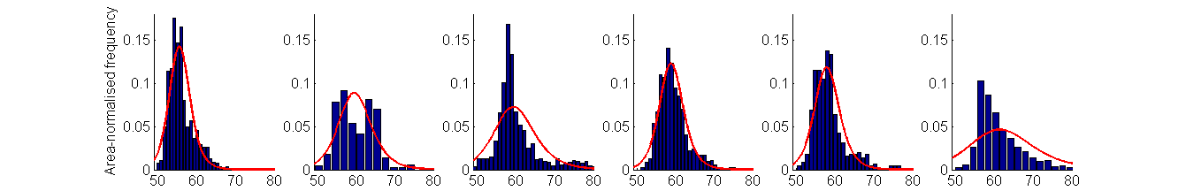
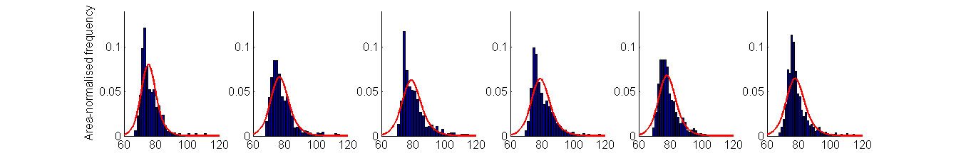
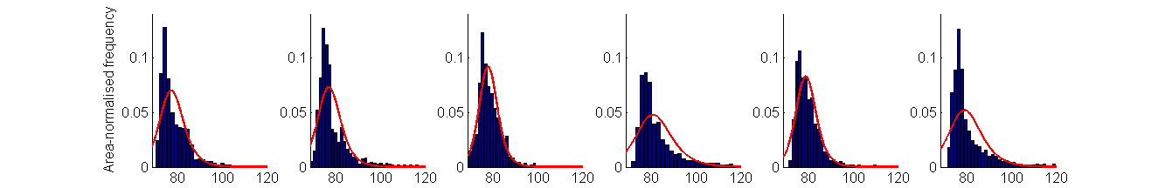
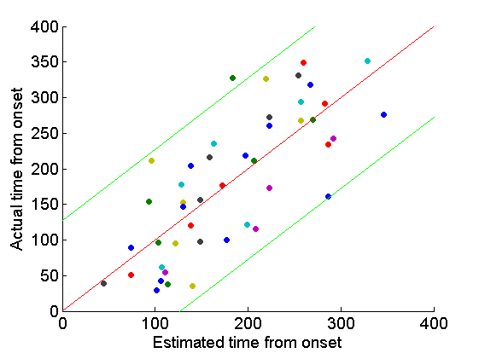
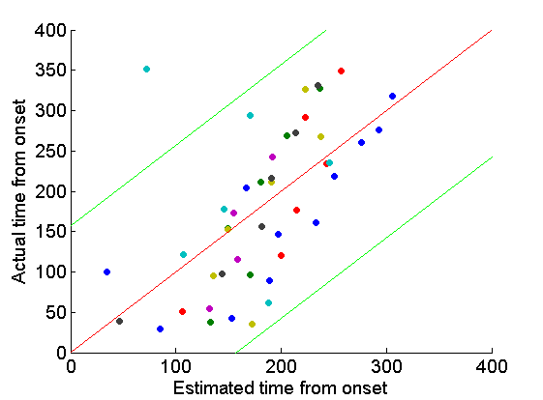
(A)
(B)
(C)
(D)
Figure S3: Distributions of (A) $T_{2}$ within contra-lateral reference (TOP) and randomly shifted reference (BOTTOM), and (B) $T_{1ρ}$ distribution within contra-lateral reference (TOP) and randomly shifted reference (BOTTOM). Regression estimators based on randomly shifted reference regions are shown in (C)-(D). $ΔT_{2}$ regression is given in (C) and ${ΔT}_{1ρ}$ regression is given in (D). 95% prediction intervals are given by green curves. Zero residual error is indicated by red curves. Coloured dots correspond to estimates from individual rats.

