Appendix I – Topic Guide for PwA Interview

Questions for people with aphasia:

- Demographics - age; location in Ireland
- Tell me about how you like to socialise with friends or family.
- Tell me if this has changed because of Covid-19
- Are there any places that you go to socialise with other people with Aphasia right now?
- Have you heard of the Aphasia Café/ Tell me about the aphasia café
- Have you been to the aphasia café in person? What are the advantages and disadvantages of attending the aphasia café in person?
- What could we do to make the in- person aphasia café better for people with aphasia?
- The aphasia café has moved online. This is because of Covid-19. What are the advantages and disadvantages of attending the aphasia café online?
- What could we do to make an online aphasia café better for people with aphasia?
- There hasn’t been an event for people with aphasia in Ireland yet. Would you be interested in going to an event specifically for people with aphasia?
- What would you like to see at this event? (Talks by experts, people with aphasia, demonstrations of hobbies?)
- How far would you travel to come to this event?
- Is there anything else you would like to discuss?

Appendix II – Topic Guide for SLTS Interview

Semi-Structured Interview Guide for Speech and Language Therapy Student

- Demographics – age; location in Ireland; year in Speech and Language Therapy course.
- How do you typically like to socialise outside of college/work?
- With your family
- With friends
- How has this been impacted by COVID-19?
- How has your social life changed with the COVID-19 restrictions and gradual easing of these? Are you reluctant to socialise again?
- What places in your area would you typically go to socialise?
- What have you learnt/what do you know about Aphasia?
- What do you know about the Aphasia café?
- Have you heard of other healthcare students talk about the Aphasia café? What have they said?
- If you have attended the Aphasia café (either online/in-person), what has your own experience of this been?
- What do you think would prevent healthcare students from attending the Aphasia café online/in person?
- As the Aphasia café has moved online due to COVID-19, what do you think the advantage and disadvantages of this are from the student perspective? How does this compare to being face-to-face?
- What do you think would encourage Speech and Language Therapy students to attend the Aphasia café online/in-person?
- What do you think would prevent students from attending the Aphasia café online/in person?
- What do you think the advantage and disadvantages of having the Aphasia café online are for people with aphasia? How does this compare to being face-to-face?
- What do you think would encourage more people with Aphasia to attend the Aphasia café online/in-person?
- If there was a user-led event/conference planned for people with Aphasia, what do you think people with Aphasia would like to see at such an event?
- What supports do you think people with Aphasia would need to attend/get involved in such an event?
- What do you think would be required to make such an event successful/beneficial for people with Aphasia?
- What role would you see for Speech and Language Therapists in supporting a user-led event in Ireland for people with aphasia?
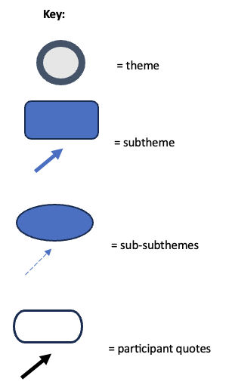
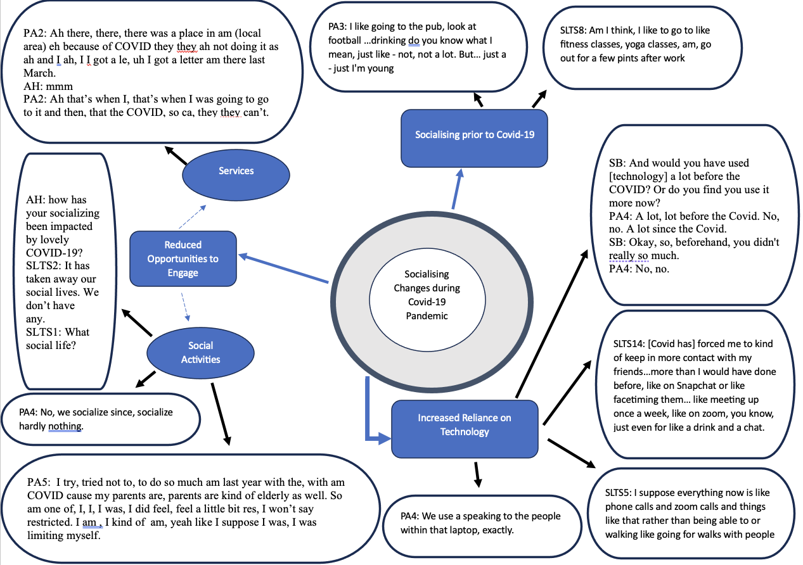
Appendix III – Themes, Subthemes and Sub-subthemes

