Supplementary Material for:
Muscle-derived proteins as serum biomarkers for monitoring disease progression in three forms of muscular dystrophy
Peter M. Burch^{1*}, Oksana Pogoryelova^{3*}, Richard Goldstein¹, Donald Bennett², Michela Guglieri³, Volker Straub³, Kate Bushby³, Hanns Lochmüller³, Carl Morris²
¹ Worldwide Research & Development, Pfizer Inc., Eastern Point Rd, Groton, CT, USA, ² Worldwide Research & Development, Pfizer Inc., 610 Main St., Cambridge, MA, USA, ³ John Walton Muscular Dystrophy Research Centre, Institute of Genetic Medicine, Newcastle University, Newcastle upon Tyne, UK, *These authors contributed equally to this work
Supplementary Material and Methods:
Protein sequence alignments. Sequence alignments were done using BLASTP 2.2.30. The accession numbers of the sequences used for troponin I, fast skeletal muscle were NP_05881 (rat), NP_001139313 (human), XP_851068 (canine) and NP_033431 (mouse). The accession numbers of the sequences used for myosin light chain 3 were NP_036738 (rat), NP_000249 (human), XP_533849 (canine) and NP_034989 (mouse). The accession numbers for fatty acid binding protein 3 were NP_077076 (rat), NP_004093 (human), XP_5335331 (canine) and NP_034304 (mouse). The accession numbers for creatine kinase M-type were NP_036662 (rat), NP_001815 (human), XP_533641 (canine) and NP_031736 (mouse).
SDS-PAGE and Western blotting. Purified recombinant MYC/DDK-tagged sTnI, CKM, Myl3 and FABP3 (catalog # TP305676, TP302721, TP303122, TP302737, respectively) were purchased from Origene Technologies, (Rockville, MD). Protein samples were diluted in NuPAGE LDS sample buffer and heated at 70ºC for 5 min. Samples were cooled on ince for 5 min then resolved on NuPage 4-12% Bis-Tris gels along with Precision molecular weight standards (Biorad, Hercules, CA) under reducing conditions. Silver staining was done using the SilverXpress staining kit as per manufacturer’s instructions. The SDS-PAGE reagents and silver staining kit were purchased from Life Technologies, Grand Island, NY. For the Flag-tag Western blot the separated protein samples were transferred to polyvinylidene fluoride membranes (Bio-rad, Hercules, CA) and blocked with a solution of 5% dry milk in Tris-buffered saline, pH 8.0 with 0.1% Tween-20 (TBST, Cell Signaling, Danvers, MA). The blocked membranes were probed with 0.5 µg/ml of the anti-FLAG M2 mouse monoclonal (Sigma-Aldrich, St. Louis, MO) diluted to in TBST with 5% bovine serum albumin (Sigma-Aldrich, St Louis, MO), washed with TBST and detected with an anti-mouse monoclonal conjugated to horse radish peroxidase (GE Healthcare, Pittsburgh, PA) diluted 1:20,000 in TBST with 5% milk. Membranes were developed with SuperSignal West Dura chemiluminescent substrate (Thermo Scientific, Rockford, IL) and imaged using a Fujifilm LAS-3000 digital darkroom.
Animal Serum Samples. Nine to ten week old C57BL/10ScSn-Dmd^{mdx}/J and C57BL/10 mice were obtained from Jackson Laboratories (Bar Harbor, Maine). Serum from the Golden Retriever Muscular Dystrophy canine model ages two weeks (N=3), five months (N=1) and 18 months (N=1) were a gift from Dr. H. Lee Sweeney at the University of Pennsylvania. Serum from unaffected dogs from the same colony ages 12-18 months (N=2), four to five years (N=4) an nine years (N=1) were also provided. All animals were handled in compliance with the NIH and institutional guidelines that were approved by the Institutional Animal Care and Use Committee of the University of Pennsylvania or Pfizer, Inc (Groton, CT).
Muscle protein immunoassay. The mdx mouse serum samples for sTnI, FABP3, Myl3 were quantified using the Meso Scale Discovery (MSD, Rockville, MD) Muscle Injury Panel 3 reagent kit (catalog # K15186C) as per the manufacturer’s instructions. The GRMD serum samples and purified proteins were quantified as described in the Materials and Methods section. All analyses and graphs were generated with Graphpad Prism version 6.03. Comparisons between groups were made using the t-test after log transformation of the data or the Mann-Whitney Test.

Supplementary Figures:
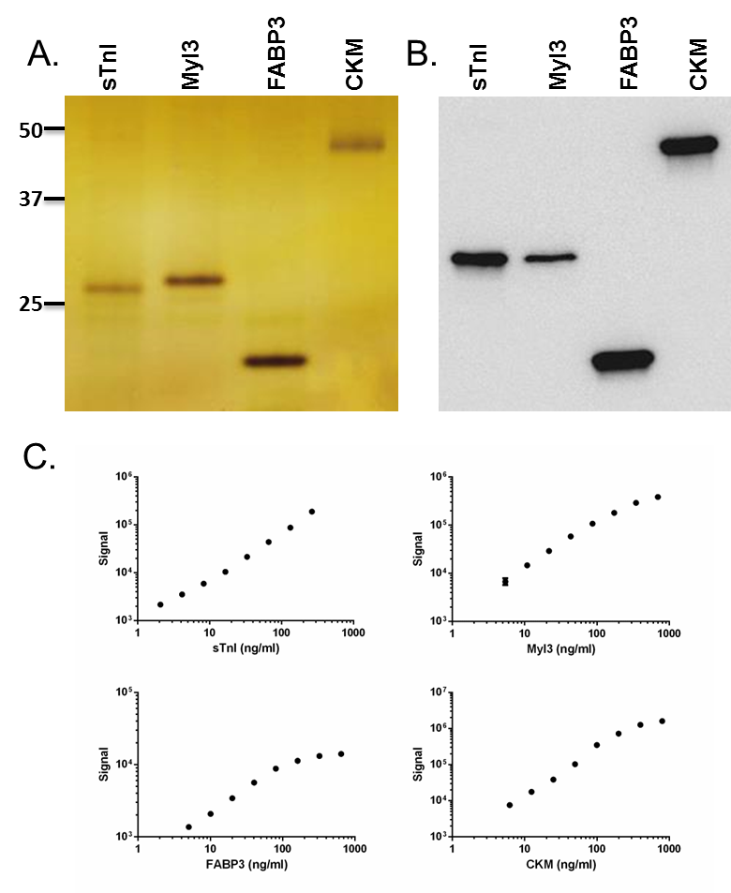
Fig. S1 Characterization of the assay using purified human proteins. (A) Ten nanograms of each protein were resolved by SDS-PAGE and Silver stained. The numbers on the left of the gel image are the molecular weight in kilodaltons corresponding to position of the protein standards that were resolved with the purified proteins (B) Twenty-five nanograms of each protein was resolved by SDS-PAGE followed by Western blotting. The blot was then probed with an anti-Flag antibody. (c) Representative dilution linearity results are shown. Serial dilutions of each purified protein were tested in duplicate and the concentration of each protein sample tested was plotted against the signal (relative light units) detected after log transformation of the data

Fig. S2 Serum biomarker concentrations in mdx mice. Serum biomarker protein concentrations for C57Bl/10 healthy control and mdx mice are shown. The serum concentrations measured for individual mice are shown with the line and error bars showing the mean and standard deviation of the group for each biomarker. *** p< 0.001; **** p< 0.0001

Fig. S3. Serum biomarker concentrations in GRMD dogs. Serum biomarker protein concentrations for GRMD dogs and healthy littermate controls are shown. The serum concentrations measured for individual dogs are shown with the line and error bars showing the mean and standard deviation of the group for each biomarker. **** P< 0.0001
Fig. S4 Serum biomarker levels are not significantly different in DMD patients treated and not treated with corticosteroids. Serum concentrations of sTnI, Myl3, FABP3, CKM and total CK activity in DMD patients treated (N=64) and not treated (N=11) with corticosteroids is shown. For each box and whisker plot the line inside the box represents the median of the group, the bottom and top of the box represents the first and third quartiles, and the whiskers denote the minimum and maximum values in each data set

Fig. S5 Scatterplots of serum biomarker concentration correlations with NSAA in DMD patients. NSAA score with non-ambulant DMD patients assigned a NSAA score of zero included in the analysis was graphed versus the serum concentrations of sTnI, Myl3, FABP3, CKM and total serum CK. The Spearman’s correlation coefficient (r), P value (p) and number of patients in the sample set (n) is shown for each analysis
Fig. S6 Scatter plots of protein serum concentrations and FVC in BMD patients. A graph of FVC measurements versus serum concentrations of sTnI, Myl3, FABP3, CKM and total serum CK for each BMD is shown. The Spearman’s correlation coefficient (r), P value (p) and number of patients in the sample set (n) is shown for each analysis

Supplementary Tables:
Table S1 Percent homology of skeletal muscle proteins in different species compared to the rat proteins.
 | Amino acid identity compared to rat (%)
Protein | Human | Canine | Mouse
Troponin I, fast skeletal muscle | 96 | 94 | 99
FABP3 | 89 | 89 | 94
Myl3 | 87 | 87 | 97
Creatine kinase-M type | 96 | 96 | 99
The NCBI reference protein amino acid sequences of rat sTnI, FABP3, Myl3 and CK-M were aligned to the human, canine and mouse proteins and the percent identity of each is reported

Table S2 Comparison of the serum biomarker concentrations in the different types of muscular dystrophy.
Biomarker | DMD  vs BMD | DMD vs  LGMD2B | LGMD2B  vs BMD
sTnI | **** | * | *
Myl3 | ns | ns | ns
FABP3 | ns | ns | *
CKM | ** | ns | ns
CK activity | ** | ns | ns
The level of statistical significance for the comparisons of the serum biomarker concentrations or total serum CK activity between the three types of muscular dystrophy was determined. Green denotes that there was and red denotes that there was not a statistically significant difference observed. Note that in cases of statistical significance the muscular dystrophy type listed first in the column title had the greater average serum concentration. * p< 0.05, ** p< 0.01, **** p< 0.0001 and ns = not significant

Table S3 Annual rate of decrease in serum protein concentrations in DMD, BMD and LGMD2B patients.
MD Type | FABP3 | Myl3 | sTnI | CKM | CK
DMD | -0.102± 0.012 | -0.146 ± 0.013 | -0.146 ± 0.018 | -0.186 ± 0.013 | -0.182 ± 0.014
BMD | - 0.001 ± 0.005 | -0.005 ± 0.007 | -0.028 ± 0.009 | -0.040 ± 0.011 | -0.031 ± 0.007
LGMD2B | -0.062 ± 0.009 | -0.020 ± 0.005 | -0.021 ± 0.004 | -0.058 ± 0.009 | -0.052 ± 0.008
The age of each muscular dystrophy patient in years was plotted versus the serum biomarker concentration and total serum CK activity after natural log transformation. The data in the table is the slope of the line generated by linear regression analysis, which approximates the annual rate of decrease in the biomarker serum concentrations for each patient group

