Supplementary Material
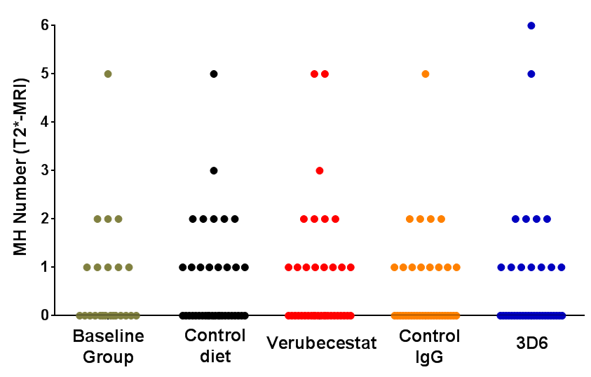
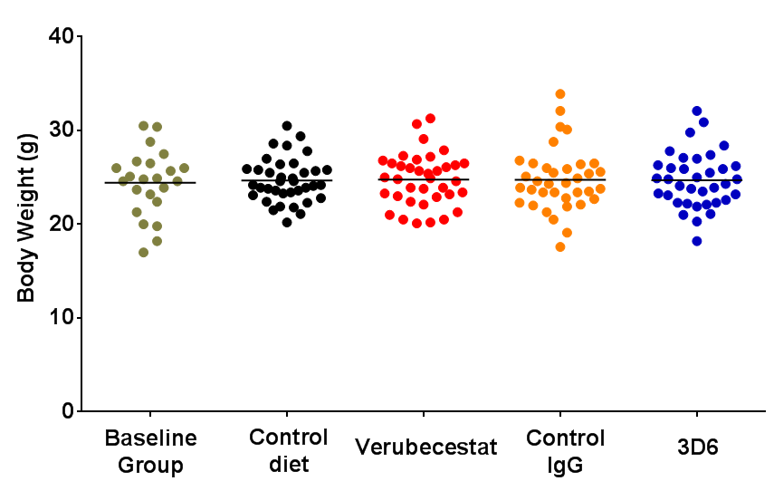
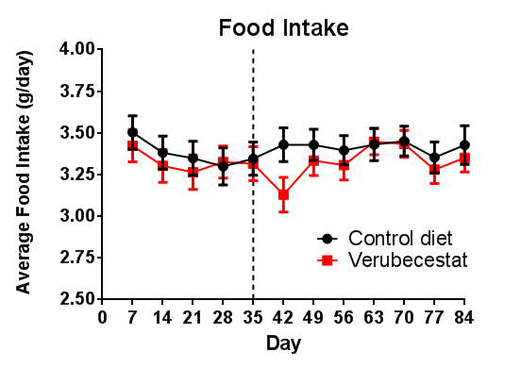
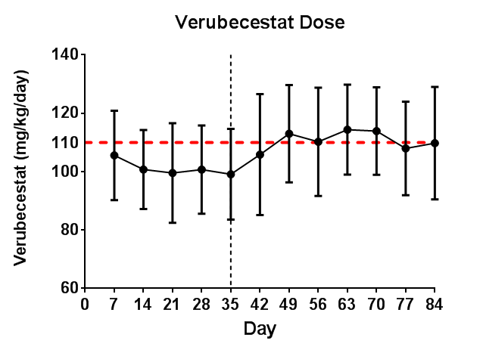
A.
B.
C.
D.

Supplementary Figure 1. Summary of baseline parameters of body weight (A) and T2*-MRI-detected MH event number (B) by group. There were no significant differences in baseline body weight or MH number between groups (p>0.5, Kruskal-Wallis test). C) Average food consumption calculated weekly for animals fed control (vehicle) diet or diet containing verubecestat. D) Calculated in-diet dose of verubecestat determined weekly from food intake and body weight measurements. Verubecestat diet formulation was adjusted upwards and introduced on day 35 (vertical dashed line in C and D) to maintain the targeted dose of 110 mg/kg/day (dashed red line) (D). This was accompanied by an expected modest and transient dip in food consumption (C). Individual animal data are plotted in A and B. Means±s.d. are plotted in C and D.

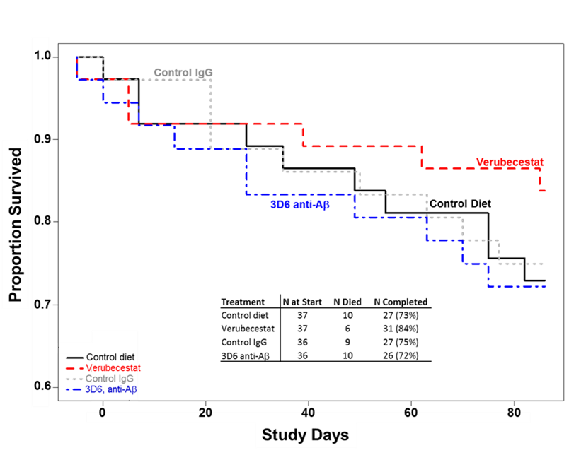
Supplementary Figure 2. Survival (Kaplan-Meier) plot summarizing animal survival across the study by treatment group. Survival between the groups was not different across the duration of the study (p >0.5, log rank test).

A B
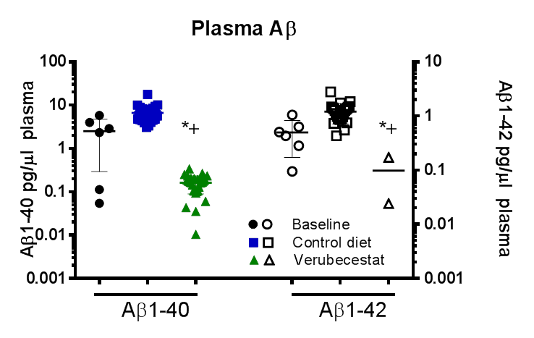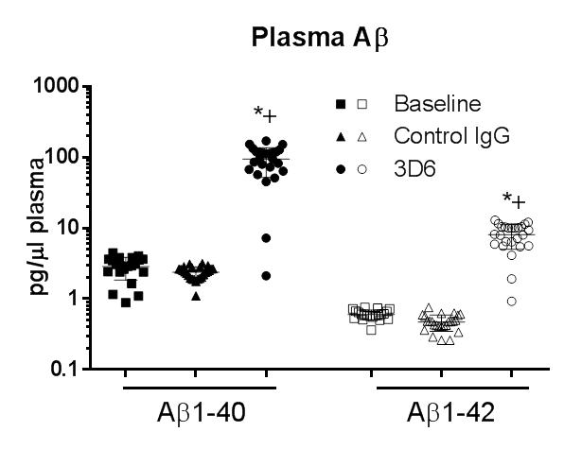

Supplementary Figure 3. Verubecestat effects on plasma Aβ₁₋₄₀(closed symbols) and Aβ₁₋₄₂ (open symbols) (A) after 12 weeks of in-diet dosing at 110 mg/kg/day. Plasma Aβ₁₋₄₂ levels were below the limit of detection in the majority of verubecestat-treated animals (n=26) and are not plotted. (B) Isotype (IgG) control antibody and 3D6 anti-Aβ antibody effects on plasma Aβ₁₋₄₀ and Aβ₁₋₄₂ levels following 12 weeks of once weekly injections at 20 mg/kg, sc. ⁺p<0.0005 versus baseline and *p<0.0001 versus vehicle diet treated mice as assessed by a two-tailed t-test. Data are means±sd.

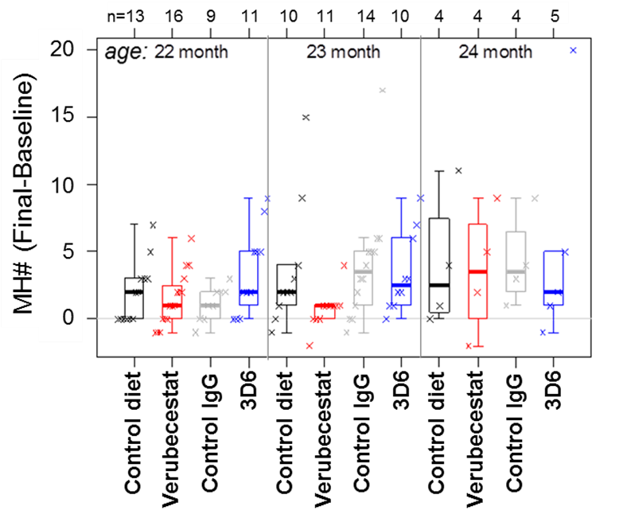

Supplementary Figure 4. Baseline subtracted microhemorrhage events detected by T2*-MRI. Plot of microhemorrhage events by treatment group stratified by age. Each figure shows a boxplot for the indicated group with a line drawn at the median and the individual values overlaid. Sample sizes are given on the top axis.

Verubecestat Exposure
Plasma |  | Brain
AUC_{4-24h}, µMh⁺  (EM) | C_{Pl}, µM  (EM) | AUC_{4-24h}, µMh⁺  (b/p) | C_{Br}, µM
181  (22.8x)* | 9.1±3.01†  (15.6x)* | 46.3  (0.26) | 2.3±0.64†

Supplementary Table 1. Verubecestat levels in plasma and brain were determined between 3.5-7.5 h after the onset of the light cycle after 12 weeks in-diet treatment at 110 mg/kg/day. ⁺AUC_{4-24h} was estimated based on the assumption that plasma levels were at steady state after 12 weeks and were relatively stable over the day of necropsy as observed in prior studies. *Plasma exposure multiples (EM) were calculated relative to the measured AUC_{0-24h} of 7.93 µMh and C_{max} of 584 nM at 60 mg, qd in Alzheimer’s disease patients (1). †C_{Pl} (n=31) and C_{Br} (n=16) are means±s.d.

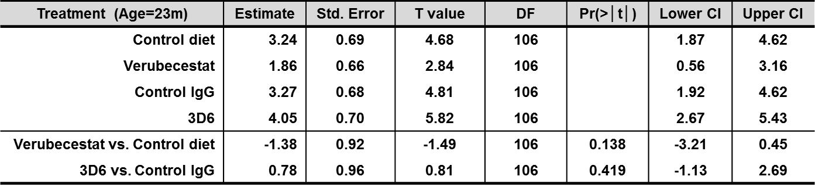

Supplementary Table 2. Estimates of treatment group T2*-MRI microhemorrhage (MH) means and differences adjusted for age based on an ANCOVA model. The treatment means were adjusted to estimate the 23 month mean. Model: MH (Final − Baseline) = Trt + Age + Error.Pr(>|t|) is the two sided p-value testing the difference between treatment groups. t value, the test statistic used for significance testing. DF, degrees of freedom for the estimate of the Standard Error. Lower and Upper bounds for a 95% confidence interval are given. Trt, treatment.

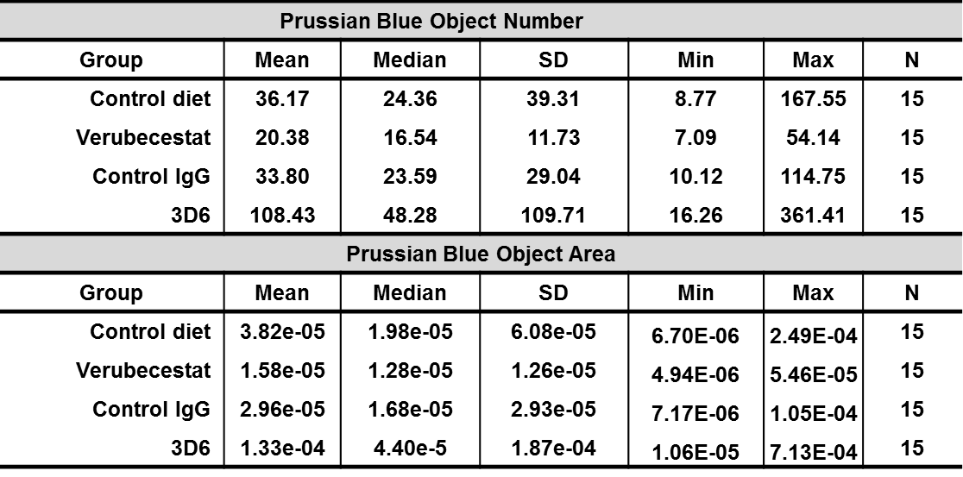

Supplementary Table 3. Summary Statistics for Prussian blue Object Number and Prussian blue Object Area without age adjustment. Object Number=microhemorrhage number and Object Area= fractional area occupied by Prussian blue.

Treatment | Control diet | Verubecestat | Control IgG | 3D6  anti-A
Number of Animals | 15 | 15 | 15 | 15
Incidence of Prussian blue staining above background indicating MH | 1 | 0 | 3 | 7

Supplementary Table 4. Determination of the incidence of Prussian Blue Staining above background in aged post-plaqueTg2576 mice by visual scoring. Based on the between group distribution of microhemorrhage incidence of affected mice, there was an anticipated test article related increase in microhemorrhage due to 3D6 treatment. There was no qualitative evidence for increased microhemorrhage due to verubecestat treatment relative to the control diet group animals.

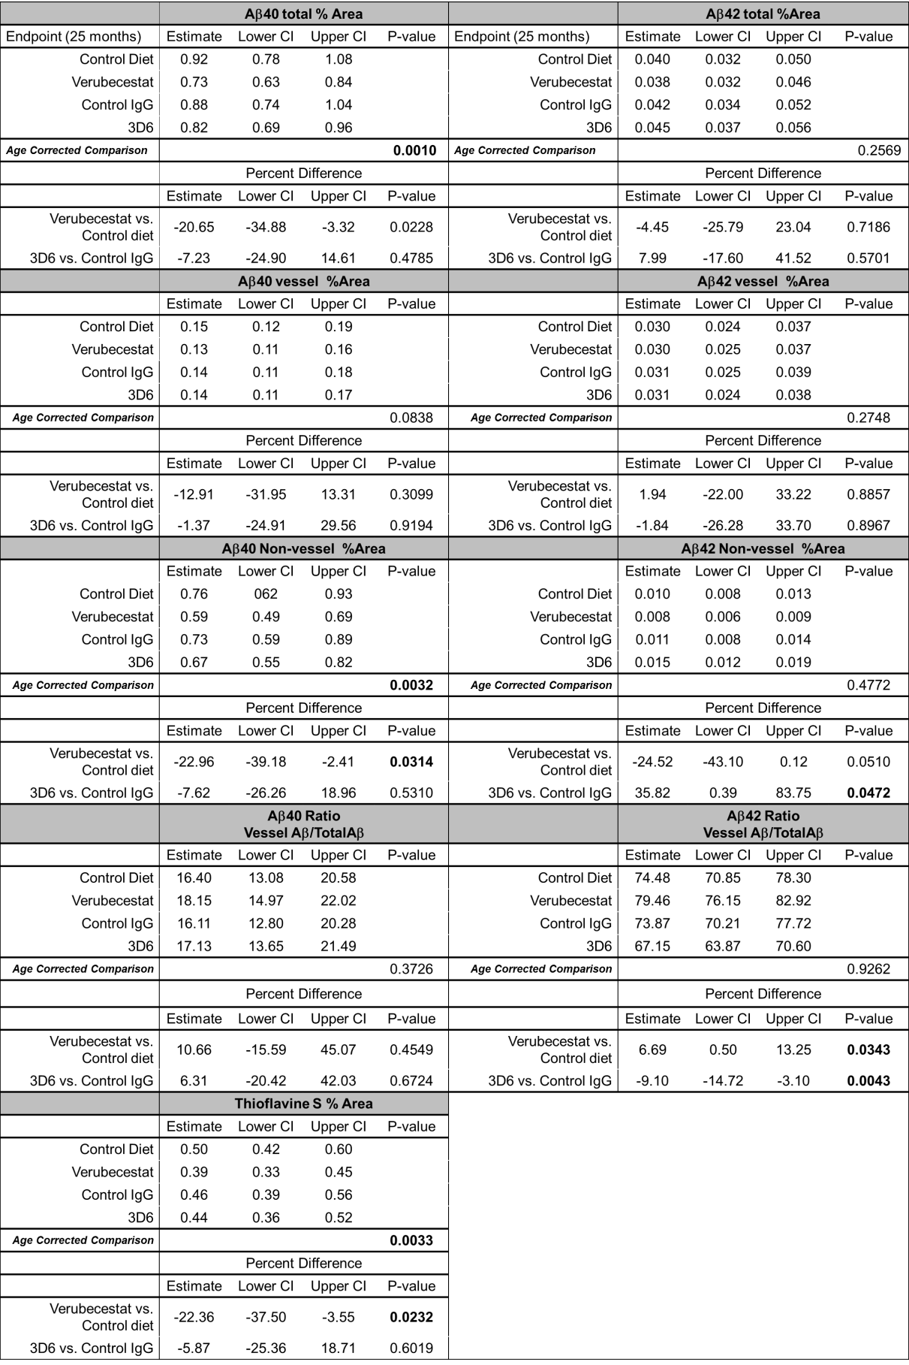

Supplementary Table 5. Age corrected analysis of vessel versus non-vessel immunohistochemistry. Application of a linear model to adjust for age effects on Thioflavin S, Total anti-Aβ₄₀ immunoreactive deposits, total anti-Aβ₄₂ immunoreactive deposits, vessel Aβ and non-vessel Aβ deposits. All variables (except Vessel/Total) were normalized to the slice area analyzed and were analyzed on log2 scale (i.e. log2(Area of Interest) - log2(Slice Area), or log2(Vessel Aβ)-log2(Total Aβ)). If x = estimate on log2 scale, percent estimates were calculated as 100*(2^x). If y= estimate of difference on the log2 scale, the percent difference estimates were calculated as 100*(2^y-1). For instance, for Total Aβ, verubecestat vs. control diet (CTL), the Pct difference is an estimate of 100*(TotalAβ(verubecestat)/TotalAβ(CTL) * SliceArea(CTL)/SliceArea(verubecestat)-1). All estimates are derived from a linear model that adjusts for age. CI=confidence interval, IgG= isotype control antibody, 3D6=anti-Aβ.

