Supplementary Figure Legends
Supplementary Figure 1: Representation of the BcCluster database architecture (schema).
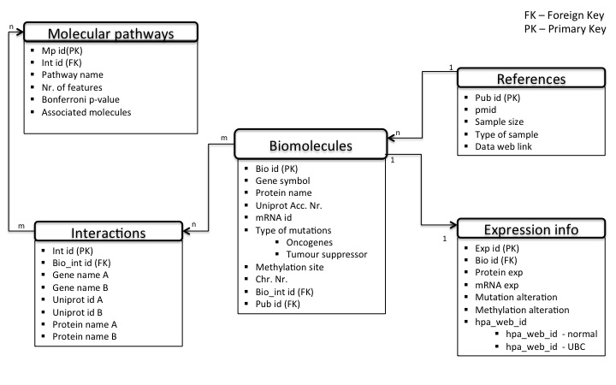
Supplementary Figure S1. BcCluster architecture. The figure describes the structure (schema) of the BcCluster database. Tables hold entities that store molecular feature information within the database. Each table contains a unique id, represented by a specific constrain PK that enforces entity integrity and uniqueness of the table. Two tables are linked to one another with FK. Relationships between tables are denoted by one-to-one (1.1), one-to-many (1:n) and many-to-many (m:n). The schema was generated by Dia 0.97

Supplementary Figure 2: Representation of the Ruby on Rails framework used in creating the BcCluster web query interface.
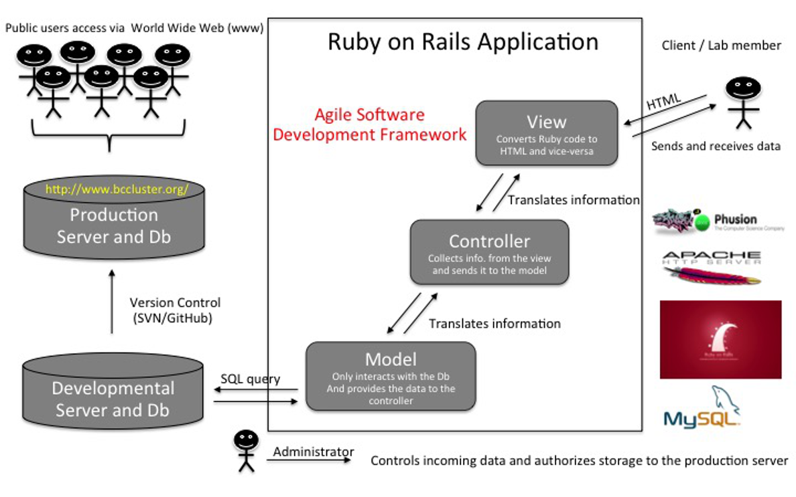
Supplementary Figure S2. BcCluster framework (Database and software application). BcCluster is a web application developed using the Ruby programming language (version 1.9.3) and the Rails (version 4.1.5) web framework (http://rubyonrails.org/). The framework is based on the architecture pattern of Model-View-Controller (MVC). The database is generated using the MySQL guidelines (http://www.mysql.com/) and follows the database schema in Figure S1. The database allows to query and store molecular features, protein interactions and pathways relative to muscle invasive bladder carcinoma. The BcCluster application functions on the developmental and the production server. The developmental server is used for all on-going changes, updates and validations, while the production is a stable server that contains the validated data and is available for users to query (http://bccluster.org/).

Supplementary Table Legends
Supplementary Table 1: List of all references used in development of the muscle invasive BC interactome and BcCluster database. Provided is a list of 112 unique MedLine references with the title and author details.
Table S1. List of 112 publications used in retreiving molecules relative to muscle invasive bladder cancer. The title, reference and authors are listed. Information on the use of neoadjuvant chemotherapy is also provided. |  |  |  | (N/A not available)
Title | Reference | Author | MedLine ID | neoadj chemo for patients undergoing cystectomy
Molecular pathogenesis and diagnostics of bladder cancer. | Annu Rev Pathol. 2009;4:251-85. | Mitra AP et.al | 18840072 | N/A
p53 expression in patients with advanced urothelial cancer of the urinary bladder. | BJU Int. 2010 Feb;105(4):489-95. | Shariat SF et.al | 19659466 | No
p53 and RB expression predict progression in T1 bladder cancer. | Clin Cancer Res. 1998 Apr;4(4):829-34. | Grossman HB et.al | 9563875 | N/A
Elevated and absent pRb expression is associated with bladder cancer progression and has cooperative effects with p53. | Cancer Res. 1998 Mar 15;58(6):1090-4. | Cote RJ et.al | 9515785 | N/A
Combined effects of p53, p21, and pRb expression in the progression of bladder transitional cell carcinoma. | J Clin Oncol. 2004 Mar 15;22(6):1007-13. Epub 2004 Feb 23. | Chatterjee SJ et.al | 14981105 | no
Use of combined apoptosis biomarkers for prediction of bladder cancer recurrence and mortality after radical cystectomy. | Lancet Oncol. 2007 Feb;8(2):128-36. | Karam JA et.al | 17267327 | yes (16/226)
Thrombospondin-1 expression in bladder cancer: association with p53 alterations, tumor angiogenesis, and tumor progression. | J Natl Cancer Inst. 1997 Feb 5;89(3):219-27. | Grossfeld GD et.al | 9017002 | N/A
Effect of p21WAF1/CIP1 expression on tumor progression in bladder cancer. | J Natl Cancer Inst. 1998 Jul 15;90(14):1072-9. | Stein JP et.al | 9672255 | N/A
Multiple biomarkers improve prediction of bladder cancer recurrence and mortality in patients undergoing cystectomy. | Cancer. 2008 Jan 15;112(2):315-25. | Shariat SF et.al | 18008359 | no
Ki67 and Bcl-2 immunoexpression in primitive urothelial bladder carcinoma. | Rom J Morphol Embryol. 2012;53(3):521-5. | Enache M et.al | 22990542 | N/A
Role of activating fibroblast growth factor receptor 3 mutations in the development of bladder tumors. | Clin Cancer Res. 2005 Nov 1;11(21):7709-19. | Zieger K et.al | 16278391 | N/A
Long-term outcome related to epidermal growth factor receptor status in bladder cancer. | J Urol. 1995 Mar;153(3 Pt 2):919-25. | Mellon K et.al | 7853575 | N/A
Distinctive expression pattern of ErbB family receptors signifies an aggressive variant of bladder cancer. | J Urol. 2008 Jan;179(1):353-8. Epub 2007 Nov 19. | Kassouf W et.al | 18006009 | N/A
Her-2/neu overexpression in muscle-invasive urothelial carcinoma of the bladder: prognostic significance and comparative analysis in primary and metastatic tumors. | Clin Cancer Res. 2001 Aug;7(8):2440-7. | Jimenez RE et.al | 11489824 | N/A
HER2 overexpression in muscle-invasive urothelial carcinoma of the bladder: prognostic implications. | Int J Cancer. 2002 Dec 10;102(5):514-8. | Krüger S et.al | 12432555 | yes (10)
Human epidermal growth factor receptor 2 expression status provides independent prognostic information in patients with urothelial carcinoma of the urinary bladder. | BJU Int. 2010 Oct;106(8):1216-22. | Bolenz C et.al | 20089105 | no
Expression and significance of vascular endothelial growth factor receptor 2 in bladder cancer. | J Urol. 2006 Apr;175(4):1245-52. | Xia G et.al | 16515971 | N/A
Stat3 activation in urothelial stem cells leads to direct progression to invasive bladder cancer. | Cancer Res. 2012 Jul 1;72(13):3135-42. | Ho PL et.al | 22532166 | N/A
Vascular endothelial growth factor (VEGF), matrix metalloproteinase-9 (MMP-9), and thrombospondin-1 (TSP-1) expression in urothelial carcinomas. | Pathol Res Pract. 2009;205(12):854-7. | Donmez G et.al | 19762163 | N/A
Association of angiogenesis related markers with bladder cancer outcomes and other molecular markers. | J Urol. 2010 May;183(5):1744-50. | Shariat SF et.al | 20299037 | no
Thrombospondin-1 expression in urothelial carcinoma: prognostic significance and association with p53 alterations, tumour angiogenesis and extracellular matrix components. | BMC Cancer. 2006 May 29;6:140. | Ioachim E et.al | 16732887 | N/A
Correlation of metastasis related gene expression and relapse-free survival in patients with locally advanced bladder cancer treated with cystectomy and chemotherapy. | J Urol. 2004 Feb;171(2 Pt 1):570-4. | Slaton JW et.al | 14713761 | yes
Imbalance between serum matrix metalloproteinase-2 and its inhibitor as a predictor of recurrence of urothelial cancer. | Br J Cancer. 1998 Feb;77(4):650-5. | Gohji K et.al | 9484825 | N/A
Role of matrix metalloproteinase-9 in the basement membrane destruction of superficial urothelial carcinomas. | J Urol. 1999 Apr;161(4):1359-63. | Ozdemir E et.al | 10081908 | N/A
High levels of tissue inhibitor of metalloproteinase-2 (TIMP-2) expression are associated with poor outcome in invasive bladder cancer. | Cancer Res. 1996 Apr 1;56(7):1654-9. | Grignon DJ et.al | 8603416 | N/A
Matrix metalloproteinase-2 immunoreactive protein as a prognostic marker in bladder cancer. | Urology. 2003 Nov;62(5):952-7. | Vasala K et.al | 14624933 | N/A
Significance of matrix metalloproteinases and tissue inhibitors of metalloproteinase expression in the recurrence of superficial transitional cell carcinoma of the bladder. | J Urol. 2001 May;165(5):1769-72. | Hara I et.al | 11342973 | N/A
A multiplexed, particle-based flow cytometric assay identified plasma matrix metalloproteinase-7 to be associated with cancer-related death among patients with bladder cancer. | Cancer. 2010 Oct 1;116(19):4513-9. | Svatek RS et.al | 20572047 | yes (44/107)
Matrix metalloproteinase-1 is induced by epidermal growth factor in human bladder tumour cell lines and is detectable in urine of patients with bladder tumours. | Br J Cancer. 1998 Jul;78(2):215-20. | Nutt JE et.al | 9683296 | N/A
Serum tissue inhibitor of metalloproteinase-2 (TIMP-2) and matrix metalloproteinase-2 in complex with the inhibitor (MMP-2:TIMP-2) as prognostic markers in bladder cancer. | Clin Biochem. 2007 Jun;40(9-10):640-4. | Vasala K et.al | 17374529 | no
Low circulating levels of ProMMP-2 are associated with adverse prognosis in bladder cancer. | Tumour Biol. 2008;29(5):279-86. | Vasala K et.al | 18802398 | N/A
Predicting survival after radical cystectomy for bladder cancer. | BJU Int. 2008 Jul;102(1):15-22. | Margulis V et.al | 18325050 | N/A
Prognostic values of matrix metalloproteinase-2 and tissue inhibitor of metalloproteinase-2 expression in bladder cancer. | Cancer. 1998 Apr 1;82(7):1359-66. | Kanayama H et.al | 9529029 | N/A
Expression signature of E2F1 and its associated genes predict superficial to invasive progression of bladder tumors. | J Clin Oncol. 2010 Jun 1;28(16):2660-7. | Lee JS et.al | 20421545 | N/A
c-Jun NH2 terminal kinase activation and decreased expression of mitogen-activated protein kinase phosphatase-1 play important roles in invasion and angiogenesis of urothelial carcinomas. | Am J Pathol. 2007 Sep;171(3):1003-12. | Shimada K et.al | 17690186 | no
Identification of common differentially expressed genes in urinary bladder cancer. | PLoS One. 2011 Apr 4;6(4):e18135. | Zaravinos A et.al | 21483740 | no
Cathepsin E, maspin, Plk1, and survivin are promising prognostic protein markers for progression in non-muscle invasive bladder cancer. | Am J Pathol. 2012 May;180(5):1824-34. | Fristrup N et.al | 22449953 | N/A
Androgen receptor expression is inversely correlated with pathologic tumor stage in bladder cancer. | Urology. 2004 Aug;64(2):383-8. | Boorjian S et.al | 15302512 | N/A
Loss of androgen receptor expression is not associated with pathological stage, grade, gender or outcome in bladder cancer: a large multi-institutional study. | BJU Int. 2011 Jul;108(1):24-30. | Mir C et.al | 21070579 | no
Survivin and MKI67 mRNA expression in bladder washings of patients with superficial urothelial cell carcinoma correlate with tumor stage and grade but do not predict tumor recurrence. | Clin Chem. 2006 Jul;52(7):1440-2. | Schultz IJ et.al | 16798976 | N/A
Cyclooxygenase-2 expression in bladder cancer and patient prognosis: results from a large clinical cohort and meta-analysis. | PLoS One. 2012;7(9):e45025. | Czachorowski MJ et.al | 23028744 | no
Overexpression of cyclooxygenase-2 in urothelial carcinoma in conjunction with tumor-associated-macrophage infiltration, hypoxia-inducible factor-1alpha expression, and tumor angiogenesis. | APMIS. 2009 Mar;117(3):176-84. | Chen WT et.al | 19245590 | N/A
Angiogenesis in bladder cancer: relationship between microvessel density and tumor prognosis. | J Natl Cancer Inst. 1995 Nov 1;87(21):1603-12. | Bochner BH et.al | 7563203 | N/A
Decreased RECK and Increased EMMPRIN expression in urothelial carcinoma of the bladder are associated with tumor aggressiveness. | Pathobiology. 2011;78(3):123-31. | Wittschieber D et.al | 21613799 | N/A
High insulin-like growth factor mRNA-binding protein 3 (IMP3) protein expression is associated with poor survival in muscle-invasive bladder cancer. | BJU Int. 2012 Sep;110(6 Pt B):E308-17. | Szarvas T et.al | 22500655 | N/A
High expression of karyopherin-α2 defines poor prognosis in non-muscle-invasive bladder cancer and in patients with invasive bladder cancer undergoing radical cystectomy. | Eur Urol. 2011 May;59(5):841-8. | Jensen JB et.al | 21330047 | N/A
Low ANXA10 expression is associated with disease aggressiveness in bladder cancer. | Br J Cancer. 2011 Oct 25;105(9):1379-87. | Munksgaard PP et.al | 21979422 | no
High frequency of tumor cells with nuclear Egr-1 protein expression in human bladder cancer is associated with disease progression. | BMC Cancer. 2009 Oct 30;9:385. | Egerod FL et.al | 19878561 | N/A
Foxo3a suppression of urothelial cancer invasiveness through Twist1, Y-box-binding protein 1, and E-cadherin regulation. | Clin Cancer Res. 2010 Dec 1;16(23):5654-63. | Shiota M et.al | 21138866 | N/A
Increased expression of HMGB1 is associated with poor prognosis in human bladder cancer. | J Surg Oncol. 2012 Jul 1;106(1):57-61. | Yang GL et.al | 22237993 | N/A
Association of steroid and xenobiotic receptor (SXR) and multidrug resistance 1 (MDR1) gene expression with survival among patients with invasive bladder carcinoma. | BJU Int. 2011 Jun;107(11):1833-8. | Rioja J et.al | 20840328 | N/A
Prognostic significance of altered p120 ctn expression in bladder cancer. | BJU Int. 2008 Mar;101(6):746-52. | Silva Neto B et.al | 17922855 | N/A
Comprehensive molecular characterization of urothelial bladder carcinoma. | Nature. 2014 Mar 20;507(7492):315-22. | Weinstein JN et.al | 24476821 | no
Orphan nuclear receptor HNF4G promotes bladder cancer growth and invasion through the regulation of the hyaluronan synthase 2 gene. | Oncogenesis. 2013 Jul 29;2:e58. | Okegawa T | 23896584 | N/A
Clinical implications in the shift of syndecan-1 expression from the cell membrane to the cytoplasm in bladder cancer. | BMC Cancer. 2014 Feb 13;14:86. | Miyake M et.al | 24524203 | N/A
Transcriptome profiling of a multiple recurrent muscle-invasive urothelial carcinoma of the bladder by deep sequencing. | PLoS One. 2014 Mar 12;9(3):e91466. | Zhang S et.al | 24622401 | N/A
GATA binding protein 3 is down-regulated in bladder cancer yet strong expression is an independent predictor of poor prognosis in invasive tumor. | Hum Pathol. 2012 Nov;43(11):2033-40. | Miyamoto H et.al | 22607700 | N/A
Loss expression of uroplakin III is associated with clinicopathologic features of aggressive bladder cancer. | Urology. 2008 Aug;72(2):444-9. | Matsumoto K et.al | 18313120 | no
Whole-genome sequencing identifies genomic heterogeneity at a nucleotide and chromosomal level in bladder cancer. | Proc Natl Acad Sci U S A. 2014 Feb 11;111(6):E672-81. | Morrison CD et.al | 24469795 | yes (5)
SNAI1 protein expression is an independent negative prognosticator in muscle-invasive bladder cancer. | Ann Surg Oncol. 2013 Oct;20(11):3669-74. | Keck B et.al | 23807662 | no
Preoperative serum C- reactive protein: a prognostic marker in patients with upper urinary tract urothelial carcinoma. | BMC Cancer. 2013 Mar 6;13:101. | Stein B et.al | 23497335 | N/A
C-reactive protein level predicts prognosis in patients with muscle-invasive bladder cancer treated with chemoradiotherapy. | BJU Int. 2008 Apr;101(8):978-81. | Yoshida S et.al | 18190628 | yes
Loss of aquaporin 3 protein expression constitutes an independent prognostic factor for progression-free survival: an immunohistochemical study on stage pT1 urothelial bladder cancer. | BMC Cancer. 2012 Oct 8;12:459. | Otto W et.al | 23043286 | no
Low circulating serum levels of second mitochondria-derived activator of caspase (Smac/DIABLO) in patients with bladder cancer. | Int J Oncol. 2012 Apr;40(4):1246-50. | Mizutani Y et.al | 22218530 | no
Fra-1 controls motility of bladder cancer cells via transcriptional upregulation of the receptor tyrosine kinase AXL. | Oncogene. 2012 Mar 22;31(12):1493-503. | Sayan AE et.al | 21822309 | N/A
Increased expression of transcription factor TFAP2α correlates with chemosensitivity in advanced bladder cancer. | BMC Cancer. 2011 Apr 14;11:135. | Nordentoft I et.al | 21489314 | no
CA19.9 and CEA in transitional cell carcinoma of the bladder: serological and immunohistochemical findings. | Anticancer Res. 2010 Dec;30(12):5195-200. | Hegele A et.al | 21187512 | N/A
Prognostic significance of replication protein A (RPA) expression levels in bladder urothelial carcinoma. | BJU Int. 2011 Jul;108(2 Pt 2):E59-65. | Levidou G et.al | 21062395 | no
MRE11 expression is predictive of cause-specific survival following radical radiotherapy for muscle-invasive bladder cancer. | Cancer Res. 2010 Sep 15;70(18):7017-26. | Choudhury A et.al | 20843819 | yes (3)
Galectin-3 expression is associated with bladder cancer progression and clinical outcome. | Tumour Biol. 2010 Aug;31(4):277-85. | Canesin G et.al | 20401558 | N/A
HYAL-1 hyaluronidase: a potential prognostic indicator for progression to muscle invasion and recurrence in bladder cancer. | Eur Urol. 2010 Jan;57(1):86-93. | Kramer MW et.al | 19345473 | N/A
Gene expression study of Aurora-A reveals implication during bladder carcinogenesis and increasing values in invasive urothelial cancer. | Urology. 2008 Oct;72(4):873-7. | Compérat E et.al | 18485461 | N/A
Beclin 1 and bcl-2 expressions in bladder urothelial tumors and their association with clinicopathological parameters. | Pathol Res Pract. 2013 Jul;209(7):418-23. | Baspinar S et.al | 23722017 | N/A
Expression and function role of DNA methyltransferase 1 in human bladder cancer. | Cancer. 2011 Nov 15;117(22):5221-33. | Wu CT et.al | 21523767 | no
Predictive value of topoisomerase II alpha immunostaining in urothelial bladder carcinoma. | J Clin Pathol. 2001 Apr;54(4):309-13. | Nakopoulou L et.al | 11304849 | N/A
Overexpression of fatty acid synthase in human urinary bladder cancer and combined expression of the synthase and Ki-67 as a predictor of prognosis of cancer patients. | Med Mol Morphol. 2011 Sep;44(3):146-50. | Sugino T et.al | 21922386 | no
Expression of three extracellular matrix degradative enzymes in bladder cancer. | Int J Cancer. 2001 Sep 20;95(5):295-301. | Gohji K et.al | 11494228 | N/A
Phosphorylated hepatocyte growth factor receptor/c-Met is associated with tumor growth and prognosis in patients with bladder cancer: correlation with matrix metalloproteinase-2 and -7 and E-cadherin. | Hum Pathol. 2009 Apr;40(4):496-504. | Miyata Y et.al | 19121849 | no
Expression of Bmi-1 is a prognostic marker in bladder cancer. | BMC Cancer. 2009 Feb 19;9:61. | Qin ZK et.al | 19228380 | N/A
CIP2A protein expression in high-grade, high-stage bladder cancer. | Cancer Med. 2012 Aug;1(1):76-81. | Huang LP et.al | 23342256 | N/A
Immunohistochemical study of the expression of cell cycle regulating proteins at different stages of bladder cancer. | J Cancer Res Clin Oncol. 2002 Jun;128(6):295-301. | Primdahl H et.al | 12073046 | no
Expression of S100A2 and S100A4 predicts for disease progression and patient survival in bladder cancer. | Urology. 2007 Sep;70(3):602-7. | Matsumoto K et.al | 17688917 | no
Stromelysin-3 expression in noninvasive and invasive neoplasms of the urinary bladder. | Hum Pathol. 2000 Jul;31(7):860-5. | Mueller J et.al | 10923925 | N/A
A systematic analysis on DNA methylation and the expression of both mRNA and microRNA in bladder cancer. | PLoS One. 2011;6(11):e28223. | Zhu J et.al | 22140553 | N/A
Molecular detection of noninvasive and invasive bladder tumor tissues and exfoliated cells by aberrant promoter methylation of laminin-5 encoding genes. | Cancer Res. 2004 Feb 15;64(4):1425-30. | Sathyanarayana UG et.al | 14973053 | N/A
Expression of transient receptor potential vanilloid-1 (TRPV1) in urothelial cancers of human bladder: relation to clinicopathological and molecular parameters. | Histopathology. 2010 Nov;57(5):744-52. | Kalogris C et.al | 21083604 | N/A
Utility of urothelial mRNA markers in blood for staging and monitoring bladder cancer. | Urology. 2012 Jan;79(1):240.e9-15. | Marín-Aguilera M et.al | 22055693 | yes (only 5/101 patients)
Expression of CD147, BIGH3 and Stathmin and their potential role as diagnostic marker in patients with urothelial carcinoma of the bladder. | Clin Chim Acta. 2012 Oct 9;413(19-20):1641-6. | Bhagirath D et.al | 22626996 | no
Defining molecular profiles of poor outcome in patients with invasive bladder cancer using oligonucleotide microarrays. | J Clin Oncol. 2006 Feb 10;24(5):778-89. Epub 2006 Jan 23. | Sanchez-Carbayo M et.al | 16432078 | N/A
Metabolomic profiling reveals potential markers and bioprocesses altered in bladder cancer progression. | Cancer Res. 2011 Dec 15;71(24):7376-86. | Putluri N et.al | 21990318 | no
Telomerase reverse transcriptase promoter mutations in bladder cancer: high frequency across stages, detection in urine, and lack of association with outcome. | Eur Urol. 2014 Feb;65(2):360-6. | Allory Y et.al | 24018021 | no
Molecular biology of bladder cancer: new insights into pathogenesis and clinical diversity. | Nat Rev Cancer. 2015 Jan;15(1):25-41. | Knowles MA et.al | 25533674 | no
The evolving understanding of microRNA in bladder cancer. | Urol Oncol. 2014 Jan;32(1):41.e31-40. | Guancial EA et.al | 23911686 | N/A
Distinct microRNA alterations characterize high- and low-grade bladder cancer. | Cancer Res. 2009 Nov 1;69(21):8472-81. | Catto JW et.al | 19843843 | no
microRNA expression profile in a large series of bladder tumors: identification of a 3-miRNA signature associated with aggressiveness of muscle-invasive bladder cancer. | Int J Cancer. 2013 Jun 1;132(11):2479-91. | Pignot G et.al | 23169479 | N/A
MicroRNA-124-3p inhibits cell migration and invasion in bladder cancer cells by targeting ROCK1. | J Transl Med. 2013 Nov 2;11:276. | Xu X et.al | 24180482 | N/A
MicroRNA-490-5p inhibits proliferation of bladder cancer by targeting c-Fos. | Biochem Biophys Res Commun. 2013 Nov 29;441(4):976-81. | Li S et.al | 24220339 | N/A
MicroRNA-101 suppresses motility of bladder cancer cells by targeting c-Met. | Biochem Biophys Res Commun. 2013 May 24;435(1):82-7. | Hu Z et.al | 23618864 | N/A
MicroRNA-23b functions as a tumor suppressor by regulating Zeb1 in bladder cancer. | PLoS One. 2013 Jul 2;8(7):e67686. | Majid S et.al | 23844063 | N/A
Oncogenic miRNA-182-5p targets Smad4 and RECK in human bladder cancer. | PLoS One. 2012;7(11):e51056. | Hirata H et.al | 23226455 | N/A
Hedgehog pathway activation in human transitional cell carcinoma of the bladder. | Br J Cancer. 2012 Mar 13;106(6):1177-86. | Pignot G et.al | 22361633 | N/A
MicroRNA expression signatures of bladder cancer revealed by deep sequencing. | PLoS One. 2011 Mar 28;6(3):e18286. | Han Y et.al | 21464941 | N/A
Functional role of LASP1 in cell viability and its regulation by microRNAs in bladder cancer. | Urol Oncol. 2012 Jul-Aug;30(4):434-43. | Chiyomaru T et.al | 20843712 | N/A
Coordinated epigenetic repression of the miR-200 family and miR-205 in invasive bladder cancer. | Int J Cancer. 2011 Mar 15;128(6):1327-34. | Wiklund ED et.al | 20473948 | N/A
miR-9, a MYC/MYCN-activated microRNA, regulates E-cadherin and cancer metastasis. | Nat Cell Biol. 2010 Mar;12(3):247-56. | Ma L et.al | 20173740 | N/A
Genomic profiling of microRNAs in bladder cancer: miR-129 is associated with poor outcome and promotes cell death in vitro. | Cancer Res. 2009 Jun 1;69(11):4851-60. | Dyrskjøt L et.al | 19487295 | N/A
Protein shedding in urothelial bladder cancer: prognostic implications of soluble urinary EGFR and EpCAM. | Br J Cancer. 2015 Mar 17;112(6):1052-8. | Bryan RT et.al | 25719831 | N/A
Highly sensitive and specific novel biomarkers for the diagnosis of transitional bladder carcinoma. | Oncotarget. 2015 Apr 15. [Epub ahead of print] | Kumar P et.al | 25915536 | N/A
Bladder cancer determination via two urinary metabolites: a biomarker pattern approach. | Mol Cell Proteomics. 2011 Oct;10(10):M111.007922. | Huang Z et.al | 21799048 | no
Bladder cancer biomarker discovery using global metabolomic profiling of urine. | PLoS One. 2014 Dec 26;9(12):e115870. | Wittmann BM et.al | 25541698 | N/A
Development of a universal metabolome-standard method for long-term LC-MS metabolome profiling and its application for bladder cancer urine-metabolite-biomarker discovery. | Anal Chem. 2014 Jul 1;86(13):6540-7. | Peng J et.al | 24877652 | N/A

